Spark Intro

* It is general purpose in memory compute engine

Compute Engine –

* Hadoop Provide 3 things –
* HDFS - Storage
* Map Reduce – Compute Engine
* and YARN – Resource Management
* Spark is a replacement for Map Reduce
* Spark is plug and play compute engine which needs Storage and resource manager
* Storage – Local, HDFS, S3 Bucket
* Resource Manager – Yarn, mesos, k8s

What is Inmemory –

* In Hadoop it reads from HDFS and writes back to HDFS and it needs to access disk and disk IO is pain, it takes lot of time
* For each Mapreduce job we need 2 disk access, one of reading and one for writing
* In spark data is loaded to in memory, at most we read 1 read initially and 1 write at the end
* Spark holds data into memory, it is 10 to 100 times faster than map reduce

General Purpose:

* It means in Hadoop we use pig for cleaning, hive for querying and mahout of ML purpose
* In Spark it is general purpose and it covers all the activities like ingestion, ML purpose
* 
* 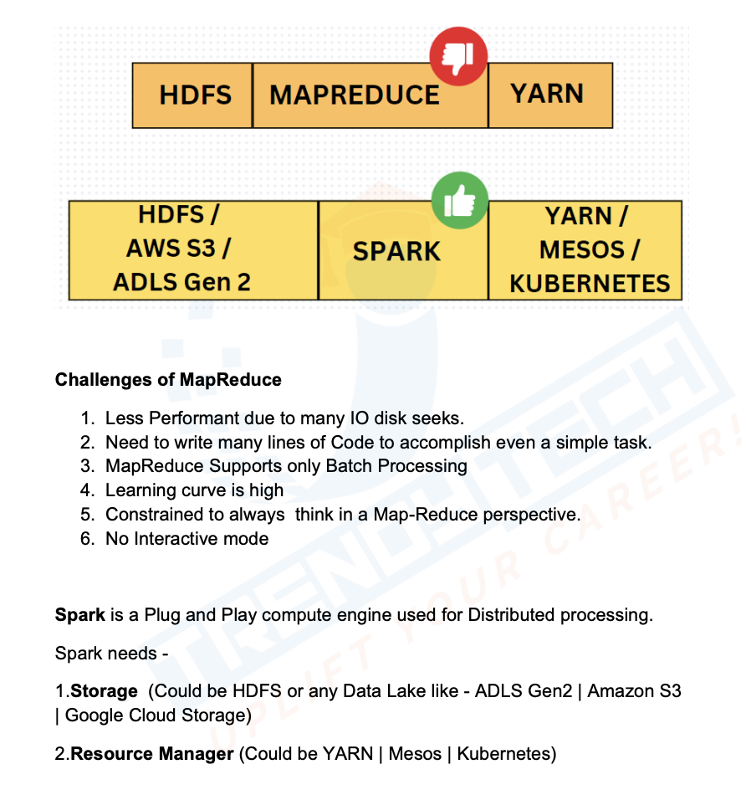
* 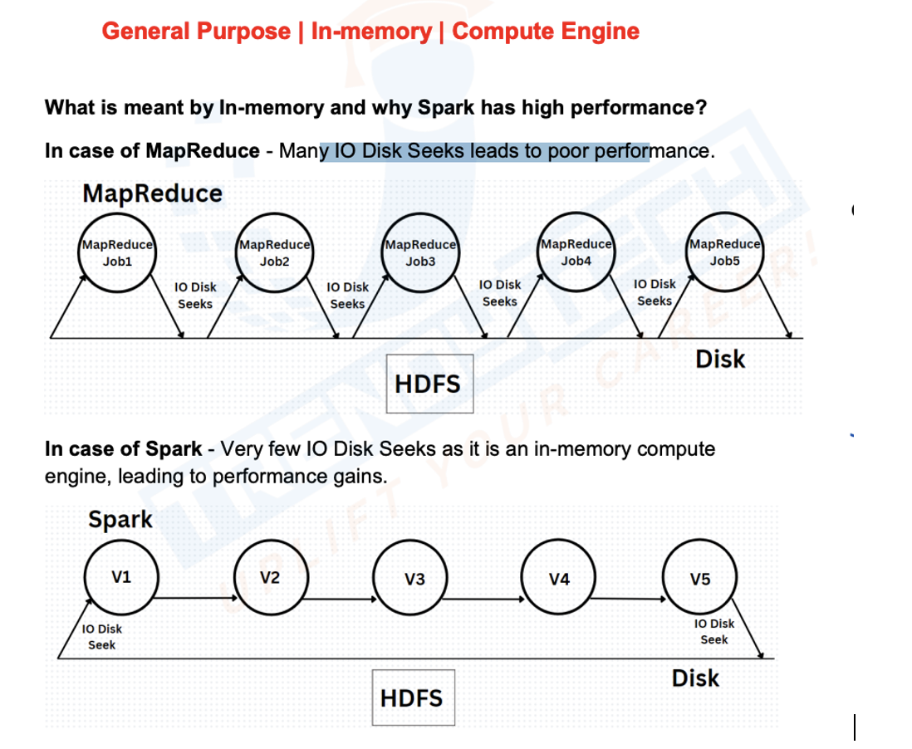
* Challenges with Map Reduce:
* 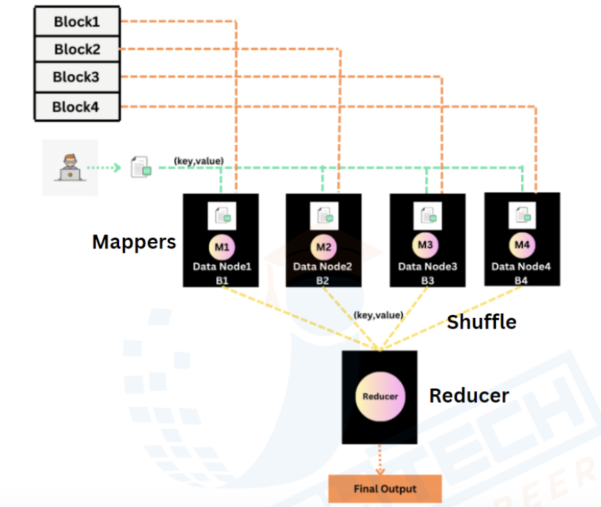
* 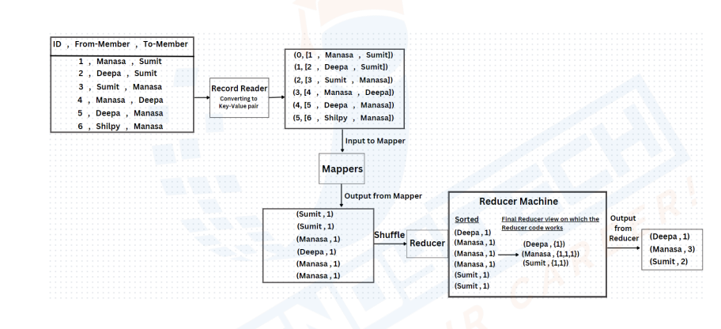
* 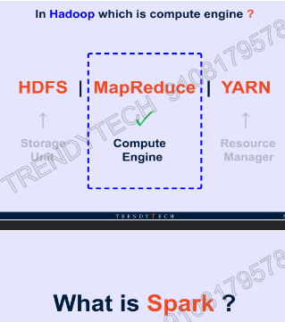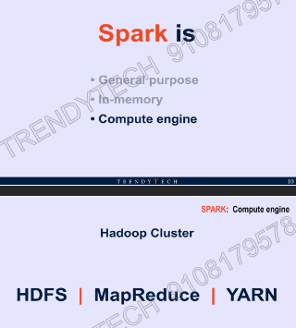
* 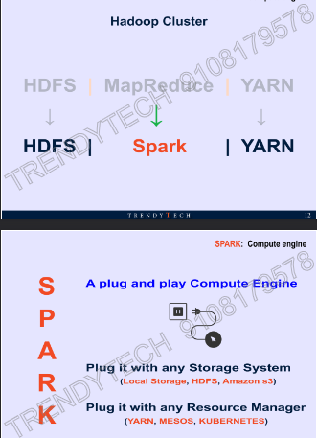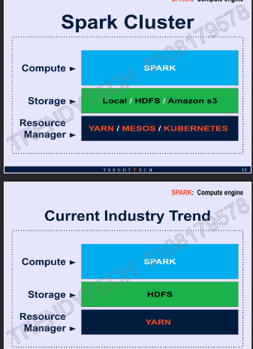
* 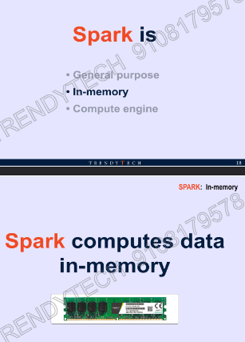
* 
* 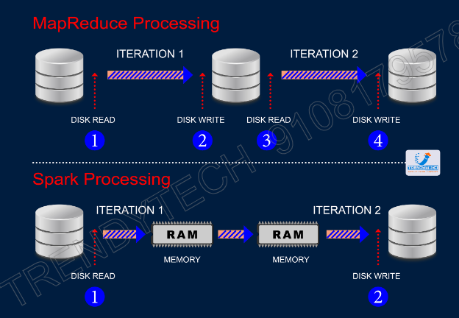
* 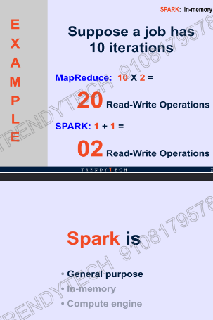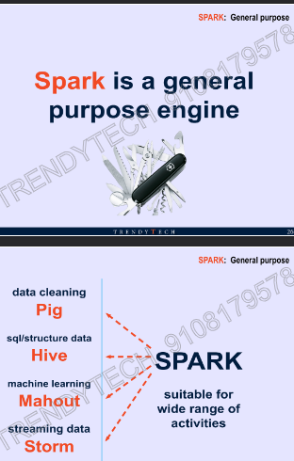

How Data is stored in Spark:

* The basic unit which holds the data in spark is called RDD – Resilient Distributed Dataset
* RDD is nothing but in memory distributed collection, we can visualize like a list which is distributed across the machine and together one unit forms RDD
* Rdd1= load file 1 from HDFS
* Rdd2=rdd1.map
* Rdd3=rdd2.filter
* Rdd3.collect()
* What happens when I execute line 1 –when I run line 1,2 & 3 nothing will happen interms of calculation or loading file but entry is added to the DAG (Directed Acyclic Graph), when I execute collect it will perform
* There are two kind of operations in spark
* 1. Transformation
* 2. Action
* Transformations are lazy but actions are not

Meaning of Lazy

* Whenever you call transformations an entry to the execution plan is added

Visualize RDD:

* Let us assume we have 4 node hadoop cluster and we have 500mb
* RDD are
* Distributed
* In Memory
* Resilient(resilient means recover from failure)– It is resilient to failure, means if we loose we can recover back
* Consider we have RDD1 and we are doing operations and generating RDD2 and then RDD3
* If RDD3 is lost, we know RDD3 is generated from RDD2, if RDD3 is lost it will check for parent RDD using lineage graph and it will quickly apply the filter transformation on RDD2
* In RDD we get fault tolerance using lineage graph
* RDD’s are immutable, once we load RDD with data and data can’t be changed
* Consider after transformation we were assigning back to RDD1, assume if RDD1 is lost and we don’t have parent RDD

Why Transformations are Lazy:

* Assume transformations are not lazy, consider you have 1GB file in HDFS and you have written code read first line of file
* Rdd1= load from hdfs
* Rdd1.print(line1)
* If transformation is not lazy then after first line is executed and data is loaded into memory and to do second task we are unnecessarily read whole file
* What if spark is lazy: it reads the code and adds entry to DAG and then will understand it just needs to print first line, so it will not load whole data into memory
* Example:
* File1 is in HDFS with 10 lakh rows
* Rdd1=load file from HDFS
* Rdd2=rdd1.map
* Rdd3=rdd2.filter
* Rdd3.collect
* Consider spark is not lazy
* Data is loaded, map will do some action on all rows and output rows will be same as input rows
* After filtering we are just interested in 5 records and we printing records
* **But consider the fact if spark is lazy, then it has complete execution plan, then it will execute filter first and then map, so unnecessary computation is saved**
* Sc means spark context, it gives capability run code on spark cluster
* Basic unit which holds the data is called RDD
* Flap map takes each lines as input and does transformation based on whatever we have added and returns single array
* Reduce by key always operates on values
* 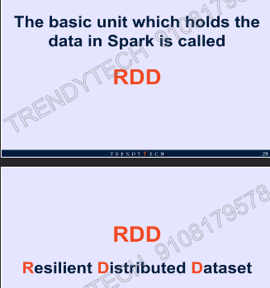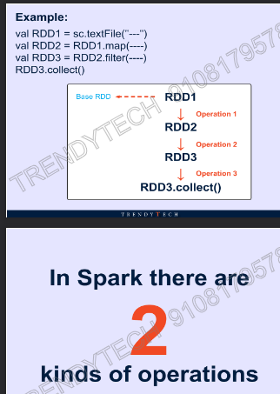
* 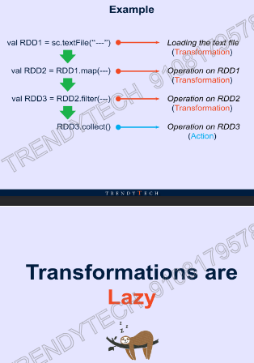
* 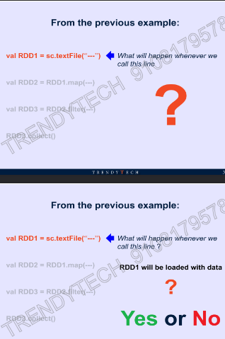
* 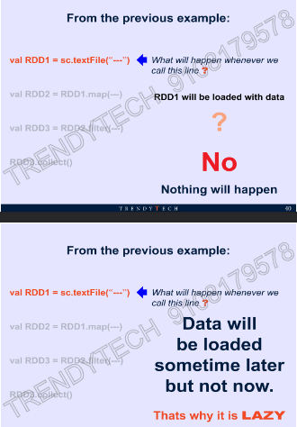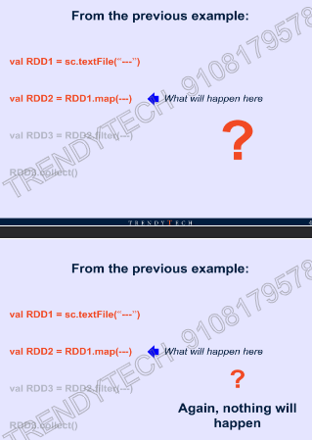
* 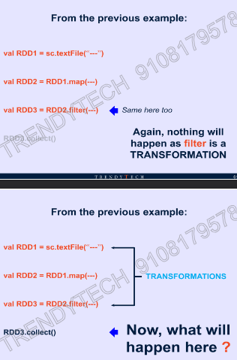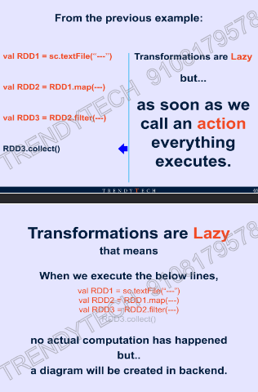
* d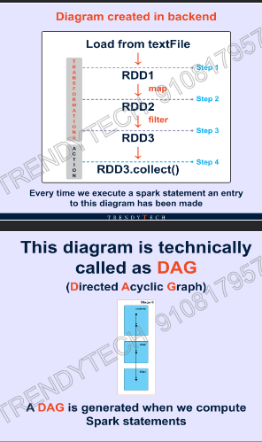

Visualizing Spark:

* 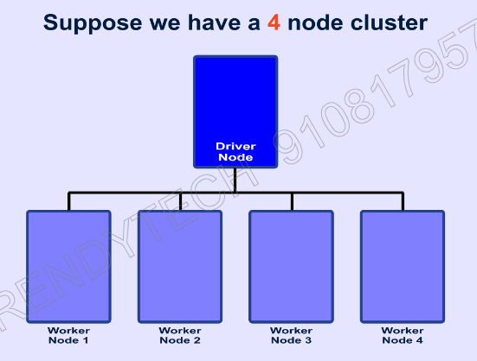
* 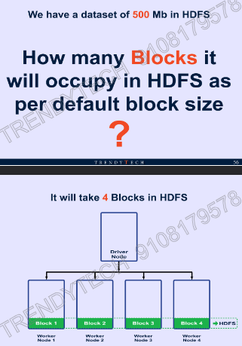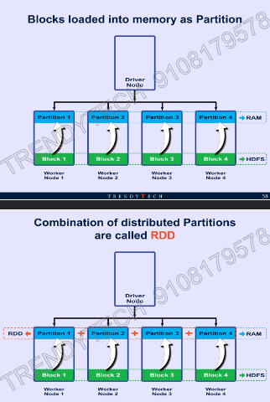
* 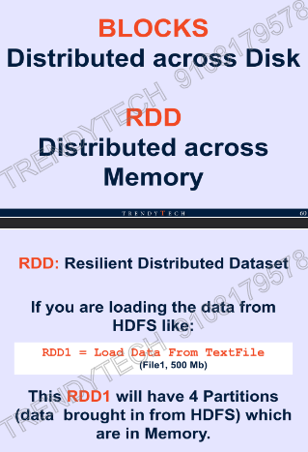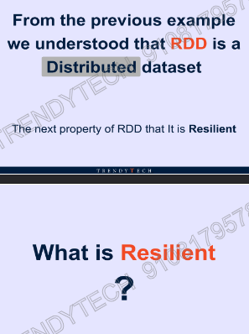
* 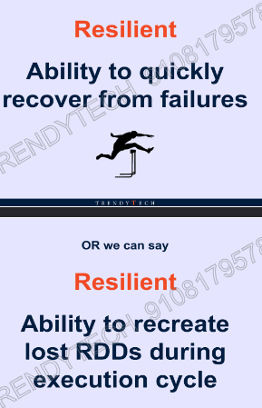
* 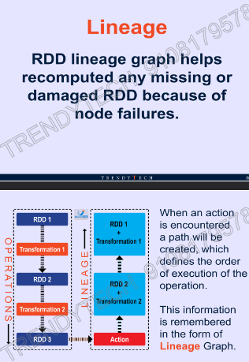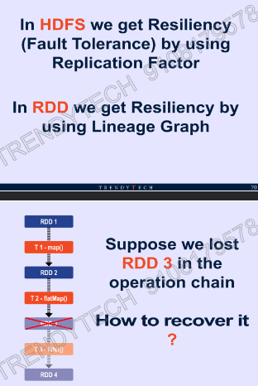
* 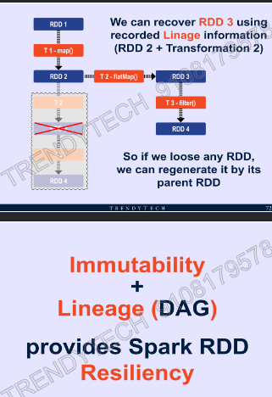
* 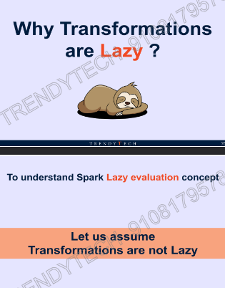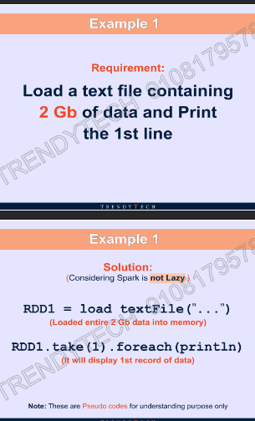
* 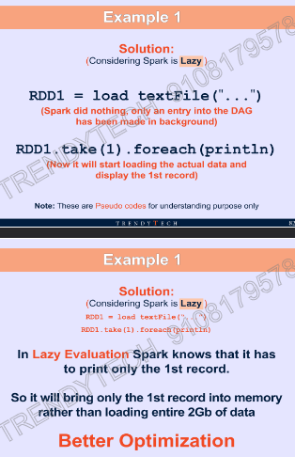
* 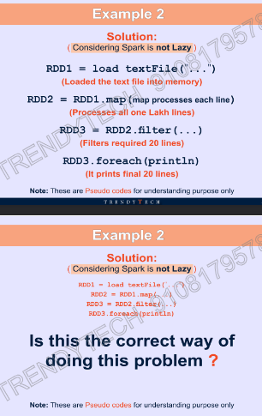
* 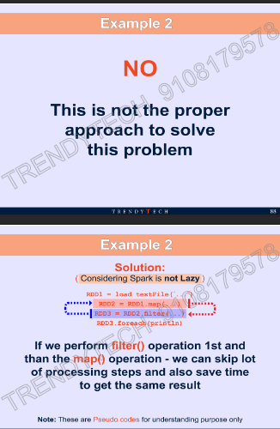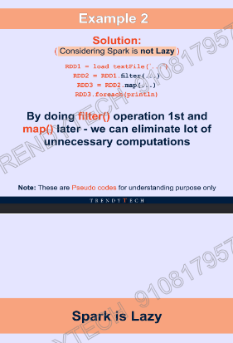
* 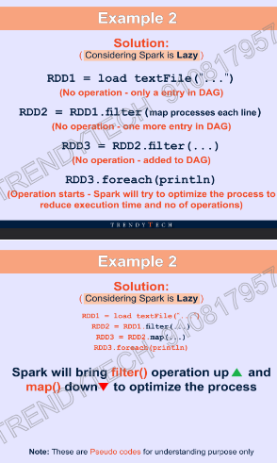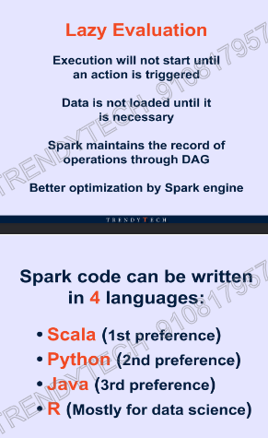
* 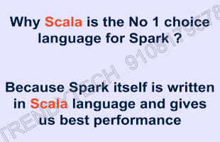

RDD Based Code:

Word Count Program

Program_1 (DF way)

* import findspark  
  findspark.init()  
  from pyspark.sqlimport SparkSession  
  from pyspark.sql.functionsimport explode**,**split**,**lower**,**col  
  spark=SparkSession.builder.appName("test").getOrCreate()  
  df=spark.read.text("./dataset/search_data.txt")  
  df_word=df.select(explode(split(lower(df.value)**,**" ")).alias("words"))  
  df_word.groupBy("words").count().orderBy("count"**,** ascending=False).show()

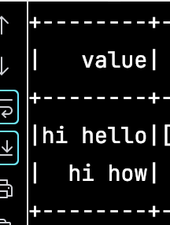

Explode will take array make each value of array to new column

RDD Way:

Program_1: Word Count Example:

import findspark  
  
findspark.init()  
  
from pyspark.sql import SparkSession  
  
spark = SparkSession.builder.appName("test").getOrCreate()  
rdd1 = spark.sparkContext.textFile("./dataset/test.txt")  
print(rdd1.collect())  
rdd2 = rdd1.flatMap(lambda x: x.split(" "))  
print(f"if I just use map instead of flat map:{rdd1.map(lambda x:x.split(' ')).collect()}")  
print(rdd2.collect())  
rdd3 = rdd2.map(lambda x: (x**, 1**))  
print(rdd3.collect())  
rdd4 = rdd3.reduceByKey(lambda x**,** y: x + y)  
print(rdd4.collect())

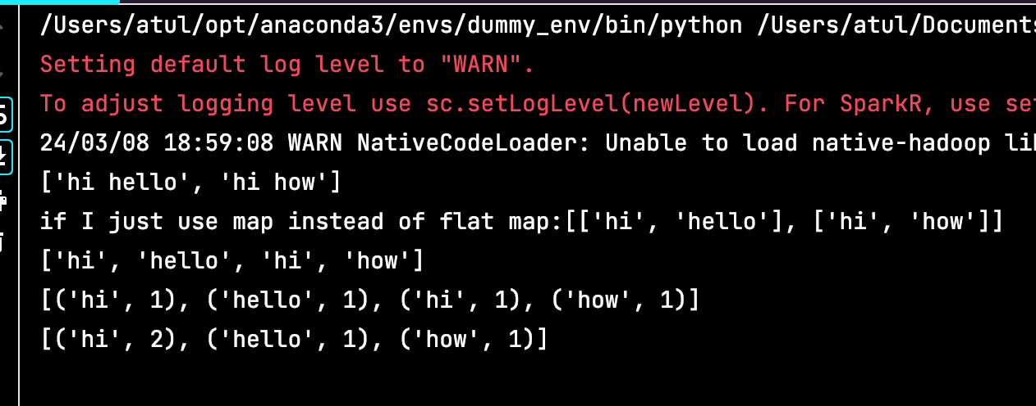

Program_2:

# Find Orders count in each category  
  
import findspark  
  
findspark.init()  
from pyspark.sql import SparkSession  
  
spark = SparkSession.builder.appName("test").getOrCreate()  
data = ['1,2013-07-25,11599,CLOSED'**,** '2,2013-07-25,256,PENDING_PAYMENT'**,** '3,2013-07-25,12111,COMPLETE'**,** '4,2013-07-25,8827,CLOSED'**,** '5,2013-07-25,11318,COMPLETE'**,** '6,2013-07-25,7130,COMPLETE'**,** '7,2013-07-25,4530,COMPLETE'**,** '8,2013-07-25,2911,PROCESSING']  
rdd1 = spark.sparkContext.parallelize(data)  
print(rdd1.map(lambda x: x.split(",")) \  
.map(lambda x: (x[**3**]**, 1**)) \  
.reduceByKey(lambda x**,** y: x + y) \  
.sortBy(lambda x: x[-**1**]**,**ascending=False).collect())

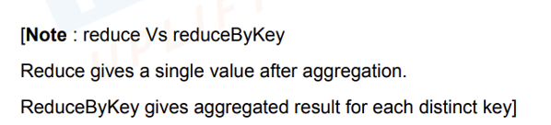

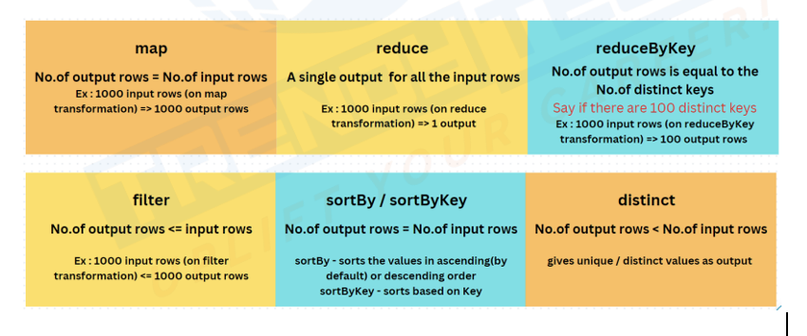

Program_2

# Customers placed more orders  
  
import findspark  
  
findspark.init()  
from pyspark.sql import SparkSession  
  
spark = SparkSession.builder.appName("test").getOrCreate()  
data = ['1,2013-07-25,11599,CLOSED'**,** '2,2013-07-25,256,PENDING_PAYMENT'**,** '3,2013-07-25,12111,COMPLETE'**,** '4,2013-07-25,8827,CLOSED'**,** '5,2013-07-25,11318,COMPLETE'**,** '6,2013-07-25,7130,COMPLETE'**,** '7,2013-07-25,4530,COMPLETE'**,** '8,2013-07-25,2911,PROCESSING'**,** '2,2013-07-25,256,PENDING_PAYMENT']  
rdd1 = spark.sparkContext.parallelize(data)  
print(rdd1.map(lambda x:x.split(",")).map(lambda x:(x[**2**]**,1**)).reduceByKey(lambda x**,**y:x+y) \  
 .sortBy(lambda x:x[-**1**]**,**ascending=False).collect())

Program_3:

# Find customers having more number of closed orders  
  
import findspark  
  
findspark.init()  
from pyspark.sql import SparkSession  
  
spark = SparkSession.builder.appName("test").getOrCreate()  
data = ['1,2013-07-25,11599,CLOSED'**,** '2,2013-07-25,256,CLOSED'**,** '3,2013-07-25,12111,COMPLETE'**,** '4,2013-07-25,8827,CLOSED'**,** '5,2013-07-25,11318,COMPLETE'**,** '6,2013-07-25,7130,COMPLETE'**,** '7,2013-07-25,4530,COMPLETE'**,** '8,2013-07-25,2911,PROCESSING'**,** '2,2013-07-25,256,CLOSED']  
rdd1 = spark.sparkContext.parallelize(data)  
print(rdd1.map(lambda x:x.split(",")).filter(lambda x:x[-**1**]=="CLOSED").map(lambda x:(x[**2**]**,1**)).reduceByKey(lambda x**,**y:x+y).collect())

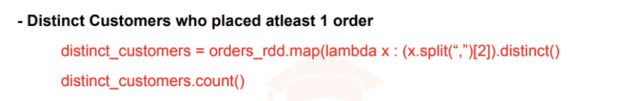

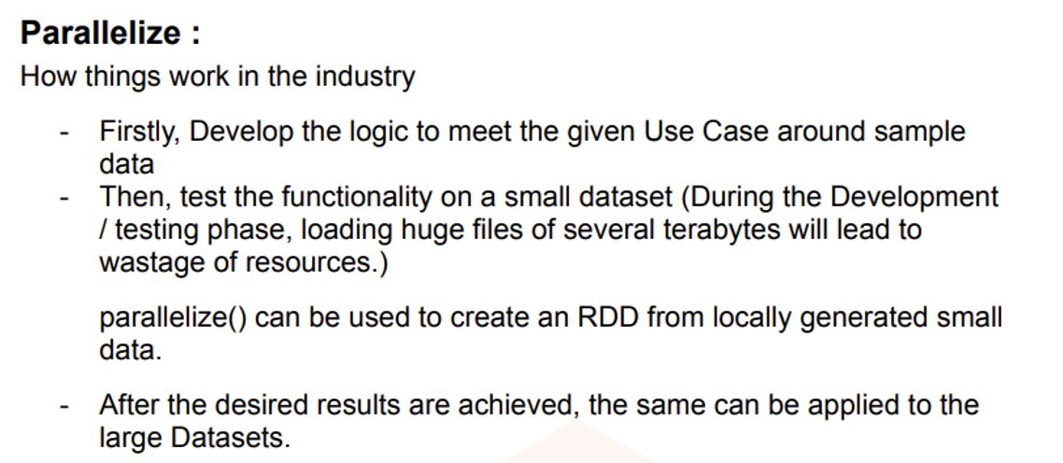

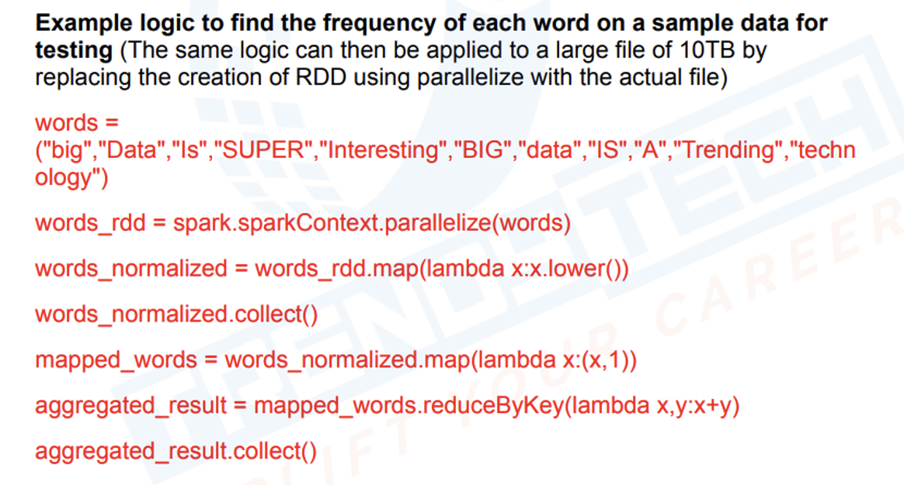

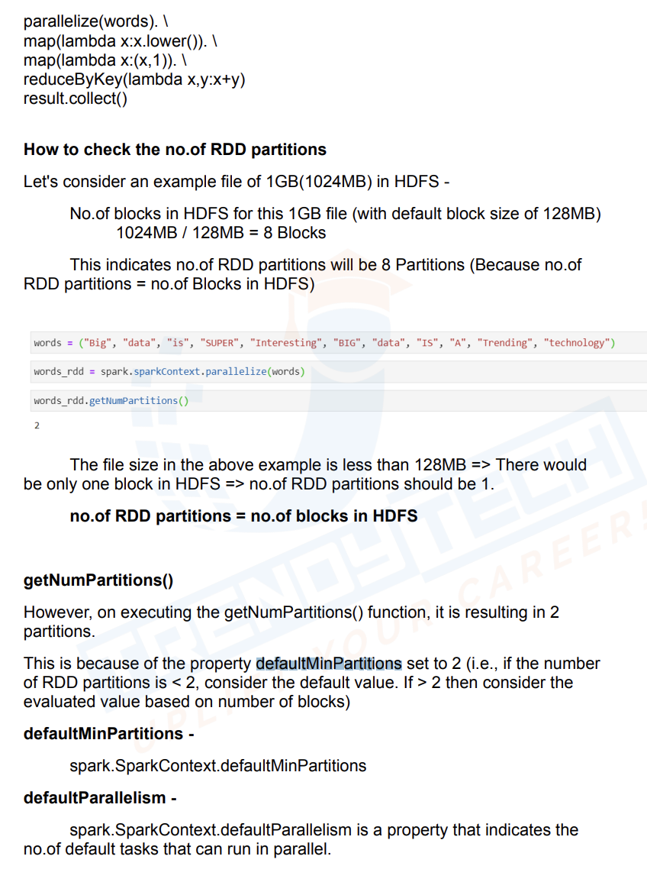

* Broadcast will load small data into all executors
* 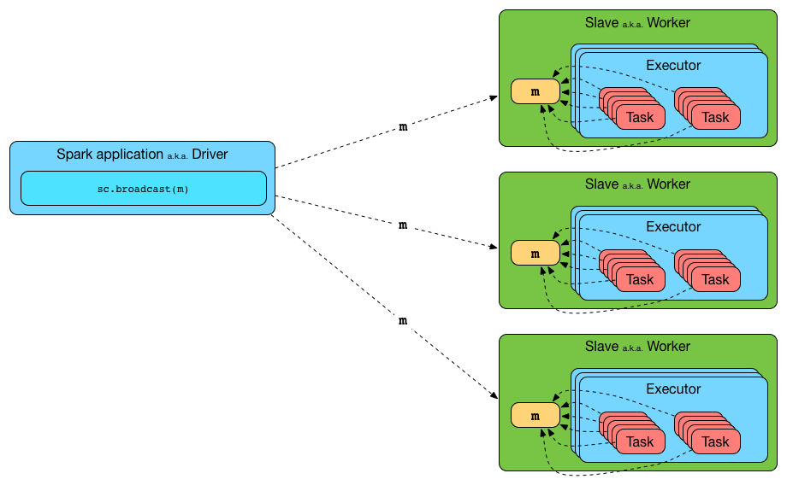

GroupByKey Example:

# Find customers having more number of closed orders  
  
import findspark  
  
findspark.init()  
from pyspark.sql import SparkSession  
spark = SparkSession.builder.appName("test").getOrCreate()  
data = ['1,2013-07-25,11599,CLOSED'**,** '2,2013-07-25,256,CLOSED'**,** '3,2013-07-25,12111,COMPLETE'**,** '4,2013-07-25,8827,CLOSED'**,** '5,2013-07-25,11318,COMPLETE'**,** '6,2013-07-25,7130,COMPLETE'**,** '7,2013-07-25,4530,COMPLETE'**,** '8,2013-07-25,2911,PROCESSING'**,** '2,2013-07-25,256,CLOSED']  
rdd1 = spark.sparkContext.parallelize(data)  
rdd = spark.sparkContext.parallelize([("a"**, 1**)**,** ("b"**, 2**)**,** ("a"**, 3**)**,** ("b"**, 4**)**,** ("a"**, 5**)**,** ("b"**, 6**)])  
  
print(rdd.groupByKey().map(lambda x:(x[**0**]**,**sum(x[-**1**]))).collect())

GroupbyKey

import findspark

findspark.init()

from pyspark.sql import SparkSession

spark = SparkSession.builder.appName("ee").getOrCreate()

data = ['1,2013-07-25,11599,CLOSED', '2,2013-07-25,256,PENDING_PAYMENT', '3,2013-07-25,12111,COMPLETE',

'4,2013-07-25,8827,CLOSED', '5,2013-07-25,11318,COMPLETE', '6,2013-07-25,7130,COMPLETE',

'7,2013-07-25,4530,COMPLETE', '8,2013-07-25,2911,PROCESSING']

rdd = spark.sparkContext.parallelize(data)

print(rdd.map(lambda x:(x.split(",")[-1],1)).groupByKey().mapValues(lambda x:sum(x)).collect())

Accumulator:

* It is a shared variable kept in driver machine
* Each of the executor will update it, however none of the executors can read it, they can only change the value
* If I want to global variable which is a single copy and wants that to be accessed across all executors then I can use accumulator
* Suppose a 500MB file is split across 4 drivers and I want to create a shared variable which can update all blank line count
* Same as counters in mapreduce

Case: To find the blank lines in a file

Program_7

import findspark  
  
findspark.init()  
from pyspark.sqlimport SparkSession  
from pysparkimport SparkContext  
from pyspark.sql.functionsimport explode**,** split**,** lower**,** col**,** sum**,** count**,** avg  
from pyspark.sql.typesimport StructType**,** StructField**,** IntegerType**,** StringType**,** FloatType**,** LongType  
  
spark=SparkSession.builder.appName("test").getOrCreate()  
df=spark.read.text("./dataset/samplefile.txt")  
blank_lines=spark.sparkContext.accumulator(**0**)  
rdd1=df.rdd.foreach(lambda x: blank_lines.add(**1**) if x.value=="" else None)  
print(blank_lines.value)

Broadcast Example

# Filter only status closed  
  
import findspark  
  
findspark.init()  
from pyspark.sql import SparkSession  
spark = SparkSession.builder.appName("test").getOrCreate()  
data = ['1,2013-07-25,11599,CLOSED'**,** '2,2013-07-25,256,CLOSED'**,** '3,2013-07-25,12111,COMPLETE'**,** '4,2013-07-25,8827,CLOSED'**,** '5,2013-07-25,11318,COMPLETE'**,** '6,2013-07-25,7130,COMPLETE'**,** '7,2013-07-25,4530,COMPLETE'**,** '8,2013-07-25,2911,PROCESSING'**,** '2,2013-07-25,256,CLOSED']  
closed_status = spark.sparkContext.broadcast("CLOSED")  
rdd = spark.sparkContext.parallelize(data)  
print(rdd.map(lambda x:x.split(",")).filter(lambda x:x[-**1**]==closed_status.value).collect())

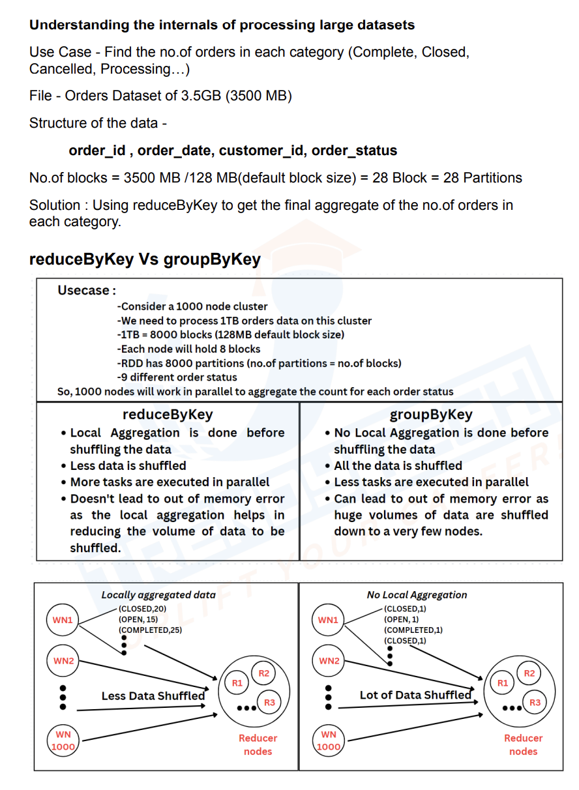

# Find Blank Lines in Text File  
import findspark  
  
findspark.init()  
from pyspark.sql import SparkSession  
  
spark=SparkSession.builder.appName("test").getOrCreate()  
rdd=spark.sparkContext.textFile("./dataset/samplefile.txt")  
blank_lines=spark.sparkContext.accumulator(**0**)  
rdd.foreach(lambda x: blank_lines.add(**1**) if x=="" else None)  
print(blank_lines.value)

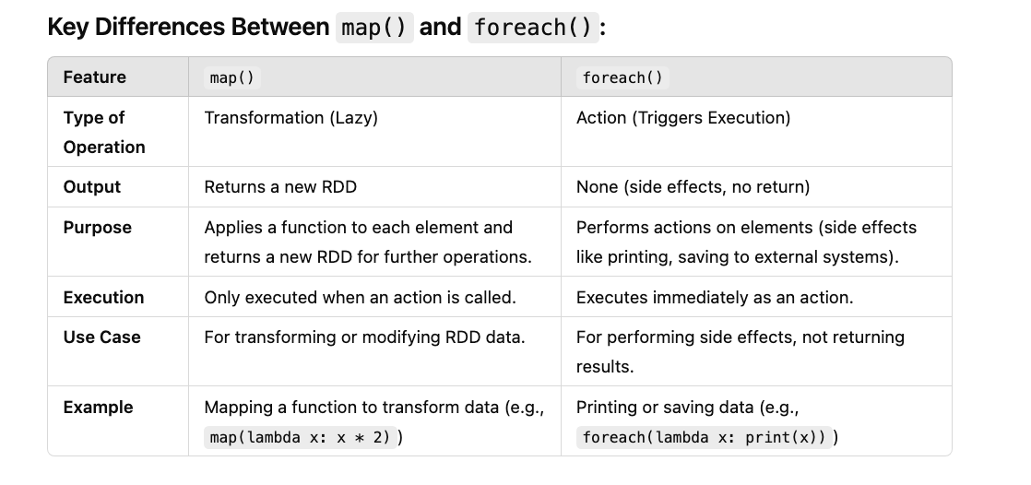

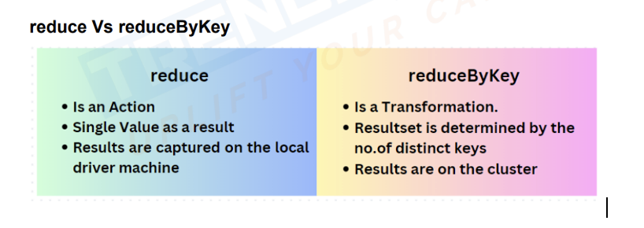

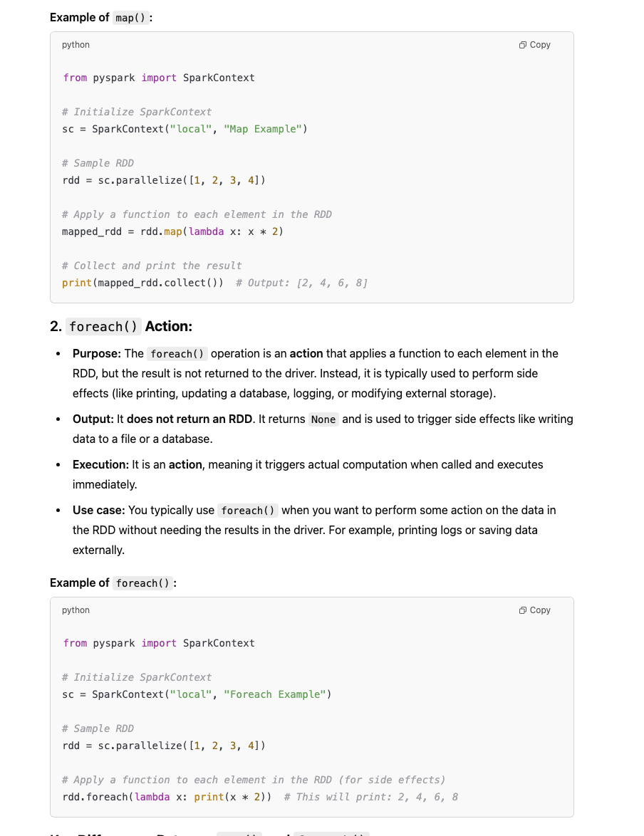



Spark Architecture:

* 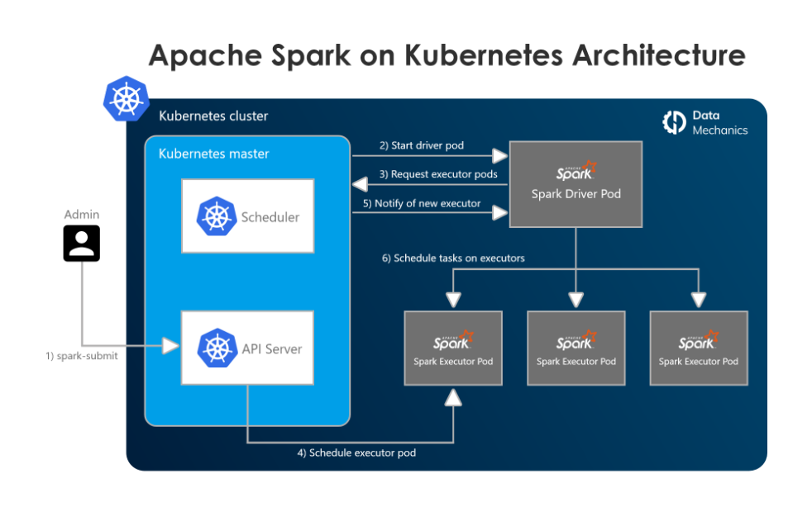
* 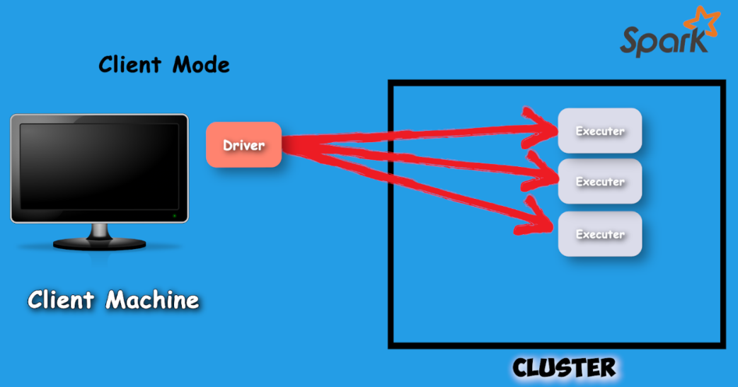
* 
* 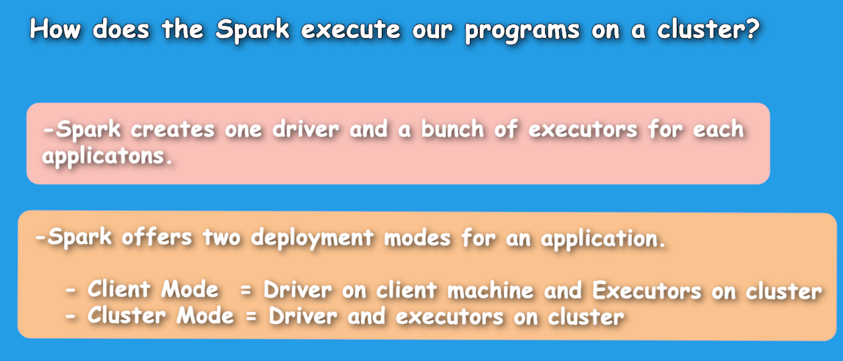
* 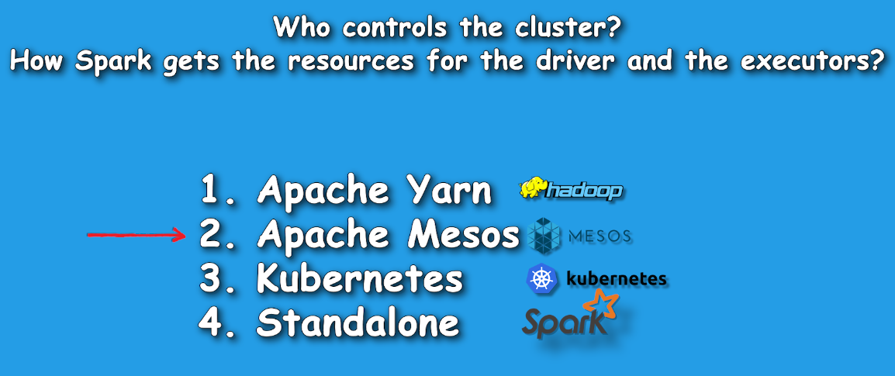
* 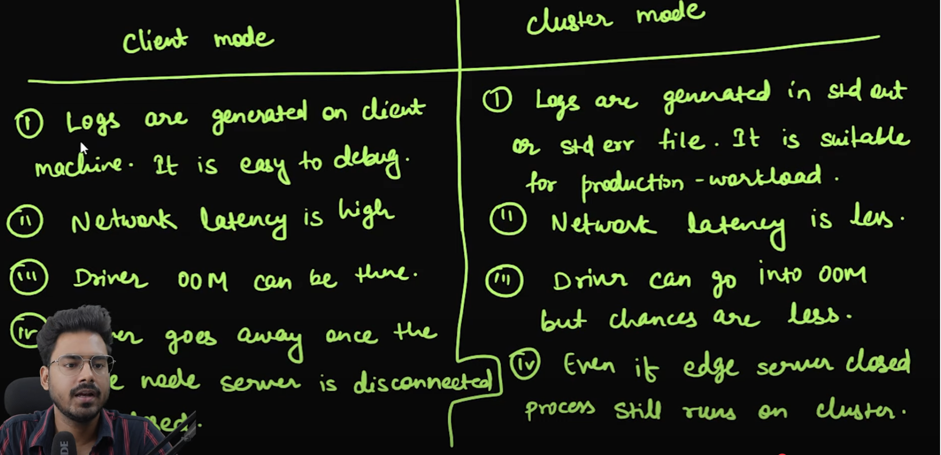

Execution Flow:

Pyspark Code Flow:

Since Spark is written in Java/Scala, PySpark uses Py4J, a library that allows Python to communicate with Java. A Java Gateway is started, which creates a bridge between Python and the JVM.

The Python driver program (your script) communicates with the Java-based Spark backend via this gateway.

Since Spark is written in Java/Scala, PySpark uses Py4J, a library that allows Python to communicate with Java. A Java Gateway is started, which creates a bridge between Python and the JVM.

The Python driver program (your script) communicates with the Java-based Spark backend via this gateway.

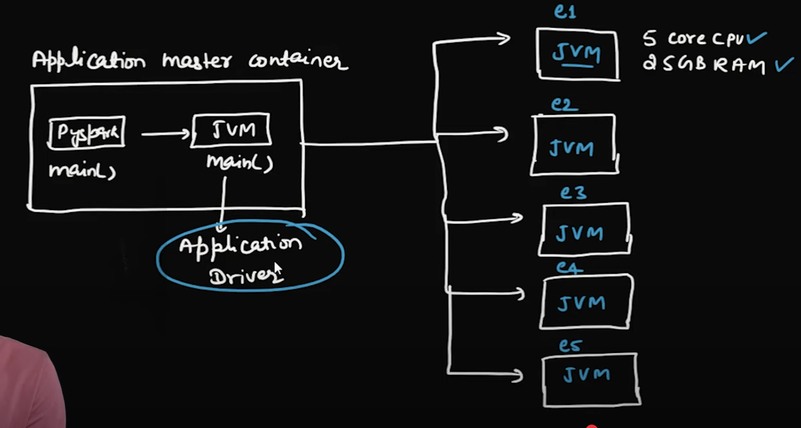

Spark Higher Level API:

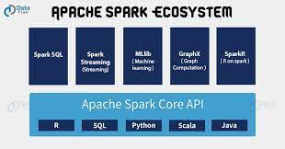

Jobs, Stages and Tasks:

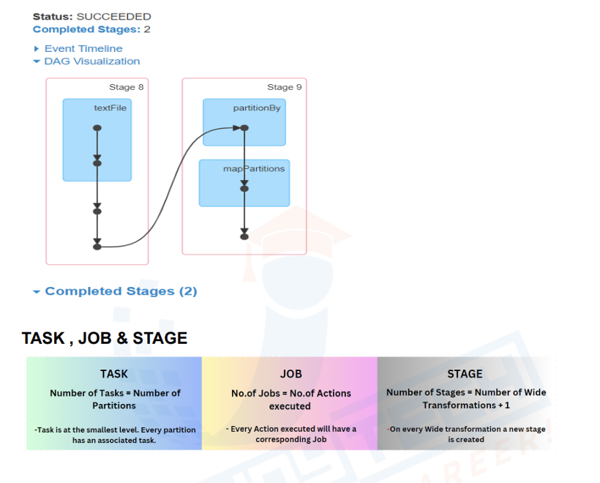

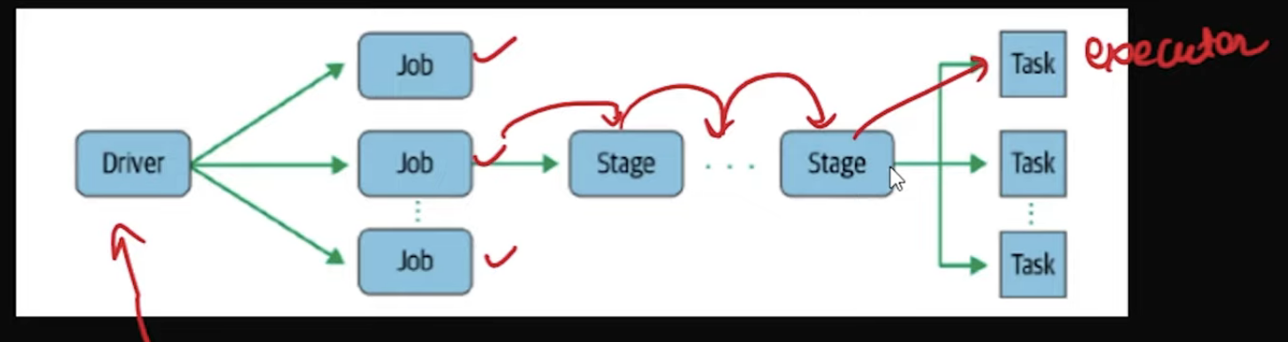

Read File:

CSV:

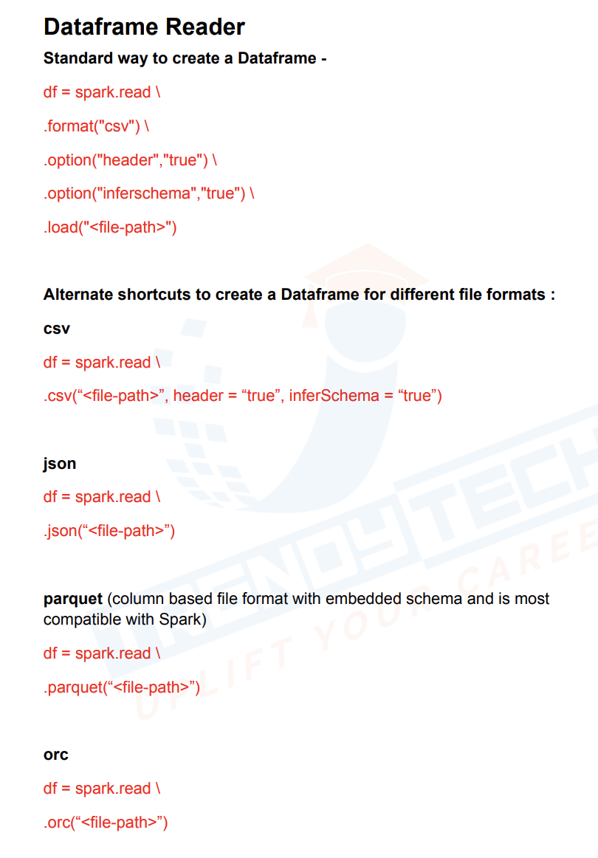

Get Corrupted record rows in spark:

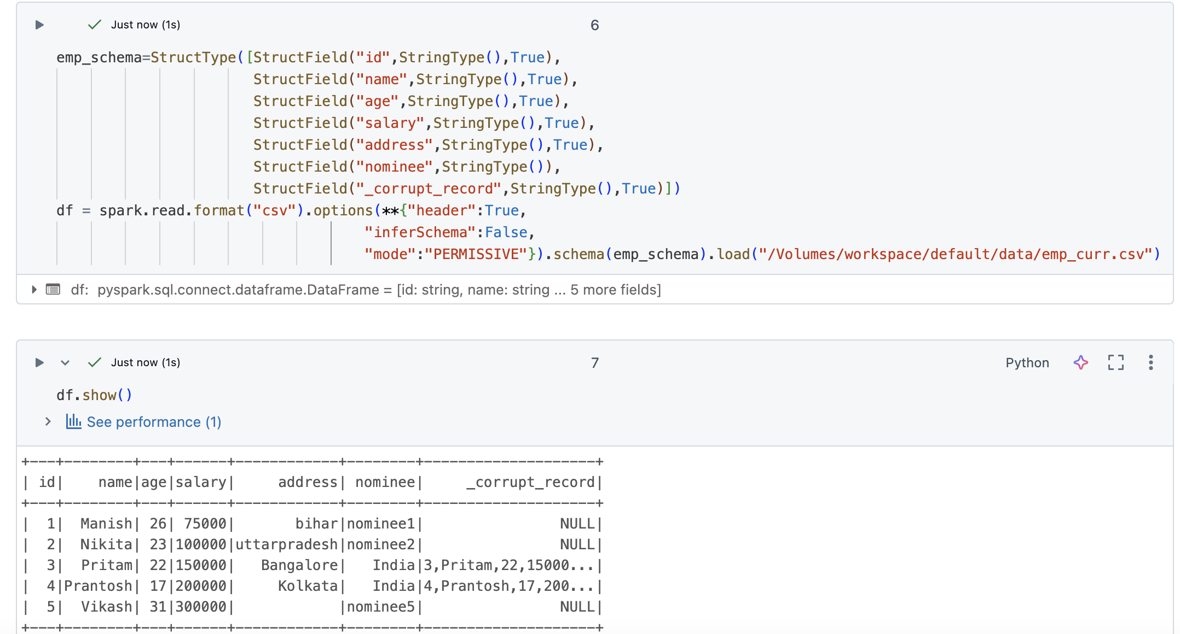

Save Corrupted Record while reading:

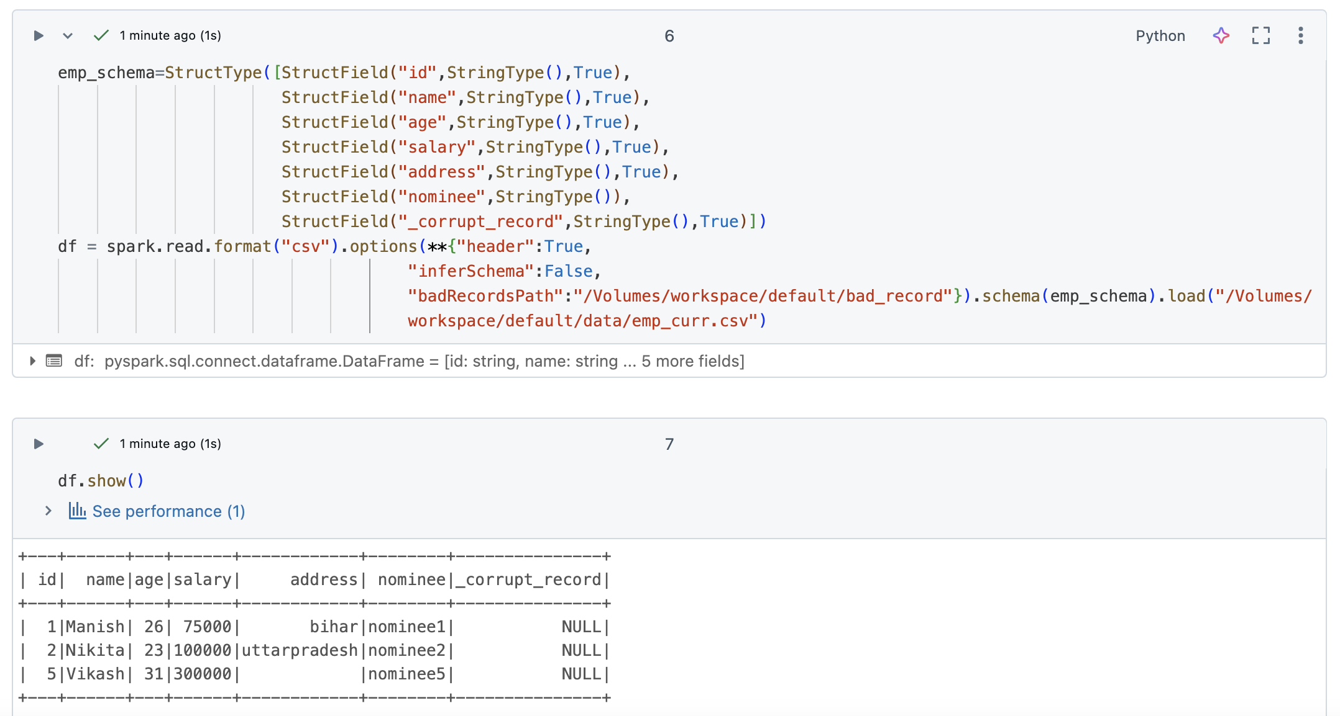

Note: mode should not be included when badRecordsPath is set

Read Modes:

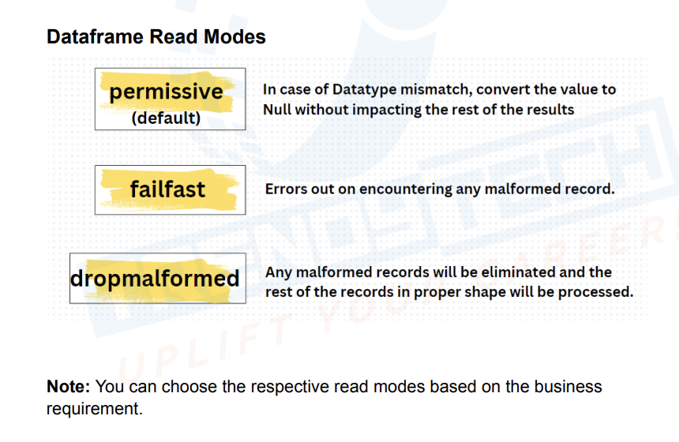

Spark Df related transformations:

Filter Data:

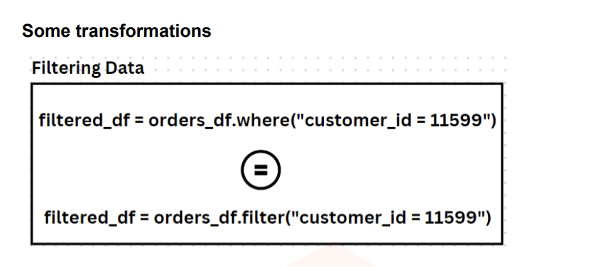

Spark Sql Table:

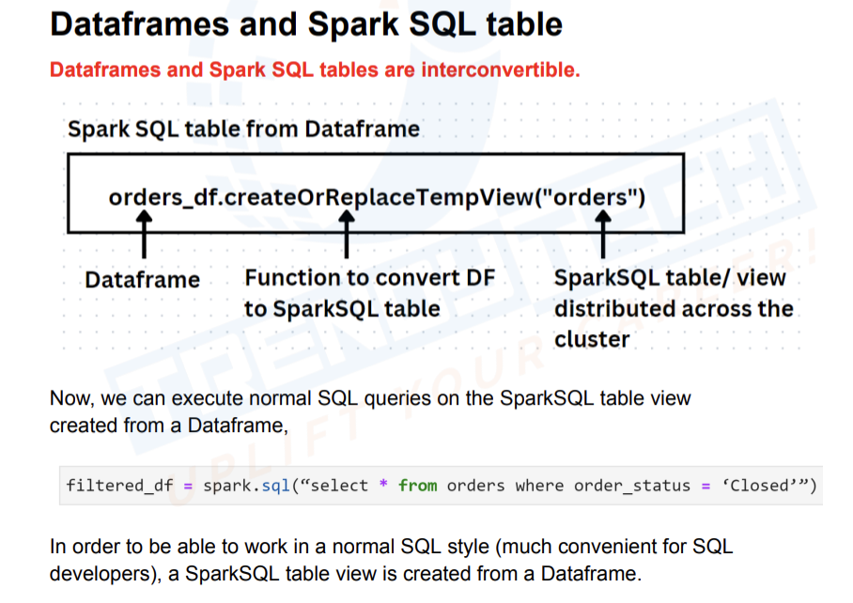

There are 4 ways of selecting column:

from pyspark.sql.functions import *

df.select(col("id"),"name",df['age'],df.salary).show()

col("id") is used when u want to do some operations like col("id")+5,

“name” is used only when u want to select column and not to do any other operation

df['age'],df.salary is used for join operations

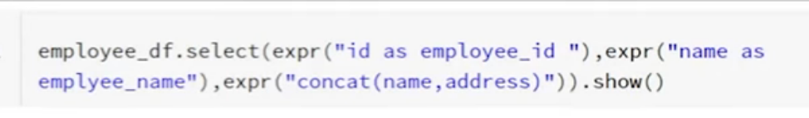

Alias:

df.select(expr("id as emp_id")).show()

df.select(col("id").alias("emp_id")).show()

Filter/Where

df.filter('salary>=75000 and age>25').show()

df.where('salary>=75000 and age>25').show()

df.where((col('salary')>=75000) & (col('age')>25) ).show()

alias:

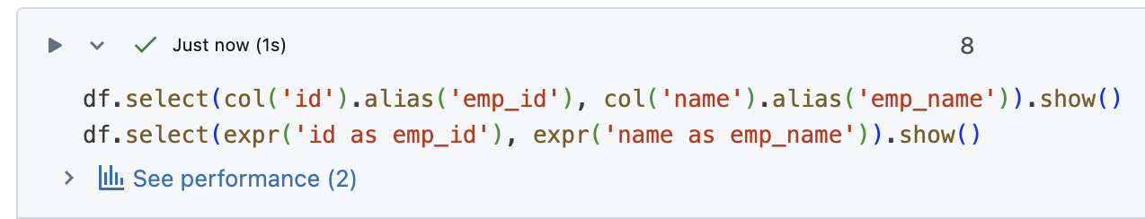

Literal: If I want to add new column with default value then we can use literal

df.select("*",lit("kumar").alias("last_name")).show()

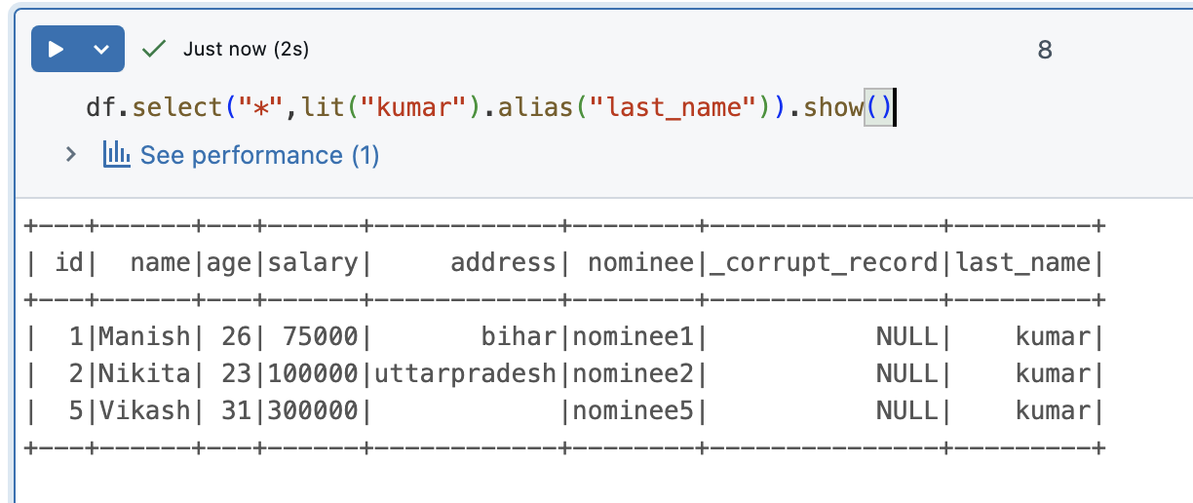

withCOlumn either adds and modifies existing column:

df.withColumnRenamed("id","emp_id").show()

Change column Type:

df.withColumn("id",col("id").cast("float")) \

.withColumn("salary",col("salary").cast("float")) \

.printSchema()

Remove columns:

df.drop("id").show()

In pyspark union & union All is same, but in spark sql it is different

df1.union(df2).show()

df1.unionAll(df2).show()

During union if column sequence are changed if datatype matches it will still go with union

During unionByname column name should match

Case/if-else :

df.withColumn("adult",when(col("age")>25,"Adult").when(col("age")<=25,"Child").otherwise("NA")).show()

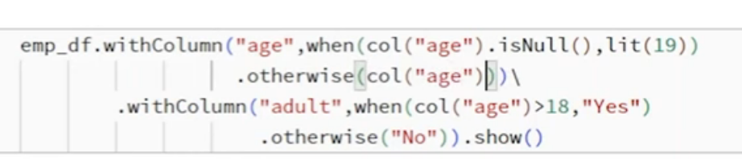

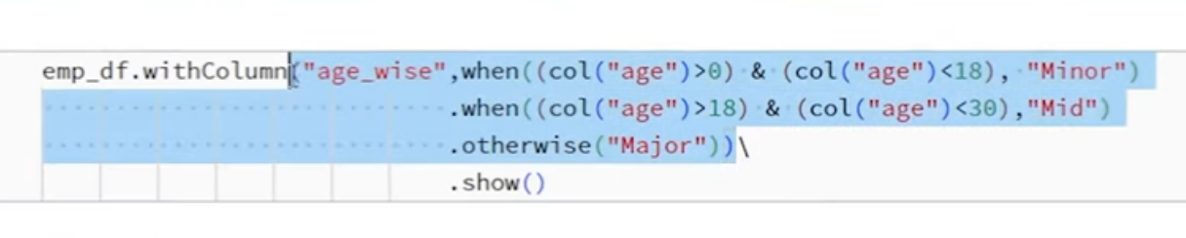

Distinct:

Default distinct compares complete record

df.select("id","name").distinct().show()

df.distinct().show()

Drop Duplicates

df.dropDuplicates(["id","name"]).show()

Sort:

df.sort(col("mgr_id").desc(),col("sal").desc()).show()

Count:

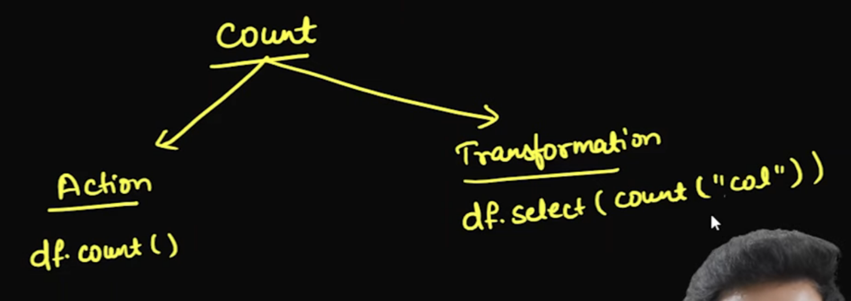

Count works as both action n transformation, if used with df then it’s action, if used with select then it’s transformation

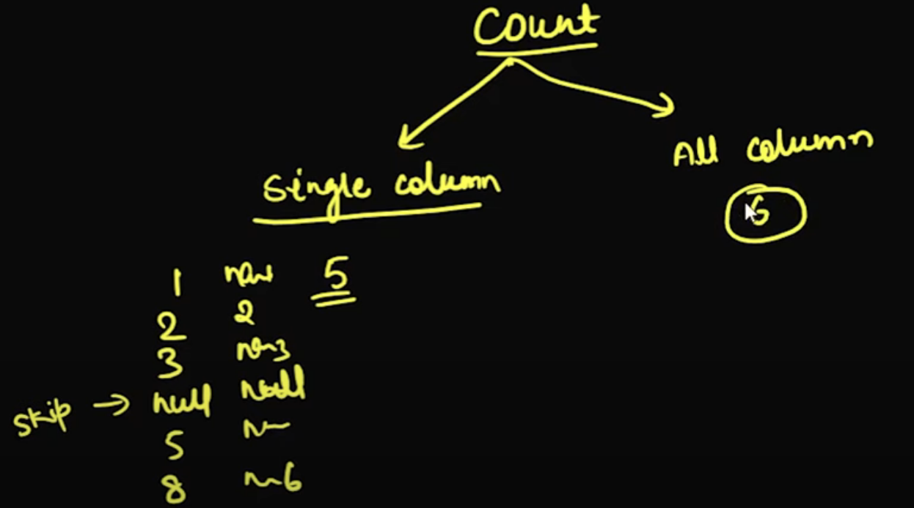

For multiple columns it will consider null, for single column it will skip null

Join with multiple columns:

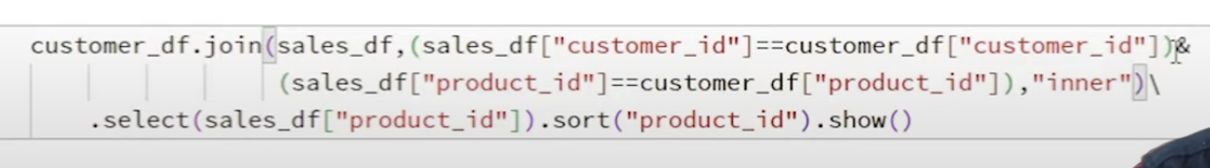

Spark Temp View:

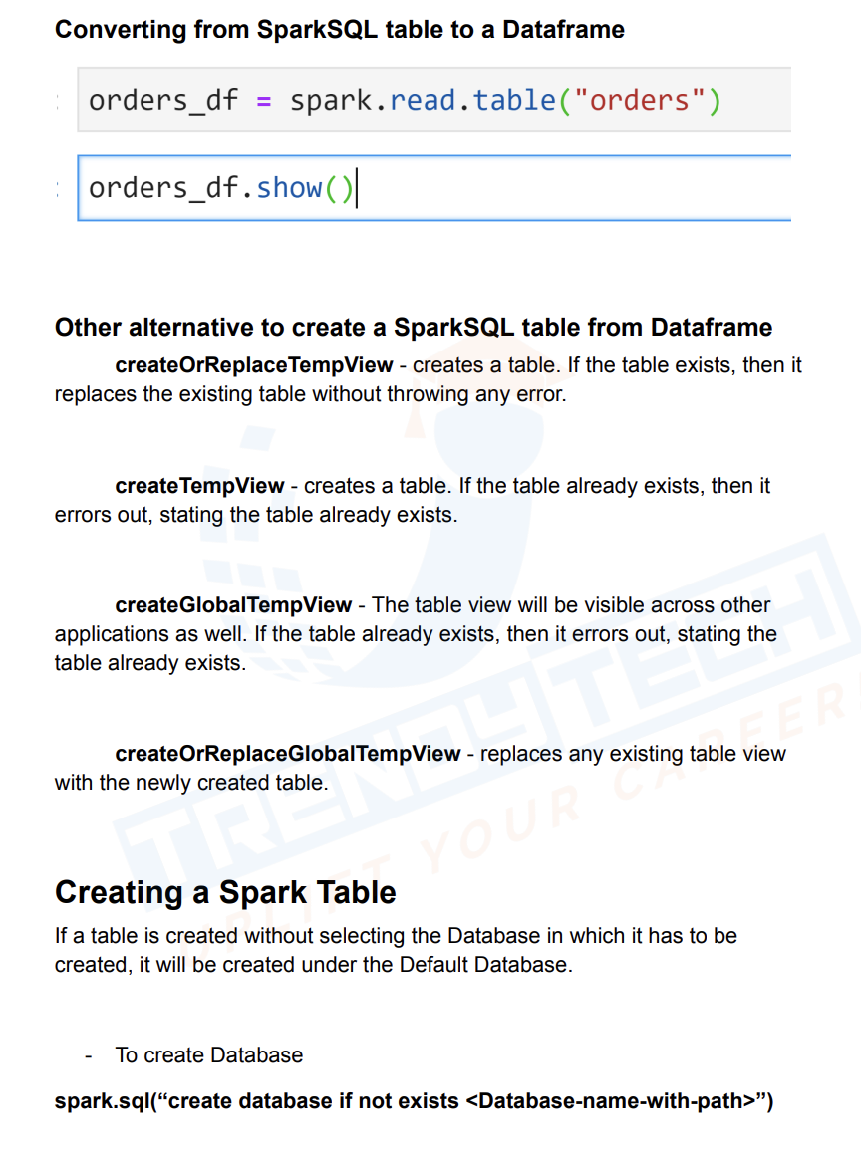

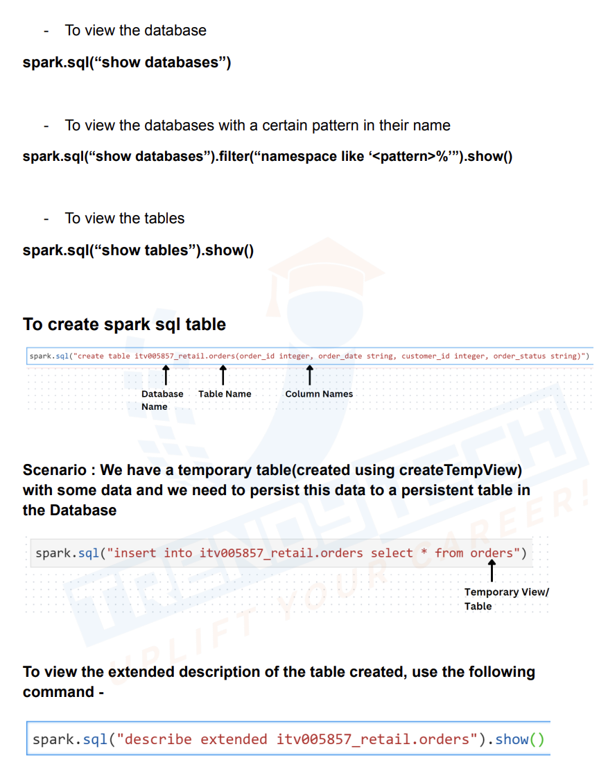

Spark sql API vs DF API

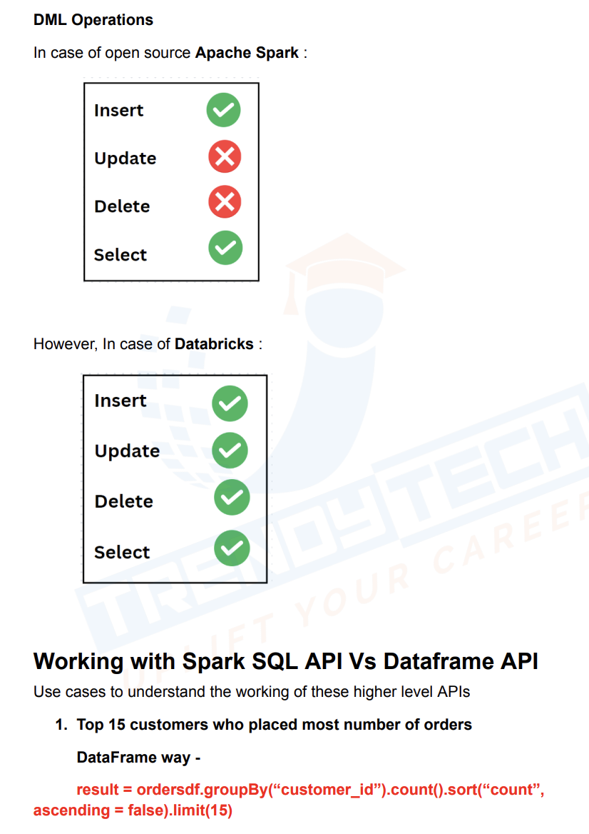

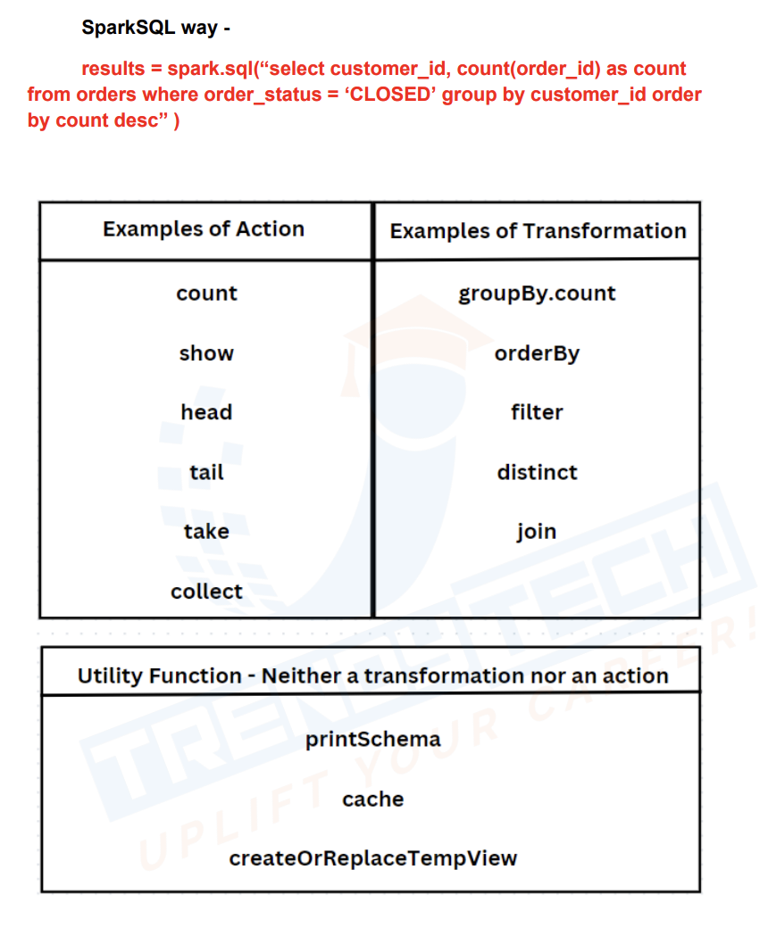

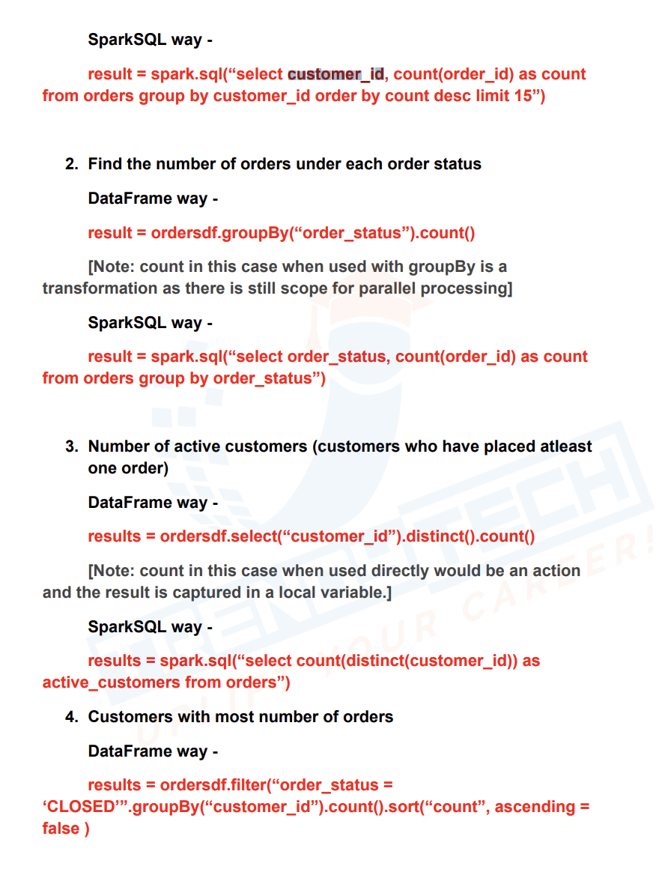

Schema Inference:

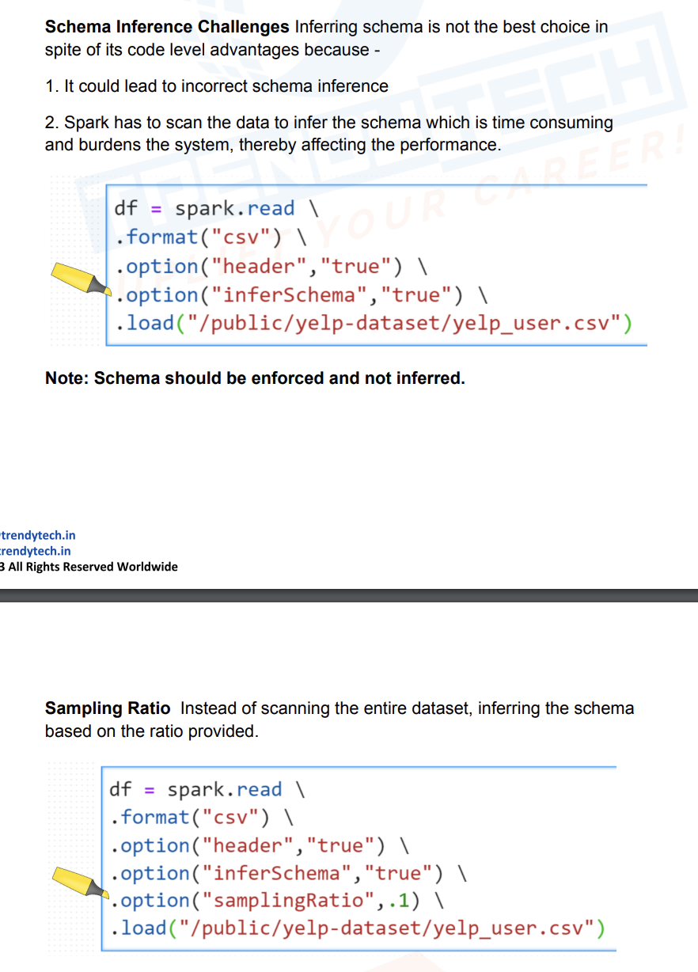

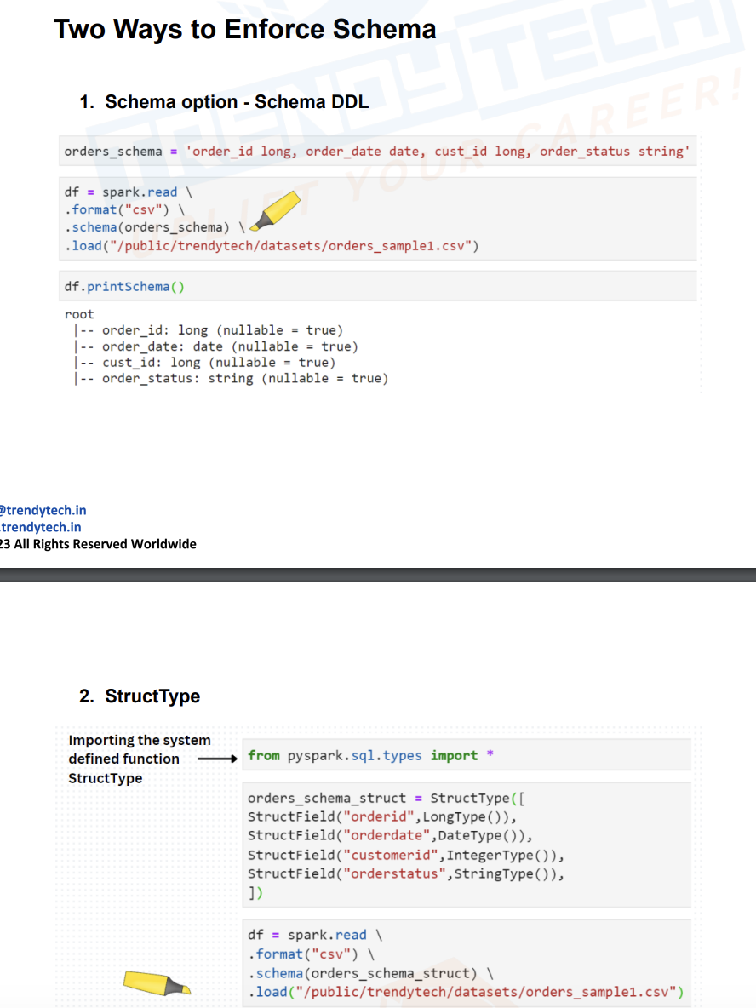

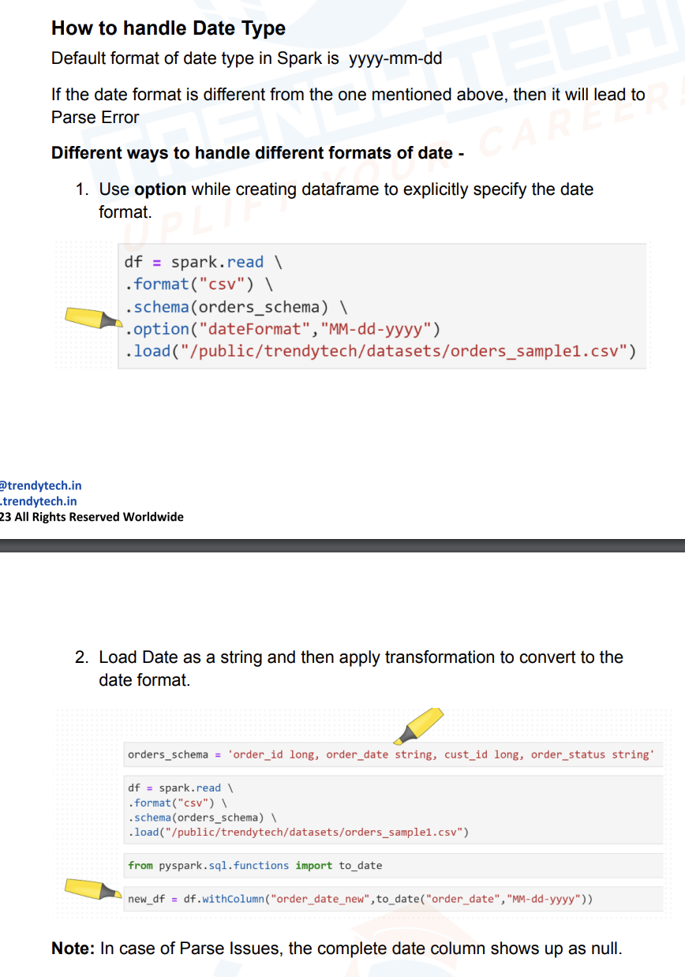

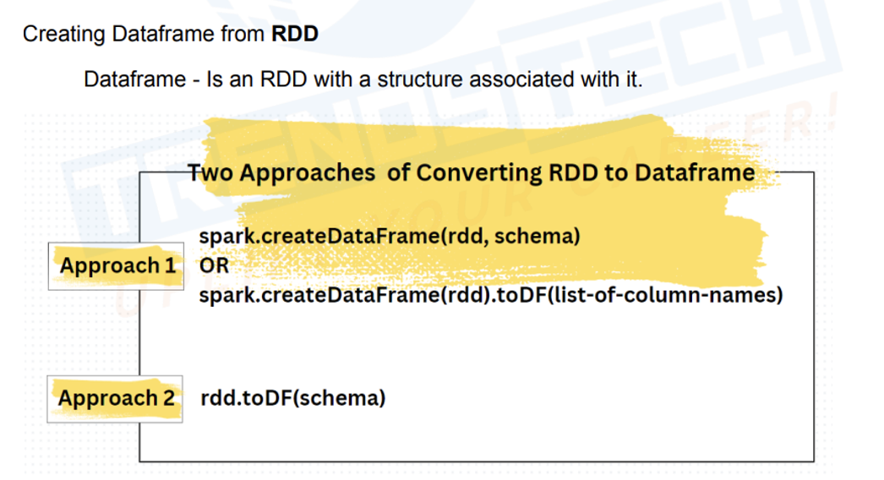

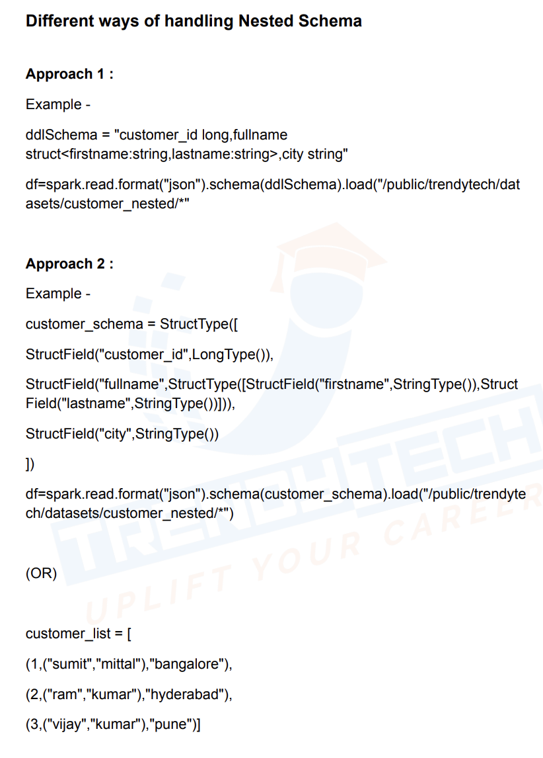

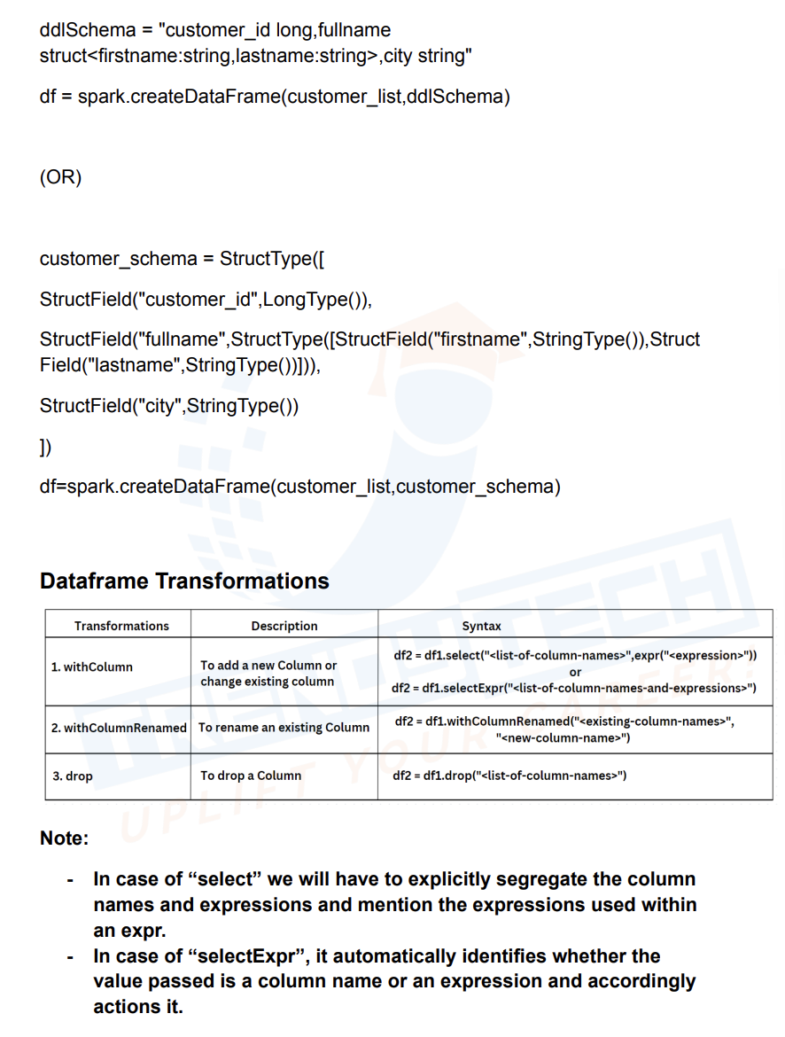

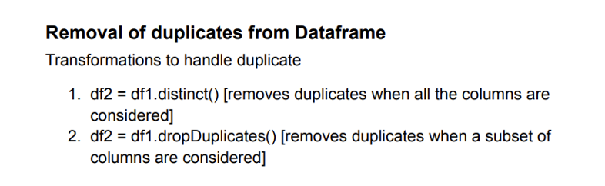

Json Data:-

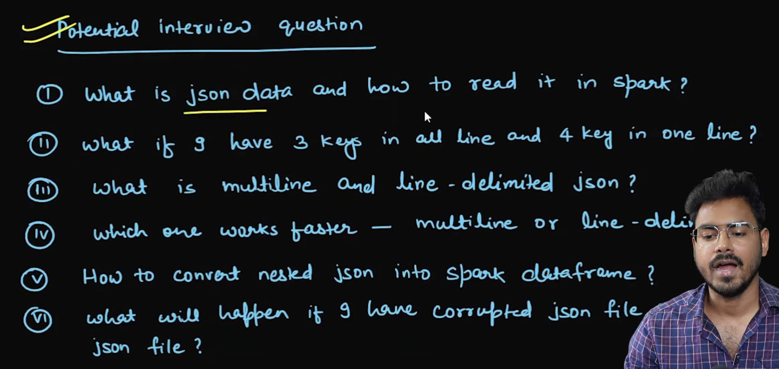

This is line delimited json:

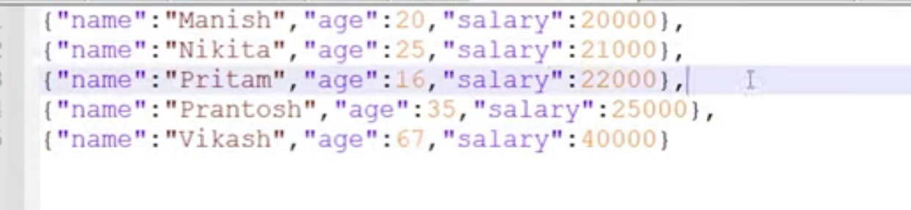

Multiline Json:

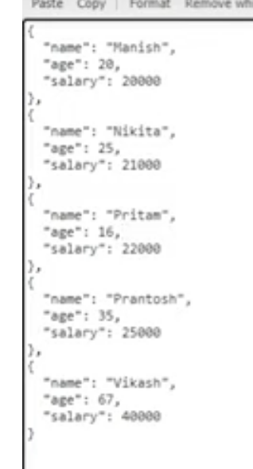

Multi-line might lead to low performance as spark has to consider whole json as one object and process it

Fir multi-line it should be enclosed in an list array it will just read first data and 2nd row will be null

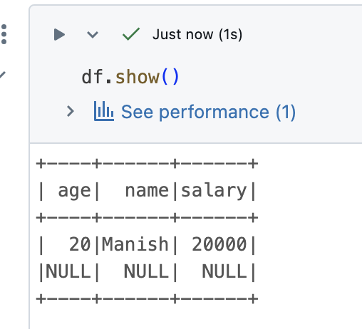

line_delimited_json

{"name":"Manish","age":20,"salary":20000},

{"name":"Nikita","age":25,"salary":21000},

{"name":"Pritam","age":16,"salary":22000},

{"name":"Prantosh","age":35,"salary":25000},

{"name":"Vikash","age":67,"salary":40000}

spark=SparkSession.builder.appName("test").getOrCreate()  
df = spark.read.format("json").options(**{"multiline":False}).load("./json_data/line_delimited.json")  
print(**1**)

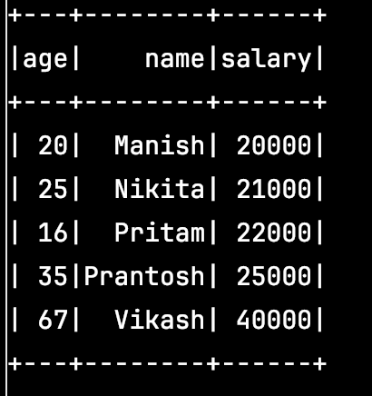

single_file_json with extra fields

{"name":"Manish","age":20,"salary":20000},

{"name":"Nikita","age":25,"salary":21000},

{"name":"Pritam","age":16,"salary":22000},

{"name":"Prantosh","age":35,"salary":25000},

{"name":"Vikash","age":67,"salary":40000,"gender":"M"}

df = spark.read.format("json").options(**{"multiline":False}).load("./json_data/single_file_json_with_extra_fields.json")

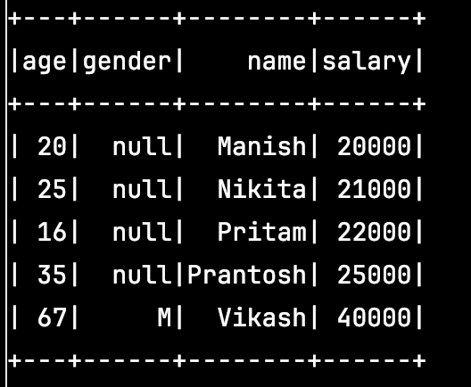

corrupted_json

{"name":"Manish","age":20,"salary":20000},

{"name":"Nikita","age":25,"salary":21000},

{"name":"Pritam","age":16,"salary":22000},

{"name":"Prantosh","age":35,"salary":25000},

{"name":"Vikash","age":67,"salary":40000

df = spark.read.format("json").options(**{"multiline":False}).load("./json_data/corrupted_json.json")

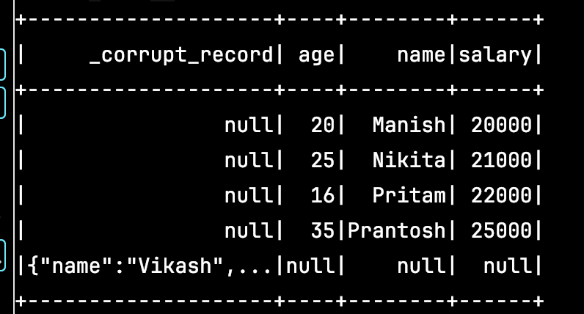

Multi_line_incorrect

{

"name": "Manish",

"age": 20,

"salary": 20000

},

{

"name": "Nikita",

"age": 25,

"salary": 21000

},

{

"name": "Pritam",

"age": 16,

"salary": 22000

},

{

"name": "Prantosh",

"age": 35,

"salary": 25000

},

{

"name": "Vikash",

"age": 67,

"salary": 40000

}

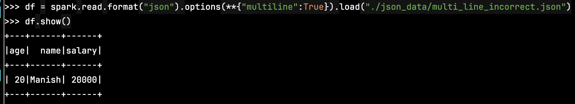

Multiline should be in list type

Multi_line_correct

[

{

"name": "Manish",

"age": 20,

"salary": 20000

},

{

"name": "Nikita",

"age": 25,

"salary": 21000

},

{

"name": "Pritam",

"age": 16,

"salary": 22000

},

{

"name": "Prantosh",

"age": 35,

"salary": 25000

},

{

"name": "Vikash",

"age": 67,

"salary": 40000

}

]

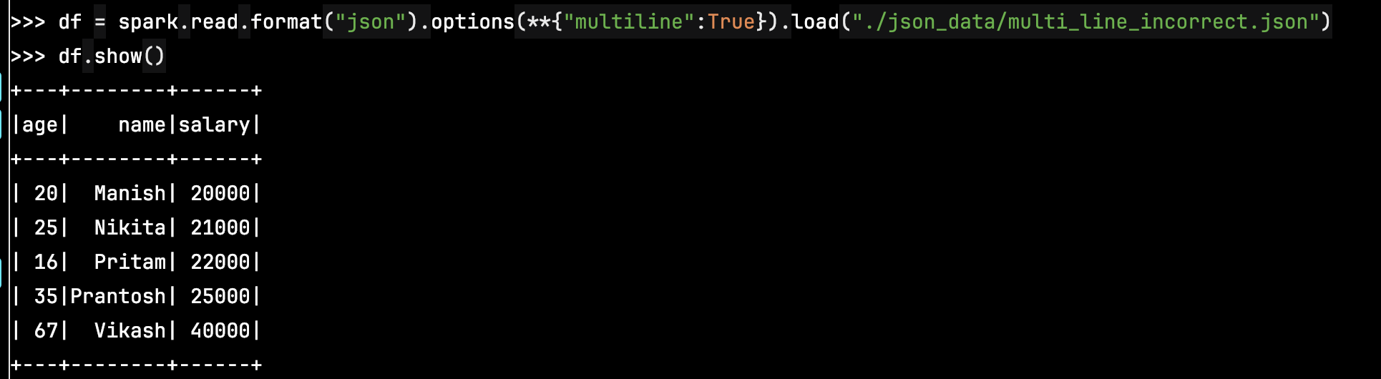

Spark Session and Spark Context

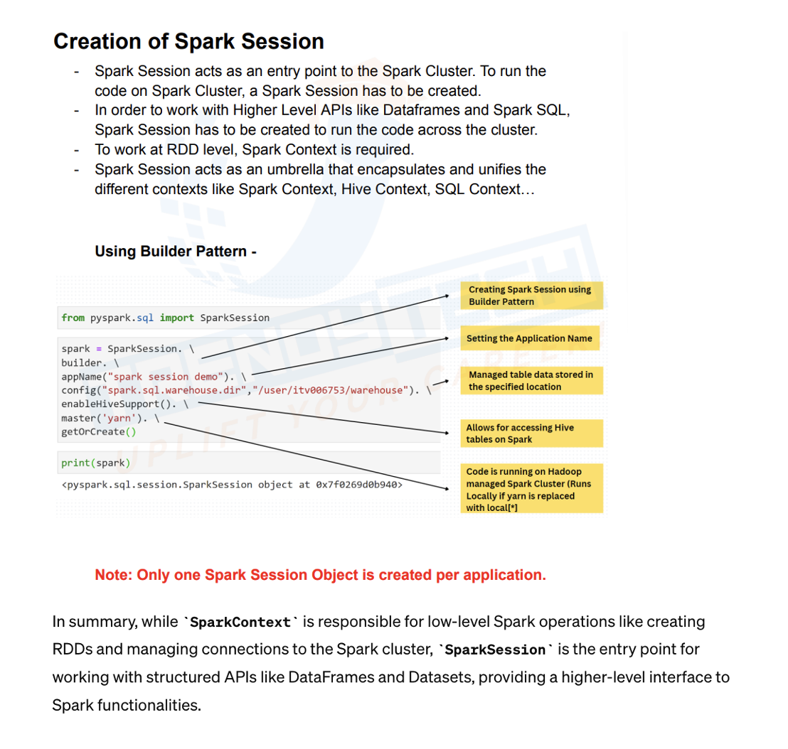

JSON Flatten:

For type is arry then use explode, if it’s struct use . operator to access

If record is null we can use explode outer

Spark Tuning:

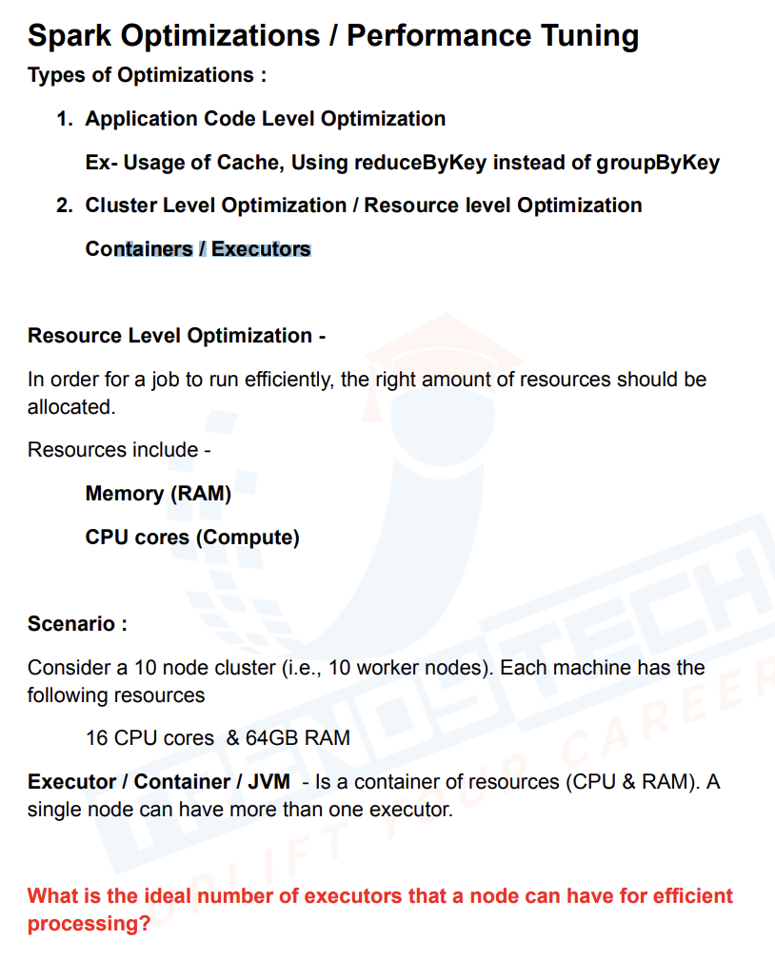

Cache & Persist:

Spark Cache:

1. we should cache a dataframe which has to be reused a lot of times...

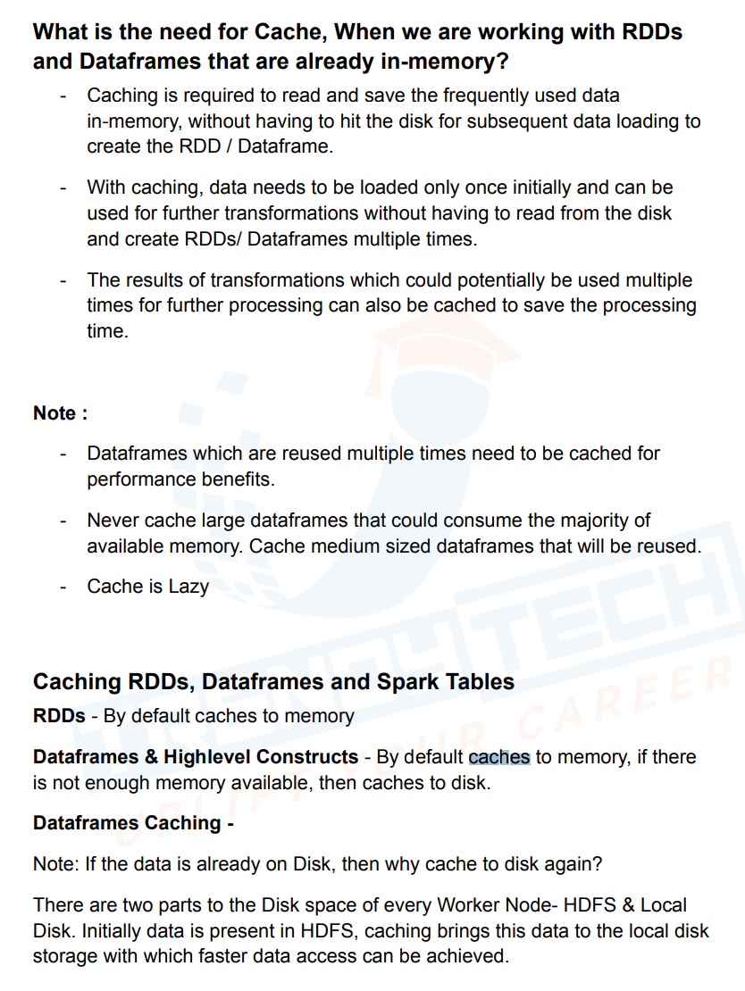

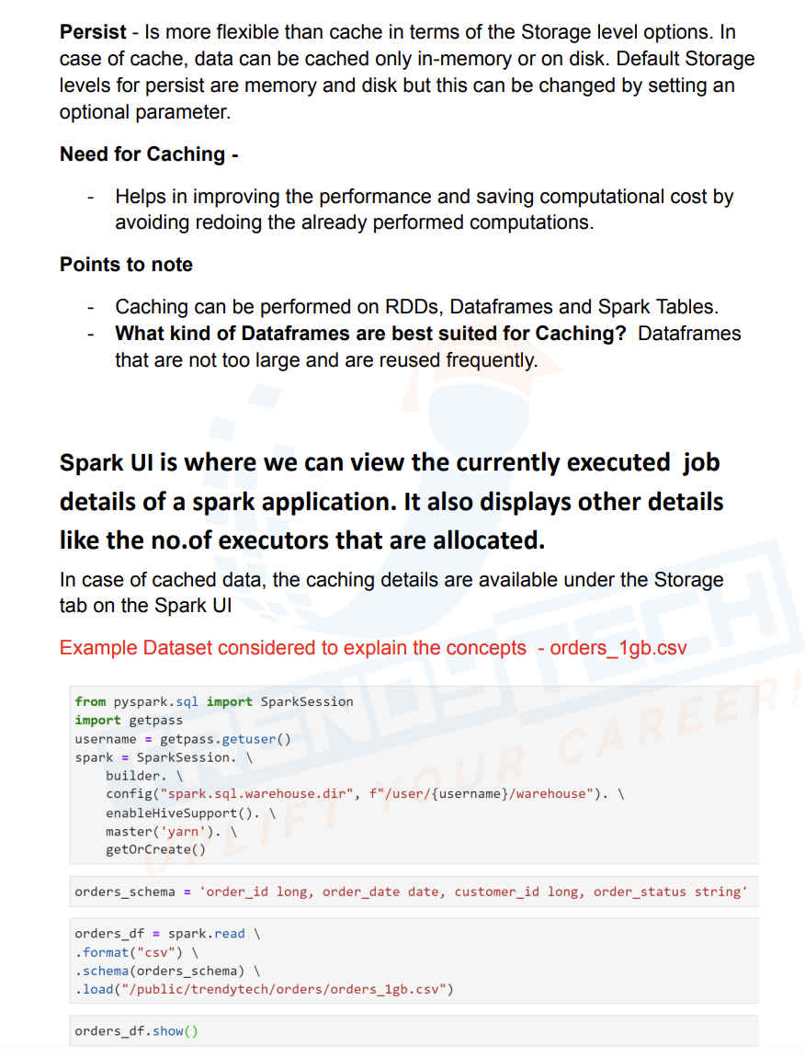

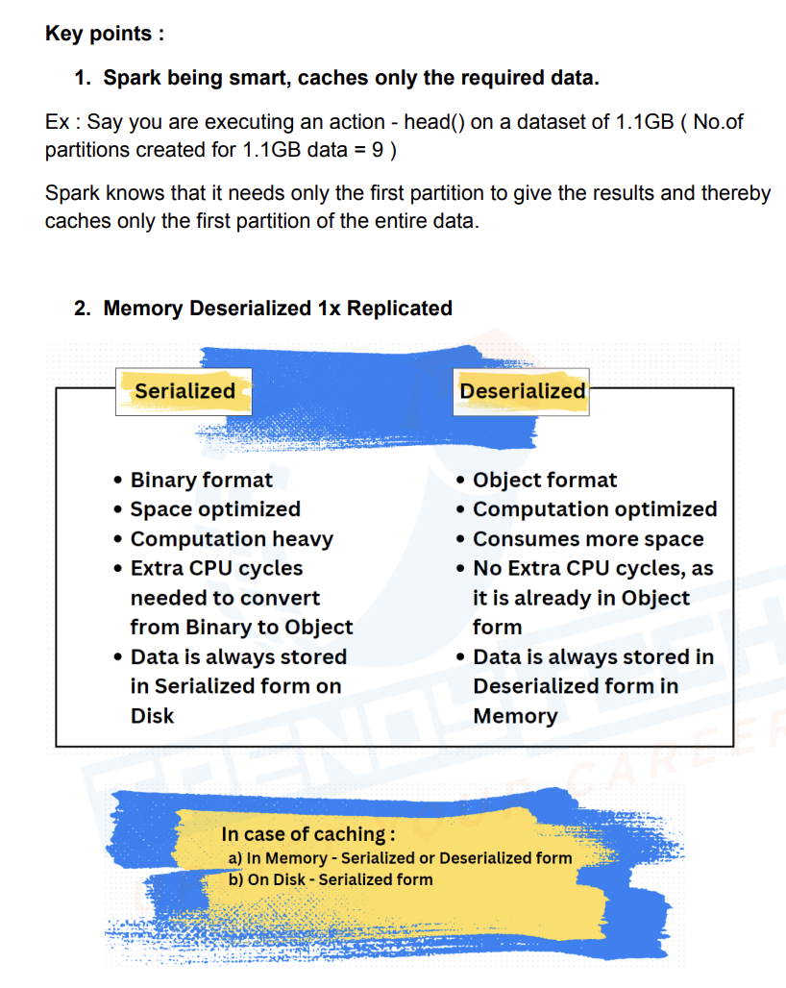

**Suppose I have a df, and I run df.count() since data is not cashed it takes more time, now I run df1=df.cache() and then df1.count(), when I run df1=df.cache() it will not cache immediately as it is a lazy transaformation and it will start caching once we call an action i.e df1.count() , after calling action it will start caching we don’t see caching benefits on that run, we will only see it for next to next action call after caching**

import findspark  
  
findspark.init()  
from pyspark.sql.types import *  
from pyspark.sql import SparkSession  
from pyspark.sql.functions import *  
from pyspark.sql.types import *  
spark = SparkSession.builder.appName("ee").getOrCreate()  
df=spark.read.format("csv").schema("order_id int,order_date date,customer_id int,order_status string")\  
 .load("/Users/atul/Downloads/ultimate_datasets/trendytech/orders/orders_1gb.csv")  
df.count()  
df1=df.cache()  
df1.count()  
df1.count()

In the below code only for the last count we get caching benefits

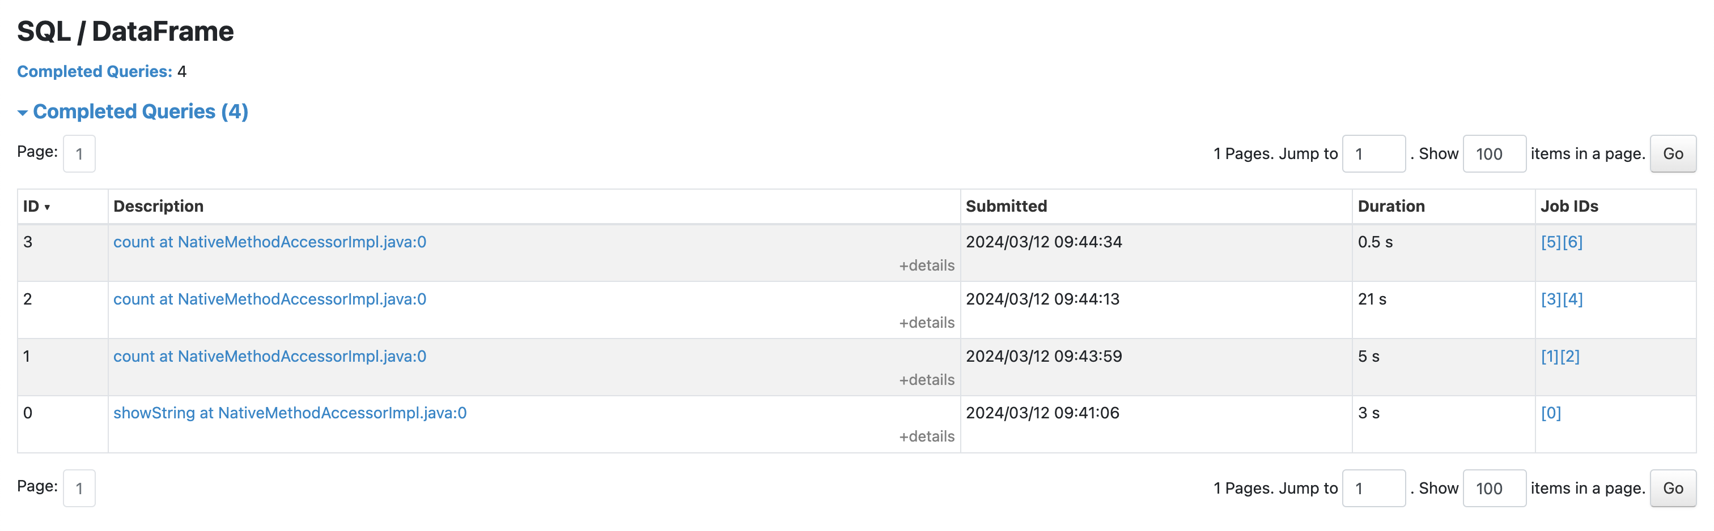

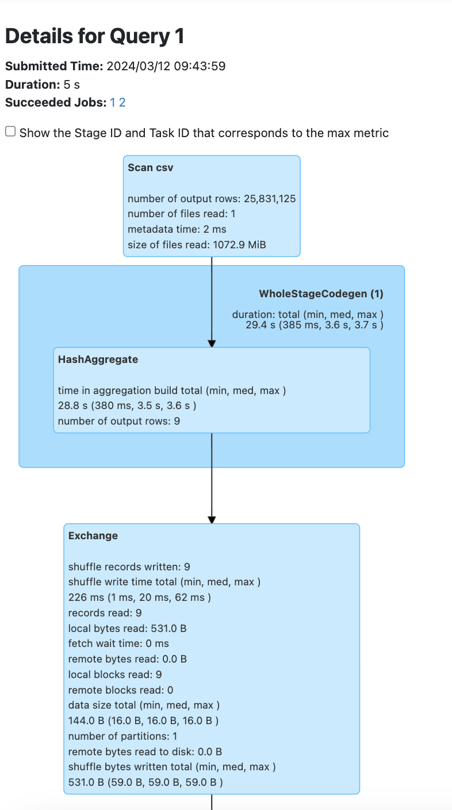 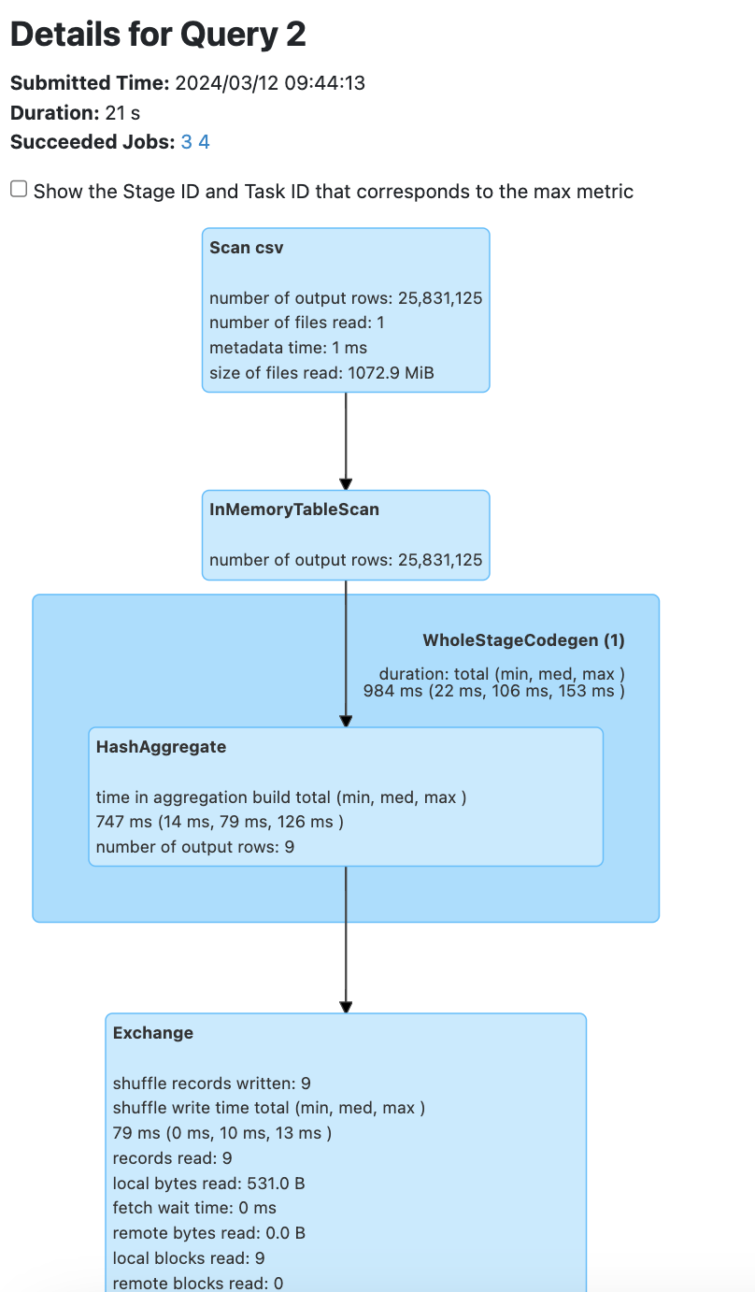

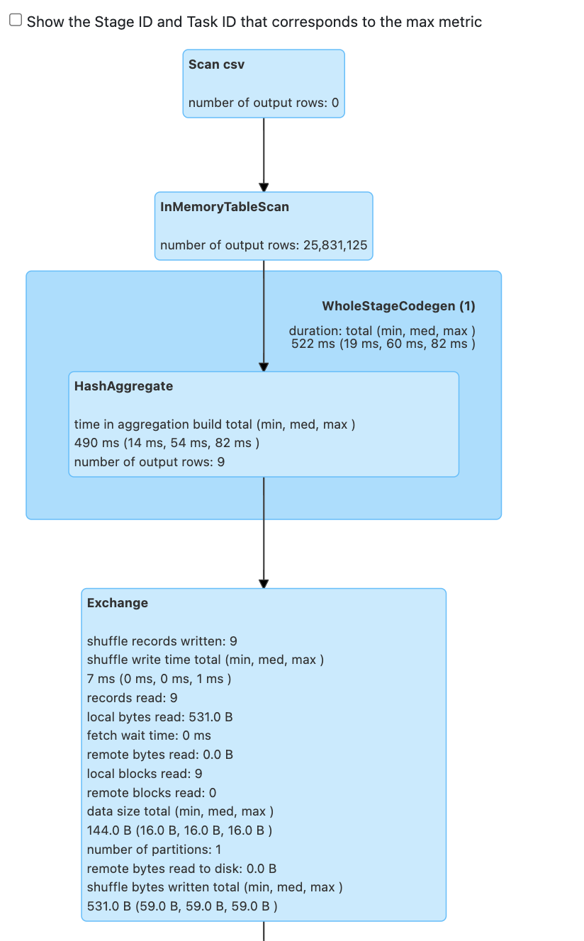

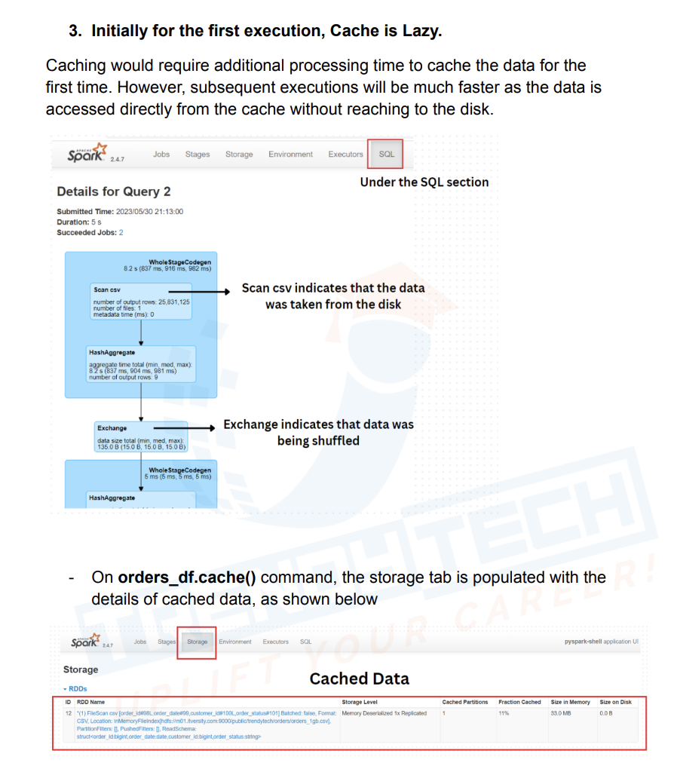

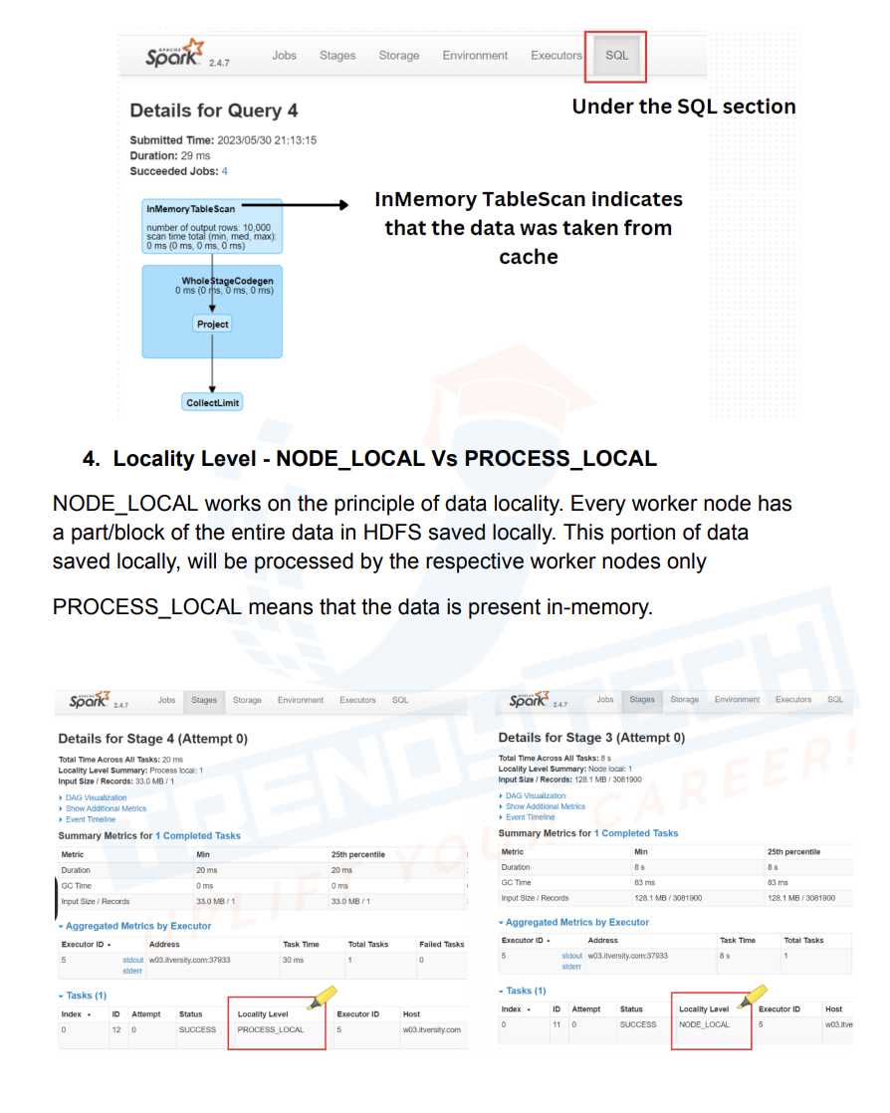

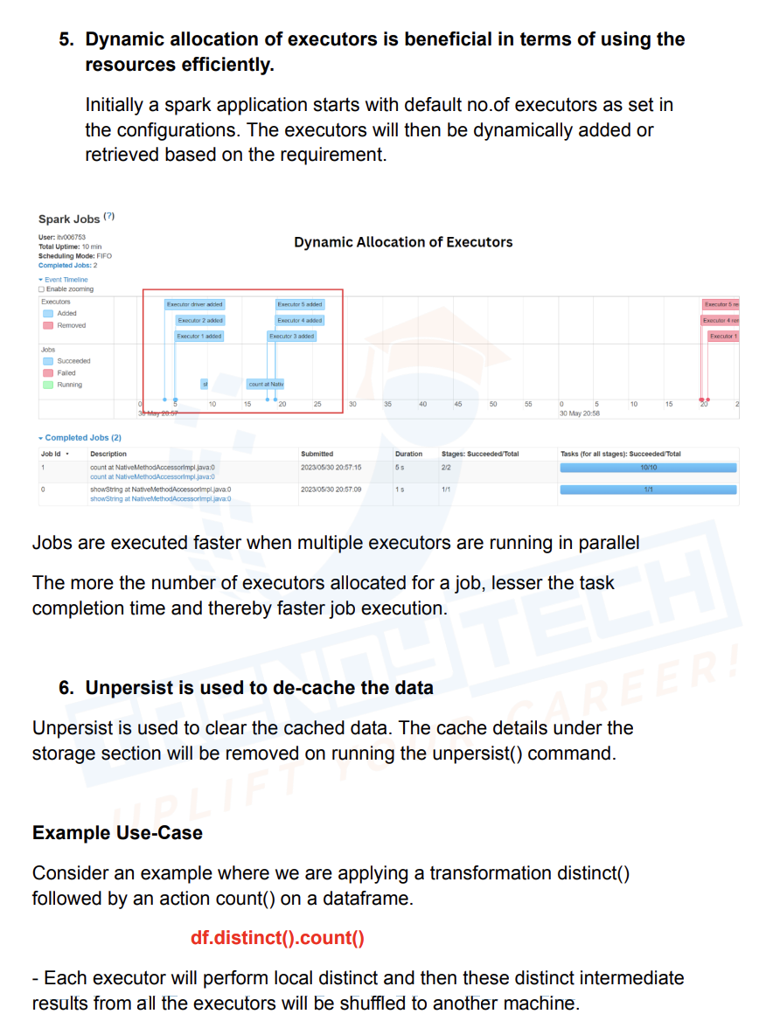

Unpersists works immideatly

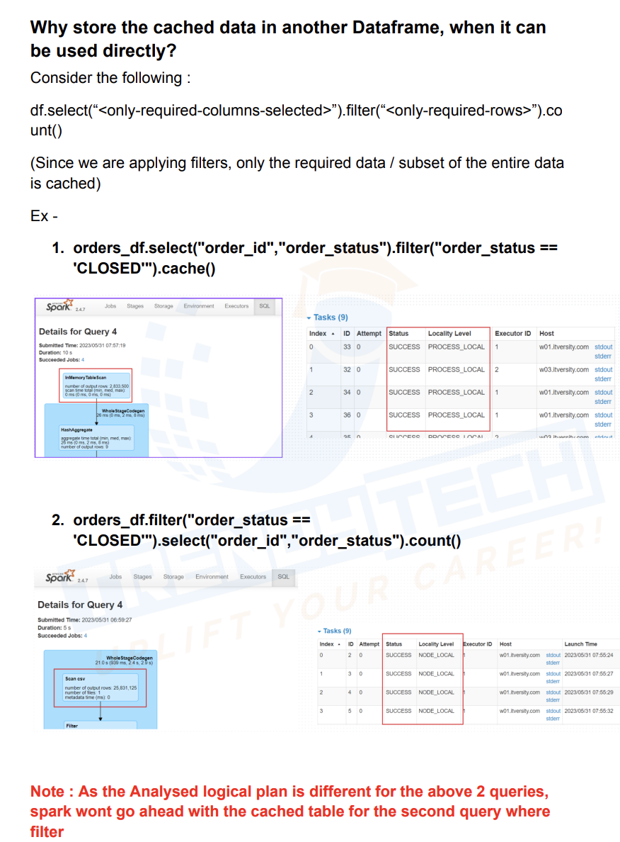

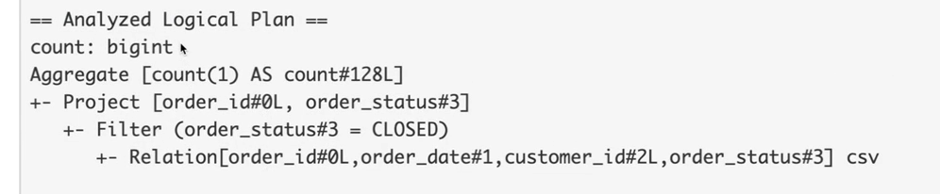

In case 2 it didn’t use cache as analysed plan was different for both the cases

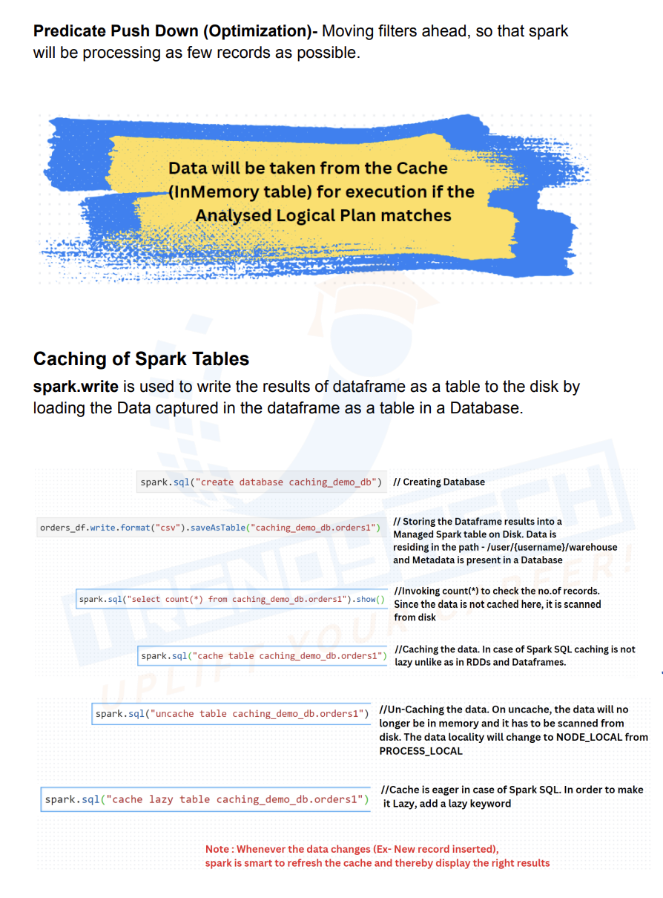

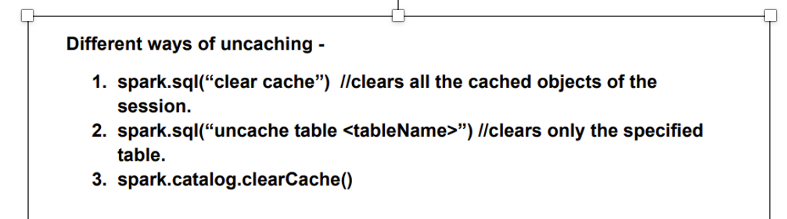

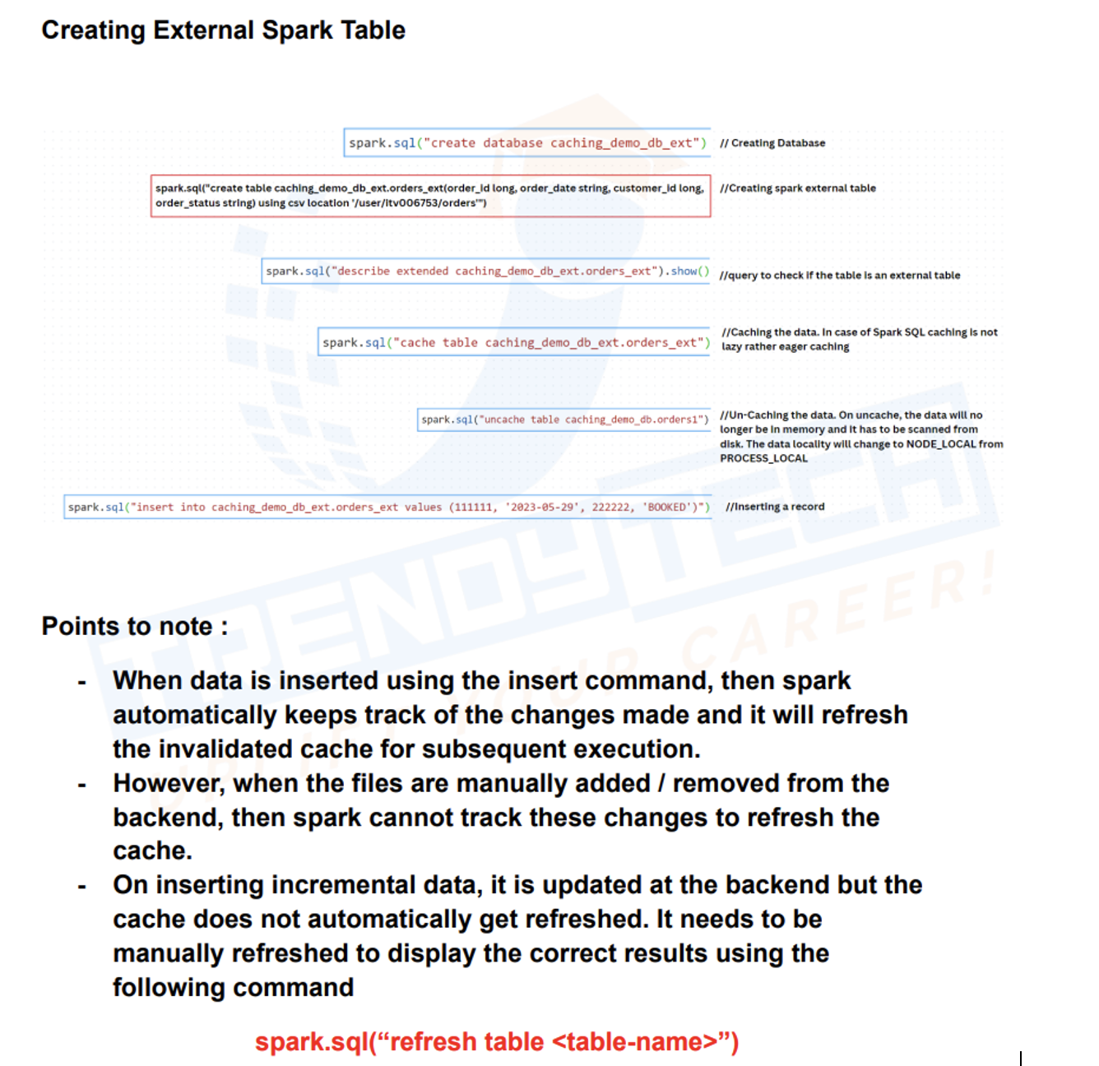

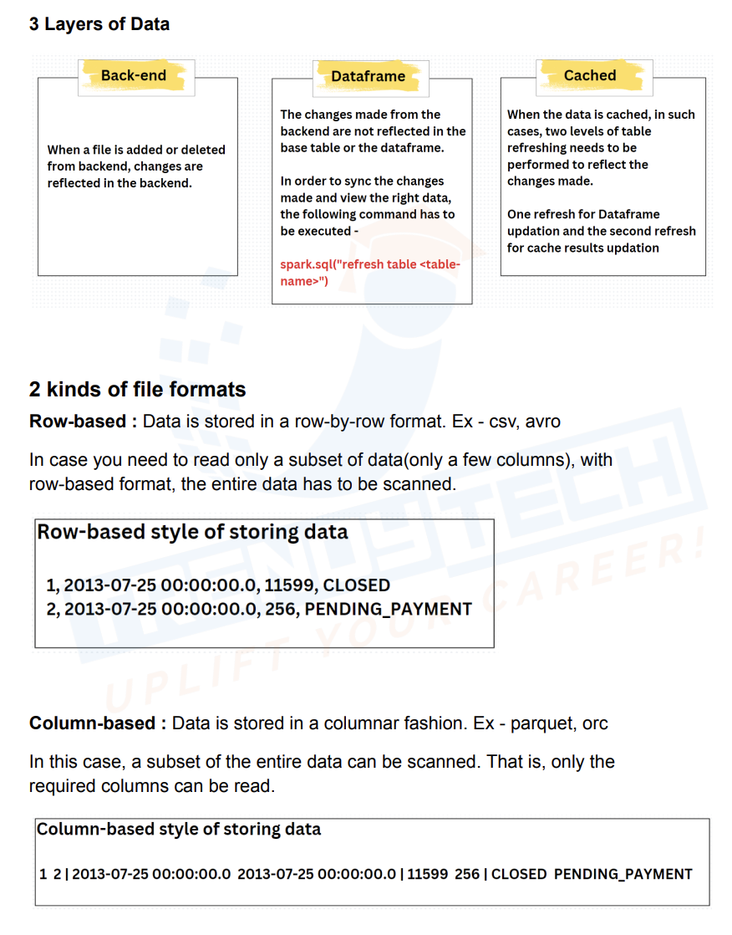

Suppose You insert new record using spark sql and try to use cached it will drop old cache data and cache again and try to show the result, but for the first time it will show NODE_LOCAL and next time if I hit same query it will show process local

If data is updated from backend we need to refresh once for DF to get updated and we need to refresh again for cache to get updated

Suppose If I save table using parquet format and load that data and then run select count(*) from table, since data is in parquet the spark will not scan all the records, but if I cache the table and run same query then it would take more time as it needs to scan all the records from the cached data

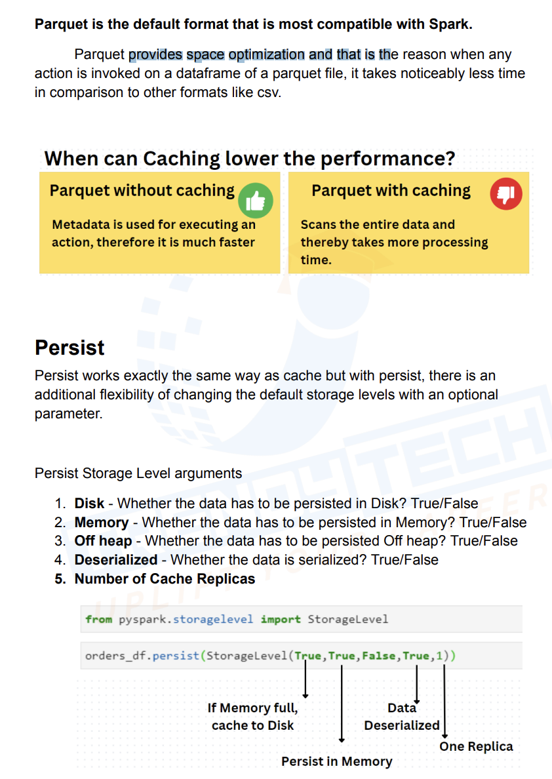

When we are doing wide transformation like join, in those cases we need to cache parquet based dataset as well

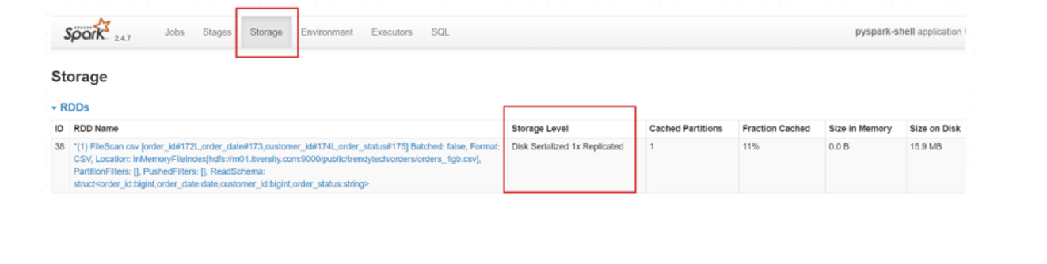

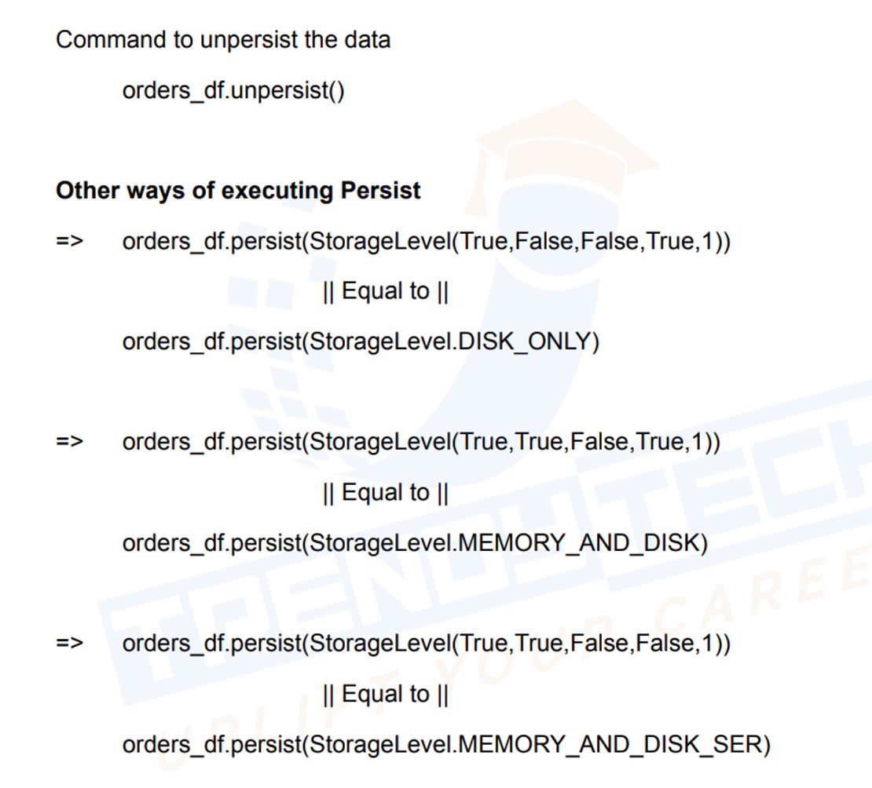

Df.cache tries to store in-memory if memory is full then it stores in disk



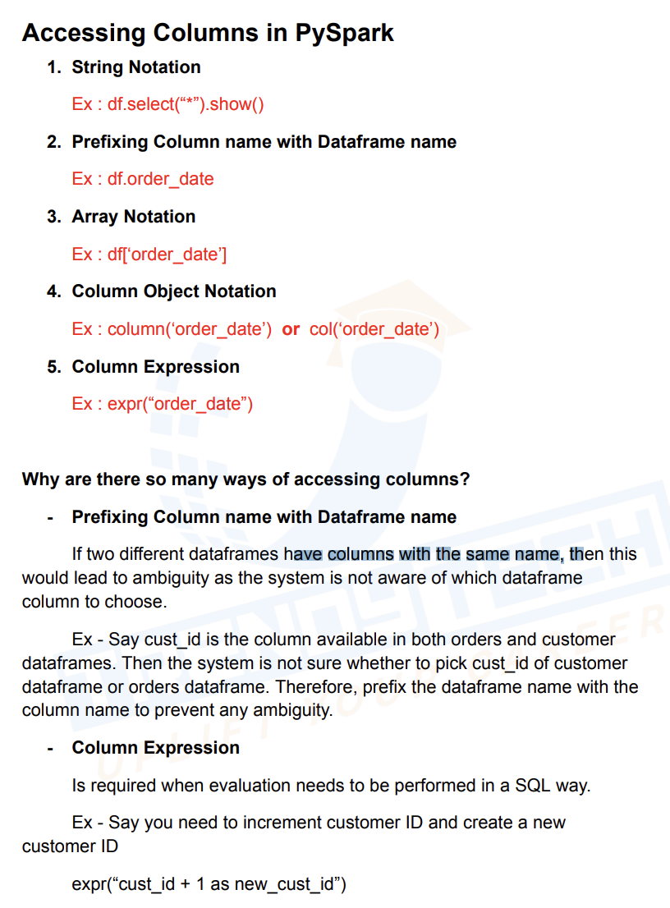

Spark Dynamic Resource Allocation:

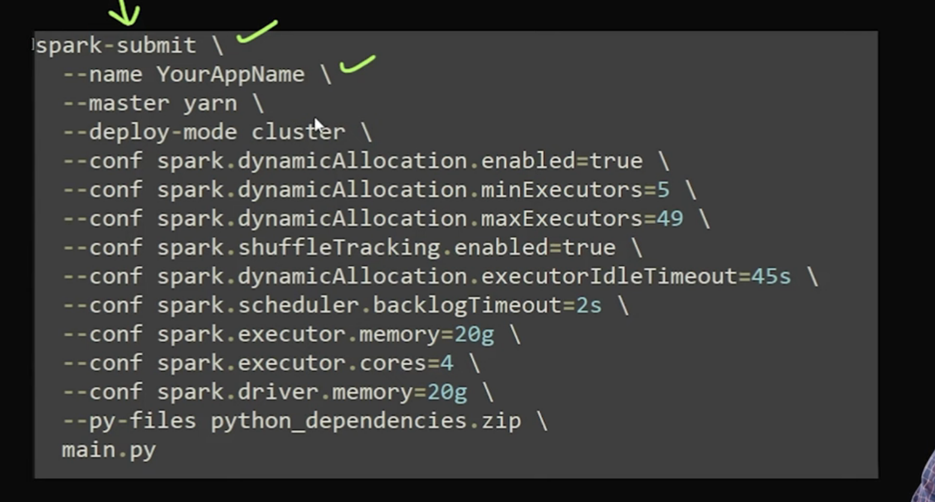

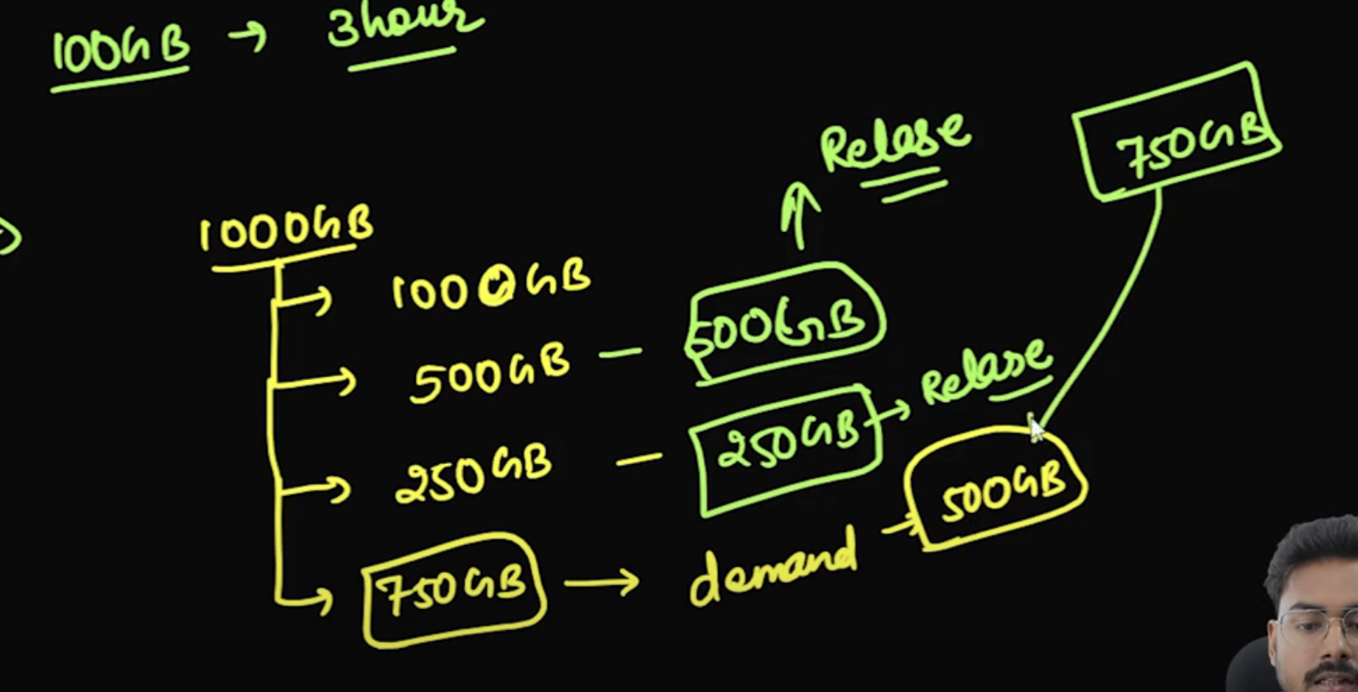

Suppose If I’m doing join later and then I need 500Gb and if there is no resource available then my job might get failed, to handle that we set min and max executors

If there is a task in backlog for 2 sec, then spark request for new executors

**External Shuffle Service (ESS) Use Case in Dynamic Resource Allocation in Spark**

Dynamic resource allocation is a feature in Apache Spark that allows Spark to dynamically adjust the number of executors based on the workload's requirements during execution. This is particularly useful in cloud or cluster environments where resource availability can fluctuate.

The **External Shuffle Service (ESS)** plays a significant role in ensuring that dynamic resource allocation works efficiently by addressing key challenges that arise when executors are added or removed during the execution of a Spark job.

**Key Challenges with Dynamic Resource Allocation:**

1. **Executor Failures and Data Loss**: When executors are added or removed dynamically (for example, scaling up or down based on resource requirements), the data stored in those executors' local storage can be lost. This is problematic during shuffle operations, where Spark exchanges data between partitions of RDDs (Resilient Distributed Datasets).
2. **Shuffle Data Management**: During a shuffle, Spark moves data between different stages and across different executors. If an executor is removed (for example, due to scaling down or failure), the shuffle data managed by that executor can become unavailable, causing job failures or delays.

**How External Shuffle Service Solves These Challenges:**

The **External Shuffle Service (ESS)** addresses the above challenges by providing a centralized mechanism to handle shuffle data. When Spark is running with dynamic resource allocation, the **External Shuffle Service** ensures that shuffle data is stored independently of the individual executors. This allows Spark to manage executor failures, scaling, and dynamic resource allocation in a more resilient and scalable manner.

**Here's how ESS works in the context of dynamic resource allocation:**

1. **Handling Executor Addition**:
   * When Spark dynamically adds new executors to handle increased load (due to an increase in data volume or more parallel tasks), the **External Shuffle Service** ensures that the new executors can access the shuffle data stored externally. This eliminates the need for re-computing or re-shuffling data, which can be time-consuming and inefficient.
2. **Executor Removal**:
   * When Spark dynamically removes executors (for example, if the system scales down to release resources), the shuffle data is preserved by the **External Shuffle Service**. The shuffle data is not lost, and other executors that are still running can continue accessing the data. This avoids data loss or the need for the job to be recomputed.
3. **Resilience to Executor Failures**:
   * If an executor fails during a shuffle operation, the **External Shuffle Service** provides fault tolerance by ensuring that the data required by the remaining executors is available. The ESS helps by storing the shuffle data on a distributed system, allowing other executors to access it and continue processing without re-shuffling or failing the job.
4. **Efficient Resource Utilization**:
   * With dynamic resource allocation, Spark can add or remove executors based on the current load. The **External Shuffle Service** minimizes the overhead associated with this by ensuring that shuffle data is not tied to the lifecycle of an executor. This leads to more efficient use of resources and can result in reduced costs and better performance in cloud environments where resources are allocated dynamically.

When getting new resource, driver asks resources in 2 fold

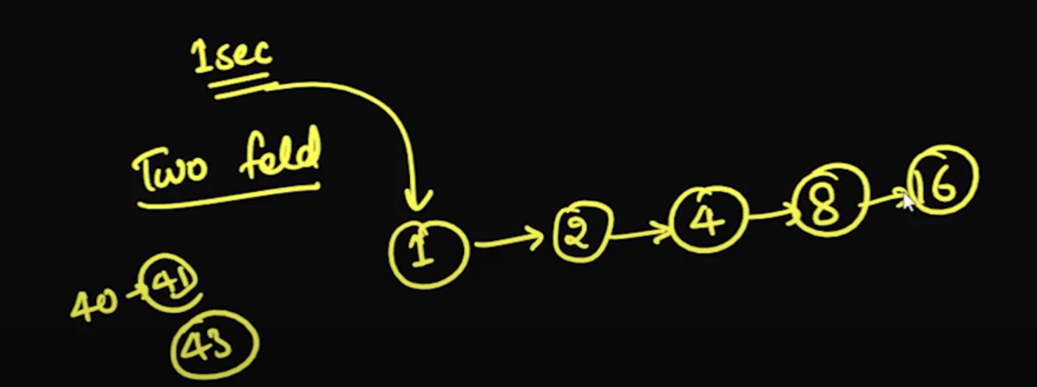

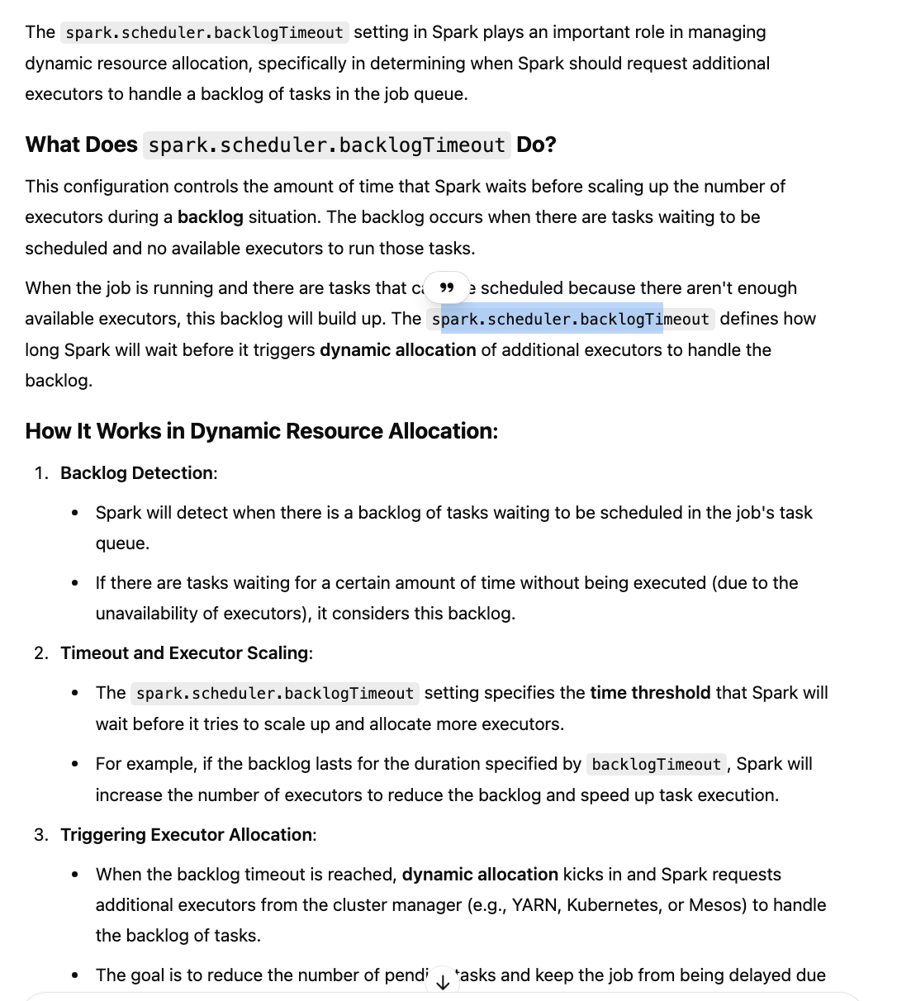

Dynamic Partitioning Pruning:

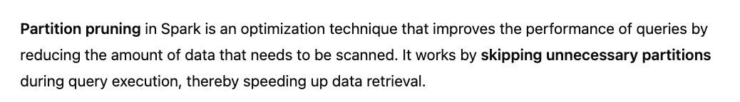

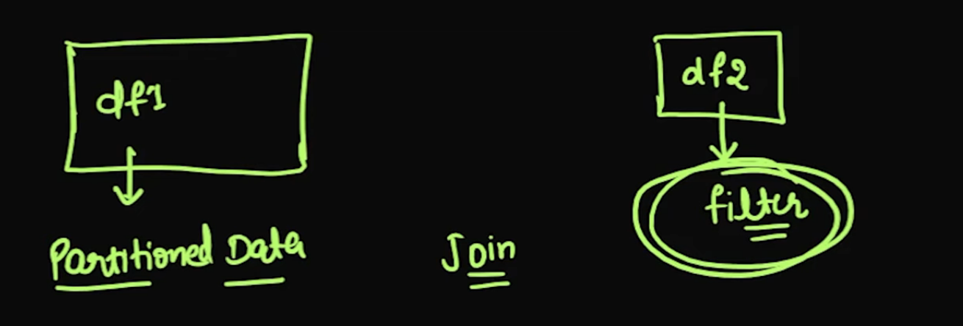

Suppose I have df1 which is partitioned data and df2 which is filtered and the joined with df1 in that case partition pruning is not done

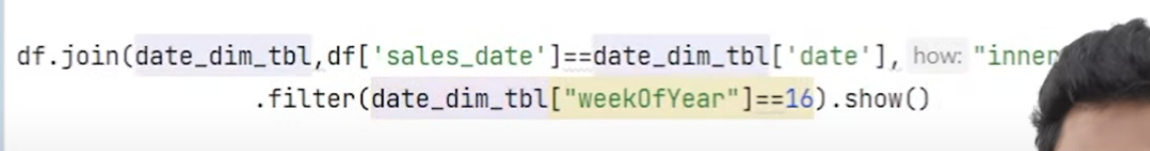

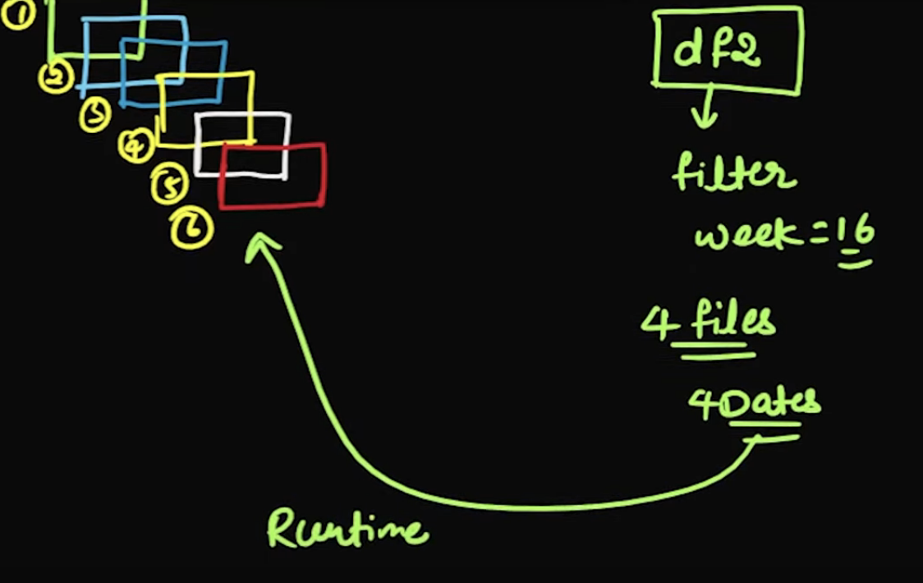



At runtime filter will be passed to big table which will only filter selected dates provided by smaller table

Aggregation:

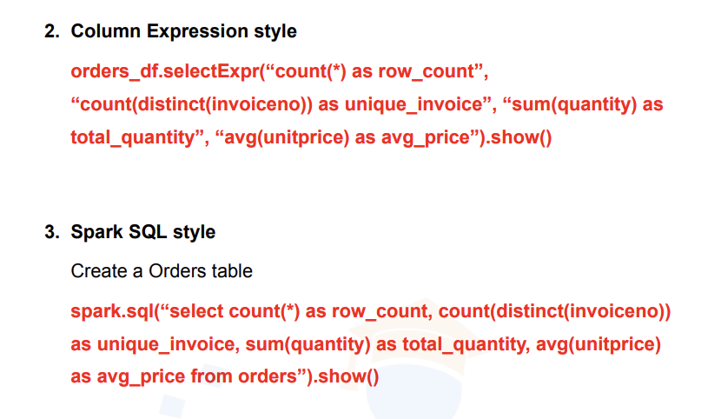

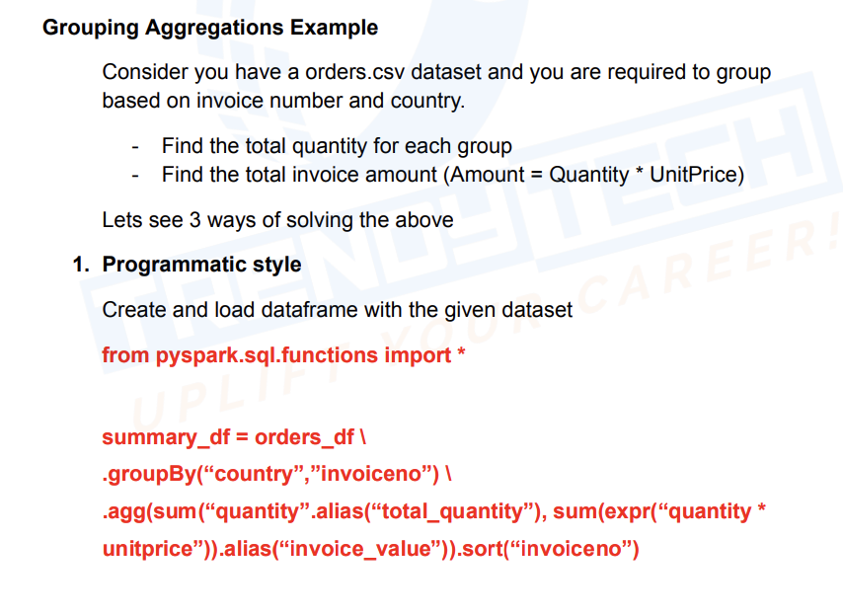

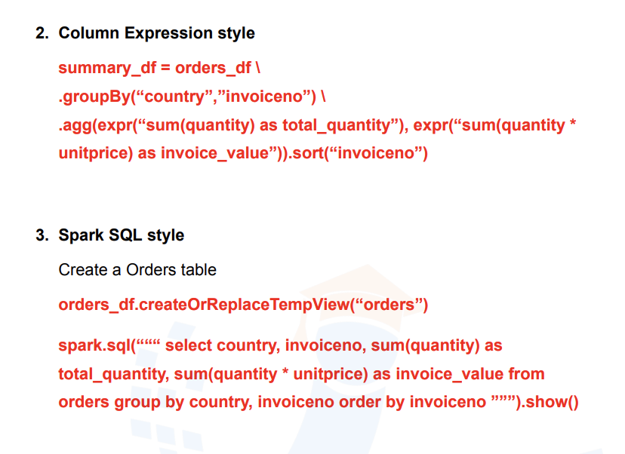

Window Function:

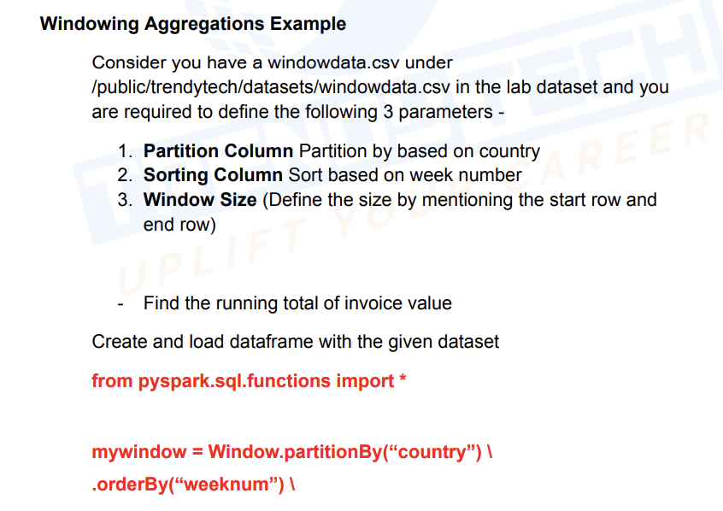

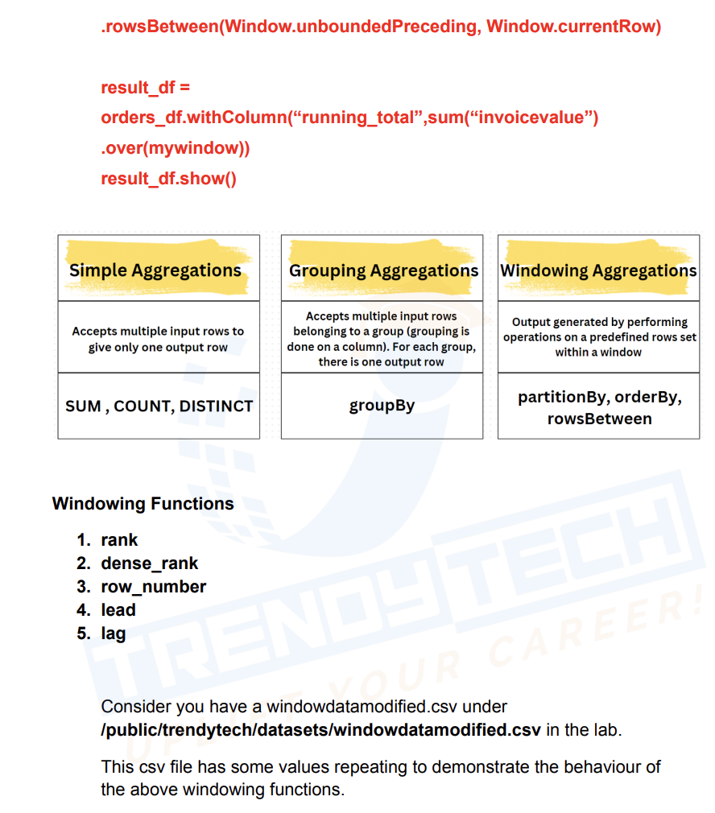

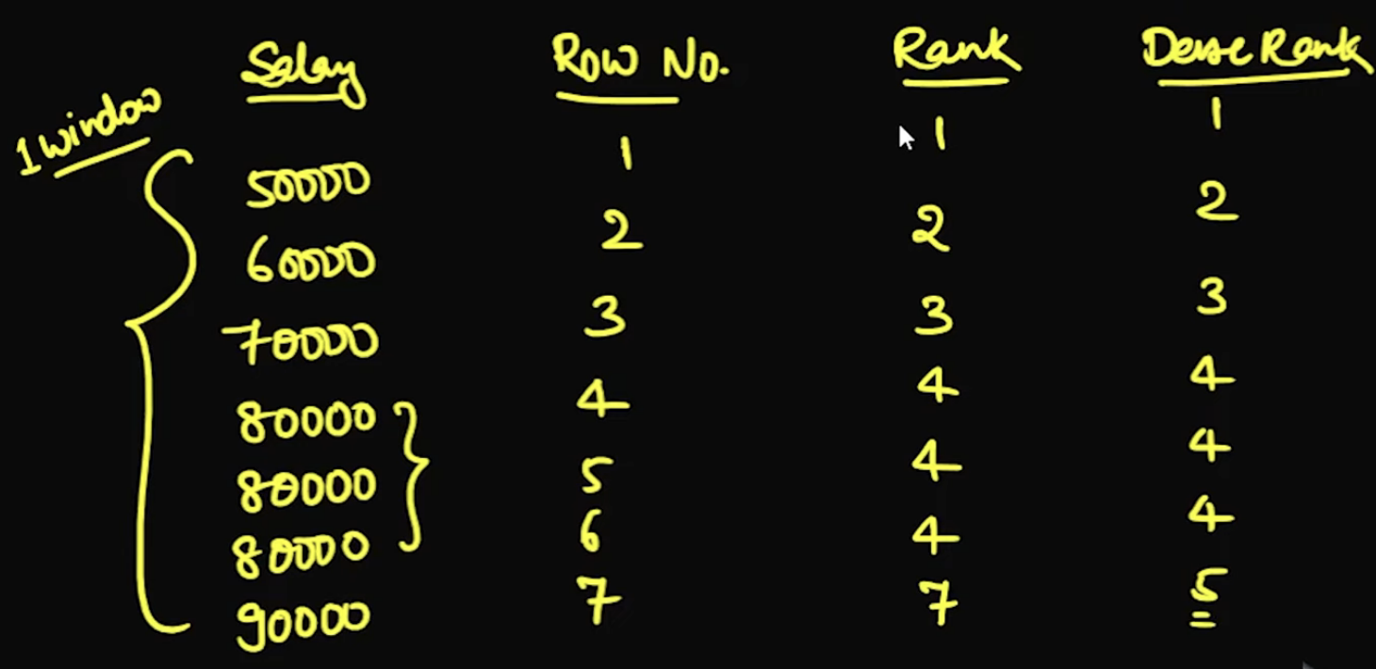

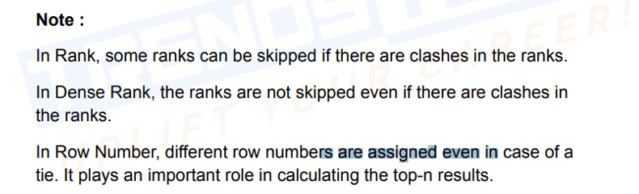

Window Function:

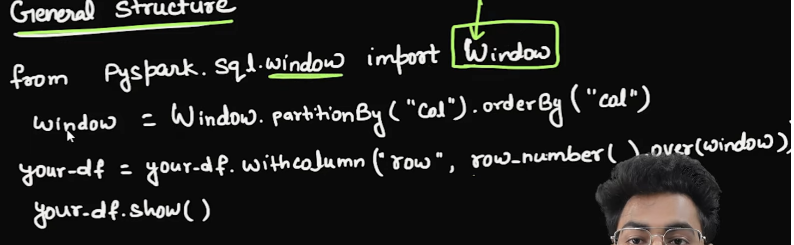

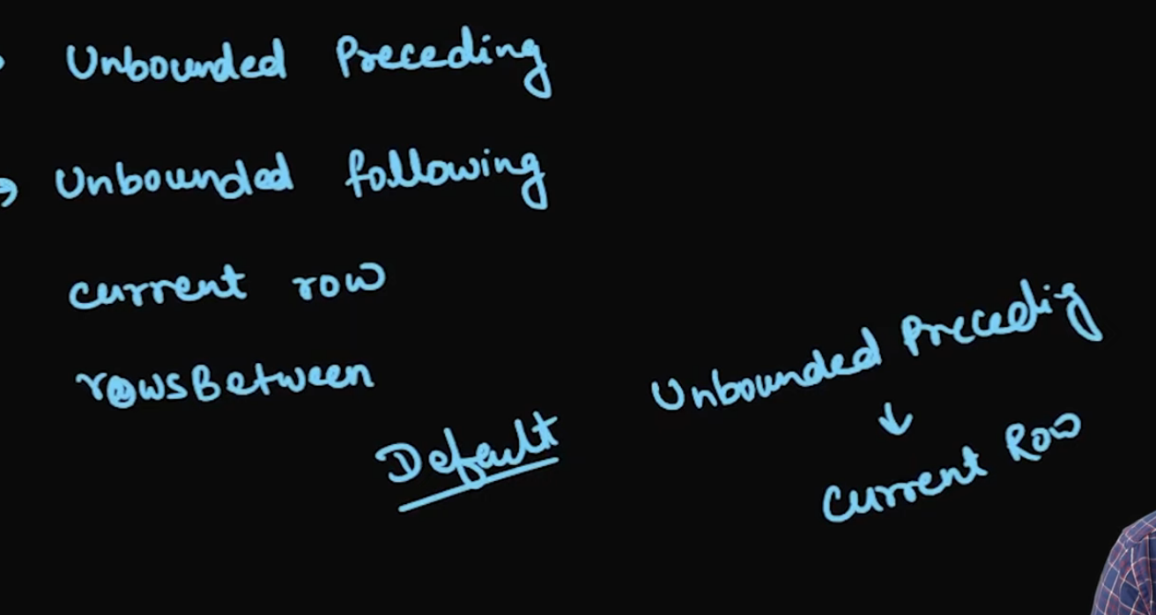

Unbounded preceding -> consider all rows before current row

Unbounded following -> consider all rows after current row

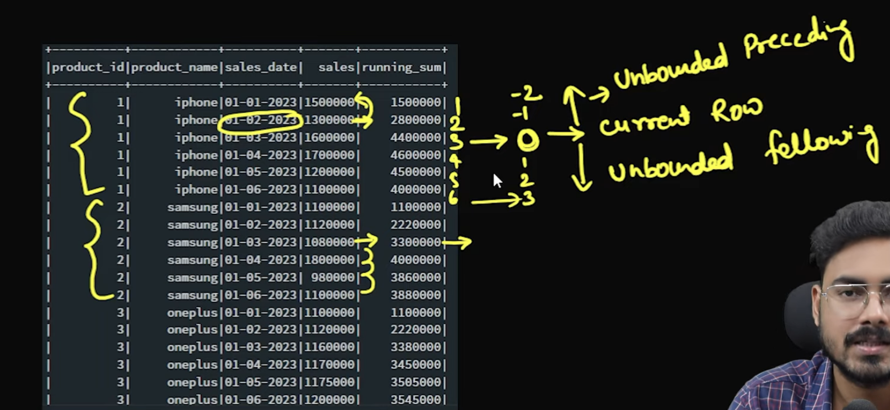

# Find Blank Lines in Text File  
import findspark  
  
findspark.init()  
from pyspark.sql import SparkSession  
  
spark=SparkSession.builder.appName("test").getOrCreate()  
  
emp_data = [(**1,**'manish'**,50000,**'IT'**,**'m')**,**(**2,**'vikash'**,60000,**'sales'**,**'m')**,**(**3,**'raushan'**,70000,**'marketing'**,**'m')**,**(**4,**'mukesh'**,80000,**'IT'**,**'m')**,**(**5,**'priti'**,90000,**'sales'**,**'f')**,**(**6,**'nikita'**,45000,**'marketing'**,**'f')**,**(**7,**'ragini'**,55000,**'marketing'**,**'f')**,**(**8,**'rashi'**,100000,**'IT'**,**'f')**,**(**9,**'aditya'**,65000,**'IT'**,**'m')**,**(**10,**'rahul'**,50000,**'marketing'**,**'m')**,**(**11,**'rakhi'**,50000,**'IT'**,**'f')**,**(**12,**'akhilesh'**,90000,**'sales'**,**'m')]  
  
df = spark.createDataFrame(data=emp_data**,**schema='id int,name string,sal int,dept string,sex string')  
from pyspark.sql.window import Window  
from pyspark.sql.functions import *  
window_f = Window.partitionBy(col('dept')).orderBy(col('sal'))  
df.withColumn("rank"**,**rank().over(window_f)). \  
withColumn("dense_rank"**,**dense_rank().over(window_f)). \  
withColumn("row_nubmer"**,**row_number().over(window_f)).show()

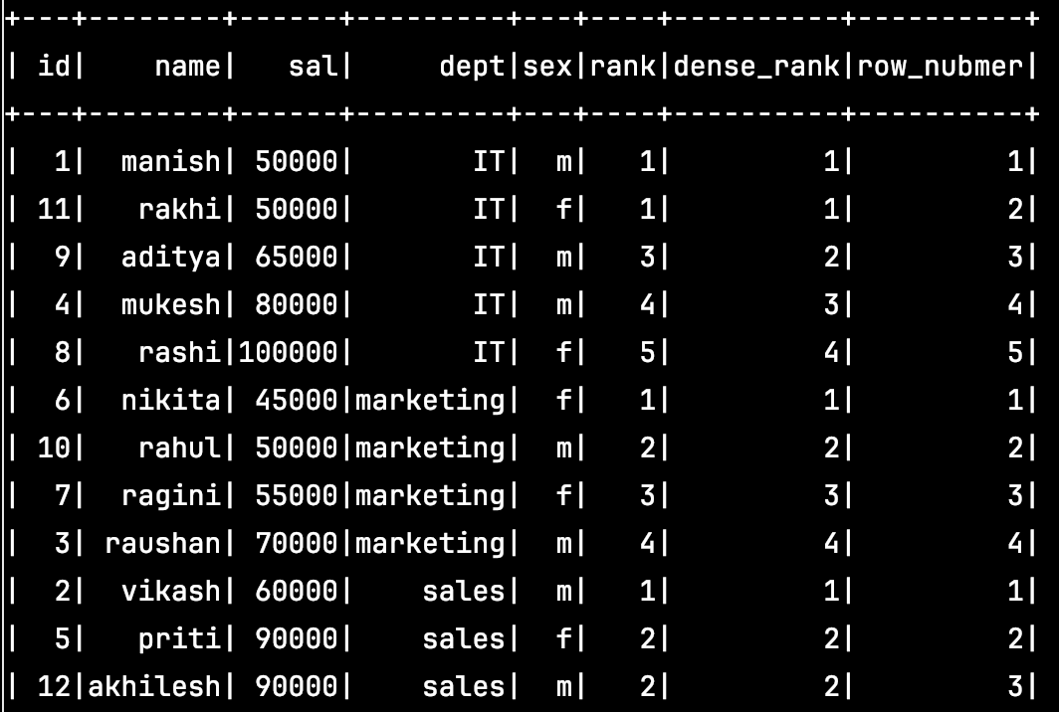

Lead Lag:

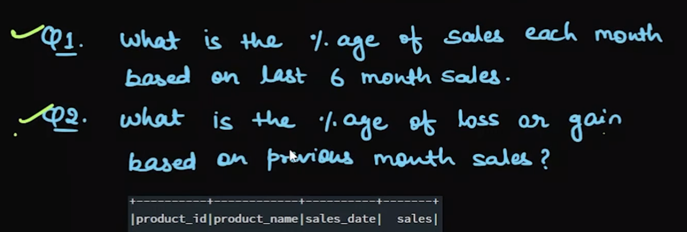

Q1:

# Find Blank Lines in Text File  
import findspark  
  
findspark.init()  
from pyspark.sql import SparkSession  
  
spark = SparkSession.builder.appName("test").getOrCreate()  
  
from pyspark.sql import SparkSession  
from pyspark.sql.window import Window  
from pyspark.sql.functions import *  
  
# Initialize Spark session  
spark = SparkSession.builder.appName("SalesPercentage").getOrCreate()  
  
# Sample product data  
product_data = [  
 (**1,** "iphone"**,** "01-01-2023"**, 1500000**)**,** (**2,** "samsung"**,** "01-01-2023"**, 1100000**)**,** (**3,** "oneplus"**,** "01-01-2023"**, 1100000**)**,** (**1,** "iphone"**,** "01-02-2023"**, 1300000**)**,** (**2,** "samsung"**,** "01-02-2023"**, 1120000**)**,** (**3,** "oneplus"**,** "01-02-2023"**, 1120000**)**,** (**1,** "iphone"**,** "01-03-2023"**, 1600000**)**,** (**2,** "samsung"**,** "01-03-2023"**, 1080000**)**,** (**3,** "oneplus"**,** "01-03-2023"**, 1160000**)**,** (**1,** "iphone"**,** "01-04-2023"**, 1700000**)**,** (**2,** "samsung"**,** "01-04-2023"**, 1800000**)**,** (**3,** "oneplus"**,** "01-04-2023"**, 1170000**)**,** (**1,** "iphone"**,** "01-05-2023"**, 1200000**)**,** (**2,** "samsung"**,** "01-05-2023"**, 980000**)**,** (**3,** "oneplus"**,** "01-05-2023"**, 1175000**)**,** (**1,** "iphone"**,** "01-06-2023"**, 1100000**)**,** (**2,** "samsung"**,** "01-06-2023"**, 1100000**)**,** (**3,** "oneplus"**,** "01-06-2023"**, 1200000**)  
]  
  
# Create DataFrame  
df = spark.createDataFrame(data=product_data**,** schema='product_id int,name string,sales_date string,sales int')  
  
# Define the window spec to calculate the previous months' sales  
windowSpec = Window.partitionBy('product_id').orderBy('sales_date')  
  
# Use lag to access the previous month's sales, up to six months back  
df_with_lag = df.withColumn("lag1"**,** lag("sales"**, 1,0**).over(windowSpec)) \  
 .withColumn("lag2"**,** lag("sales"**, 2,0**).over(windowSpec)) \  
 .withColumn("lag3"**,** lag("sales"**, 3,0**).over(windowSpec)) \  
 .withColumn("lag4"**,** lag("sales"**, 4,0**).over(windowSpec)) \  
 .withColumn("lag5"**,** lag("sales"**, 5,0**).over(windowSpec)) \  
 .withColumn("lag6"**,** lag("sales"**, 6,0**).over(windowSpec))  
  
  
# Calculate the total sales of the last 6 months by summing the current sales and the lagged values  
df_with_total_sales = df_with_lag.withColumn(  
 "total_sales_last_6_months"**,** col("sales") + col("lag1") + col("lag2") + col("lag3") + col("lag4") + col("lag5") + col("lag6")  
)  
  
# Calculate percentage of sales for each month  
df_with_percentage = df_with_total_sales.withColumn(  
 "sales_percentage"**,** (col("sales") / col("total_sales_last_6_months")) * **100**)  
  
# Round the percentage to 2 decimal places  
df_with_percentage = df_with_percentage.withColumn("sales_percentage"**,** round(col("sales_percentage")**, 2**))  
  
# Show the result  
df_with_percentage.show()

Q2: # Find Blank Lines in Text File  
import findspark  
  
findspark.init()  
from pyspark.sql import SparkSession  
  
spark = SparkSession.builder.appName("test").getOrCreate()  
  
from pyspark.sql import SparkSession  
from pyspark.sql.window import Window  
from pyspark.sql.functions import *  
  
# Initialize Spark session  
spark = SparkSession.builder.appName("SalesPercentage").getOrCreate()  
  
# Sample product data  
product_data = [  
 (**1,** "iphone"**,** "01-01-2023"**, 1500000**)**,** (**2,** "samsung"**,** "01-01-2023"**, 1100000**)**,** (**3,** "oneplus"**,** "01-01-2023"**, 1100000**)**,** (**1,** "iphone"**,** "01-02-2023"**, 1300000**)**,** (**2,** "samsung"**,** "01-02-2023"**, 1120000**)**,** (**3,** "oneplus"**,** "01-02-2023"**, 1120000**)**,** (**1,** "iphone"**,** "01-03-2023"**, 1600000**)**,** (**2,** "samsung"**,** "01-03-2023"**, 1080000**)**,** (**3,** "oneplus"**,** "01-03-2023"**, 1160000**)**,** (**1,** "iphone"**,** "01-04-2023"**, 1700000**)**,** (**2,** "samsung"**,** "01-04-2023"**, 1800000**)**,** (**3,** "oneplus"**,** "01-04-2023"**, 1170000**)**,** (**1,** "iphone"**,** "01-05-2023"**, 1200000**)**,** (**2,** "samsung"**,** "01-05-2023"**, 980000**)**,** (**3,** "oneplus"**,** "01-05-2023"**, 1175000**)**,** (**1,** "iphone"**,** "01-06-2023"**, 1100000**)**,** (**2,** "samsung"**,** "01-06-2023"**, 1100000**)**,** (**3,** "oneplus"**,** "01-06-2023"**, 1200000**)  
]  
  
# Create DataFrame  
df = spark.createDataFrame(data=product_data**,** schema='product_id int,name string,sales_date string,sales int')  
window_f = Window.partitionBy("name").orderBy("sales_date")  
df = df.withColumn("prev_month_sale"**,**lag("sales"**,1,0**).over(window_f))  
df.withColumn("%sales"**,**round((((df['sales']-df['prev_month_sale'])/df['sales'])\***100**)**,2**)).show()

Range and Row Between:

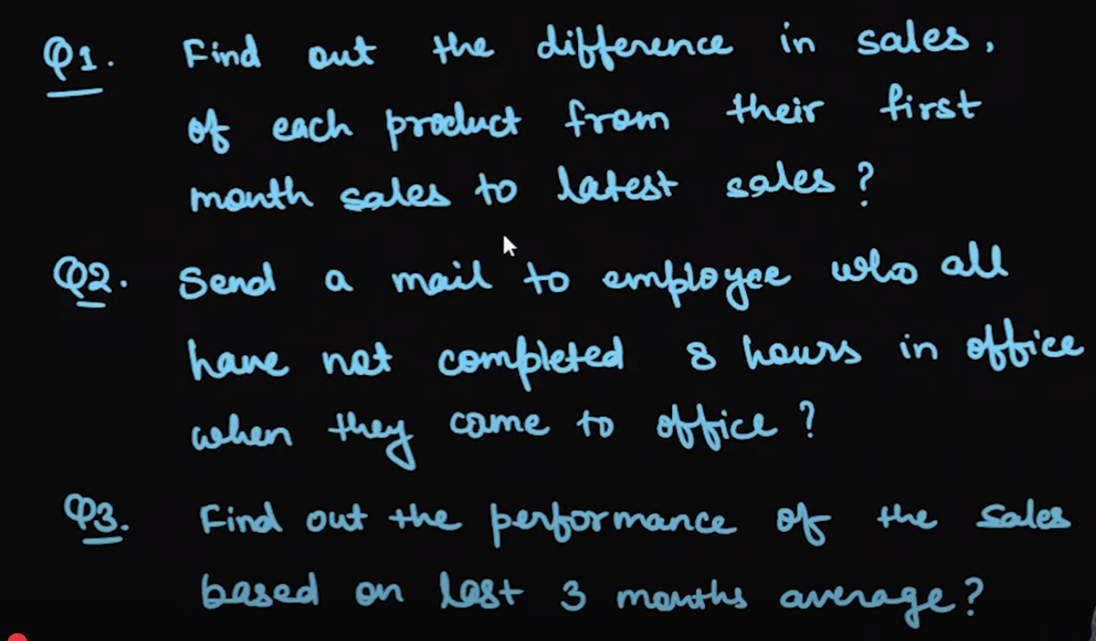

Q1: # Find Blank Lines in Text File  
import findspark  
  
findspark.init()  
from pyspark.sql import SparkSession  
  
spark = SparkSession.builder.appName("test").getOrCreate()  
  
from pyspark.sql import SparkSession  
from pyspark.sql.window import Window  
from pyspark.sql.functions import *  
  
# Initialize Spark session  
spark = SparkSession.builder.appName("SalesPercentage").getOrCreate()  
  
# Sample product data  
product_data = [  
(**2,**"samsung"**,**"01-01-1995"**,11000**)**,**(**1,**"iphone"**,**"01-02-2023"**,1300000**)**,**(**2,**"samsung"**,**"01-02-2023"**,1120000**)**,**(**3,**"oneplus"**,**"01-02-2023"**,1120000**)**,**(**1,**"iphone"**,**"01-03-2023"**,1600000**)**,**(**2,**"samsung"**,**"01-03-2023"**,1080000**)**,**(**3,**"oneplus"**,**"01-03-2023"**,1160000**)**,**(**1,**"iphone"**,**"01-01-2006"**,15000**)**,**(**1,**"iphone"**,**"01-04-2023"**,1700000**)**,**(**2,**"samsung"**,**"01-04-2023"**,1800000**)**,**(**3,**"oneplus"**,**"01-04-2023"**,1170000**)**,**(**1,**"iphone"**,**"01-05-2023"**,1200000**)**,**(**2,**"samsung"**,**"01-05-2023"**,980000**)**,**(**3,**"oneplus"**,**"01-05-2023"**,1175000**)**,**(**1,**"iphone"**,**"01-06-2023"**,1100000**)**,**(**3,**"oneplus"**,**"01-01-2010"**,23000**)**,**(**2,**"samsung"**,**"01-06-2023"**,1100000**)**,**(**3,**"oneplus"**,**"01-06-2023"**,1200000**)  
]  
  
product_schema=["product_id"**,**"product_name"**,**"sales_date"**,**"sales"]  
  
df = spark.createDataFrame(data=product_data**,**schema=product_schema)  
  
window_f= Window.partitionBy("product_name").orderBy("sales_date").rowsBetween(Window.unboundedPreceding**,**Window.unboundedFollowing)  
df = df.withColumn("first_month_sale"**,**first("sales").over(window_f))  
df = df.withColumn("latest_sales"**,**last("sales").over(window_f))  
df.withColumn("diff_sales"**,**(df['latest_sales']-df["first_month_sale"])).show()

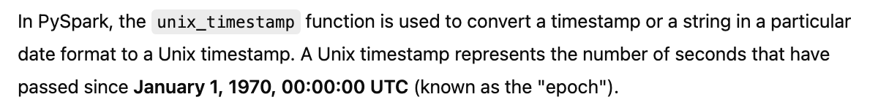

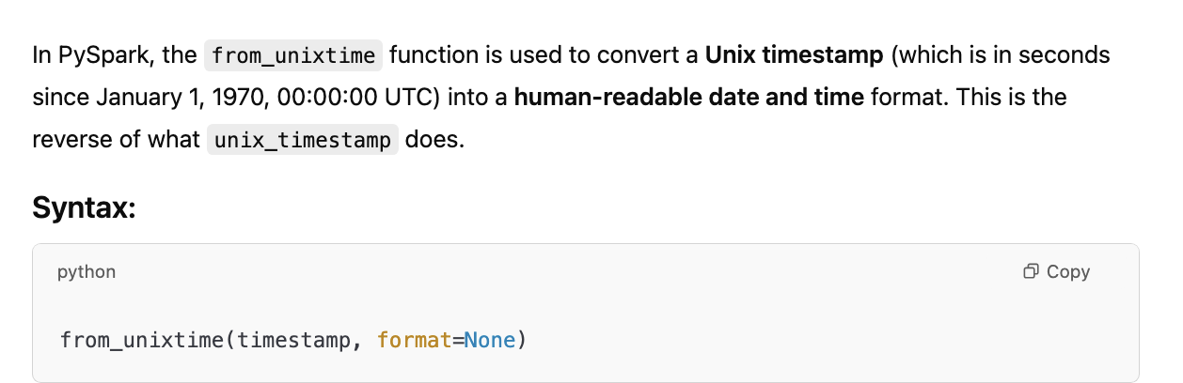

Q2

# Find Blank Lines in Text File  
import findspark  
  
findspark.init()  
from pyspark.sql import SparkSession  
from pyspark.sql.functions import *  
from pyspark.sql.window import Window  
spark = SparkSession.builder.appName("test").getOrCreate()  
  
emp_data = [(**1,** "manish"**,** "11-07-2023"**,** "10:20")**,** (**1,** "manish"**,** "11-07-2023"**,** "11:20")**,** (**2,** "rajesh"**,** "11-07-2023"**,** "11:20")**,** (**1,** "manish"**,** "11-07-2023"**,** "11:50")**,** (**2,** "rajesh"**,** "11-07-2023"**,** "13:20")**,** (**1,** "manish"**,** "11-07-2023"**,** "19:20")**,** (**2,** "rajesh"**,** "11-07-2023"**,** "17:20")**,** (**1,** "manish"**,** "12-07-2023"**,** "10:32")**,** (**1,** "manish"**,** "12-07-2023"**,** "12:20")**,** (**3,** "vikash"**,** "12-07-2023"**,** "09:12")**,** (**1,** "manish"**,** "12-07-2023"**,** "16:23")**,** (**3,** "vikash"**,** "12-07-2023"**,** "18:08")]  
  
emp_schema = ["id"**,** "name"**,** "date"**,** "time"]  
df = spark.createDataFrame(data=emp_data**,** schema=emp_schema)  
df = df.withColumn("date_time"**,** to_timestamp(from_unixtime(unix_timestamp(expr("concat(date,' ',time,':00')")**,**'dd-MM-yyyy HH:mm:ss'))))  
window_f= Window.partitionBy("id"**,**"date").orderBy("date_time"). \  
rowsBetween(Window.unboundedPreceding**,**Window.unboundedFollowing)  
df = df.withColumn("login_time"**,**first(col('date_time')).over(window_f)). \  
 withColumn("logout_time"**,**last(col('date_time')).over(window_f))  
df.withColumn("office_time"**,**(col('logout_time')-col('login_time')).cast("long")).where('office_time<28800').show()

Q3

# Find Blank Lines in Text File  
import findspark  
  
findspark.init()  
from pyspark.sql import SparkSession  
from pyspark.sql.functions import *  
from pyspark.sql.window import Window  
spark = SparkSession.builder.appName("test").getOrCreate()  
  
product_data = [  
(**1,**"iphone"**,**"01-01-2023"**,1500000**)**,**(**2,**"samsung"**,**"01-01-2023"**,1100000**)**,**(**3,**"oneplus"**,**"01-01-2023"**,1100000**)**,**(**1,**"iphone"**,**"01-02-2023"**,1300000**)**,**(**2,**"samsung"**,**"01-02-2023"**,1120000**)**,**(**3,**"oneplus"**,**"01-02-2023"**,1120000**)**,**(**1,**"iphone"**,**"01-03-2023"**,1600000**)**,**(**2,**"samsung"**,**"01-03-2023"**,1080000**)**,**(**3,**"oneplus"**,**"01-03-2023"**,1160000**)**,**(**1,**"iphone"**,**"01-04-2023"**,1700000**)**,**(**2,**"samsung"**,**"01-04-2023"**,1800000**)**,**(**3,**"oneplus"**,**"01-04-2023"**,1170000**)**,**(**1,**"iphone"**,**"01-05-2023"**,1200000**)**,**(**2,**"samsung"**,**"01-05-2023"**,980000**)**,**(**3,**"oneplus"**,**"01-05-2023"**,1175000**)**,**(**1,**"iphone"**,**"01-06-2023"**,1100000**)**,**(**2,**"samsung"**,**"01-06-2023"**,1100000**)**,**(**3,**"oneplus"**,**"01-06-2023"**,1200000**)  
]  
  
product_schema=["product_id"**,**"product_name"**,**"sales_date"**,**"sales"]  
  
df = spark.createDataFrame(data=product_data**,**schema=product_schema)  
window_f=Window.partitionBy("product_id").orderBy(col("sales_date")).rowsBetween(-**2,0**)  
df.withColumn("3_months_sales"**,**round(avg(col('sales')).over(window_f)**,2**))

Df Write:

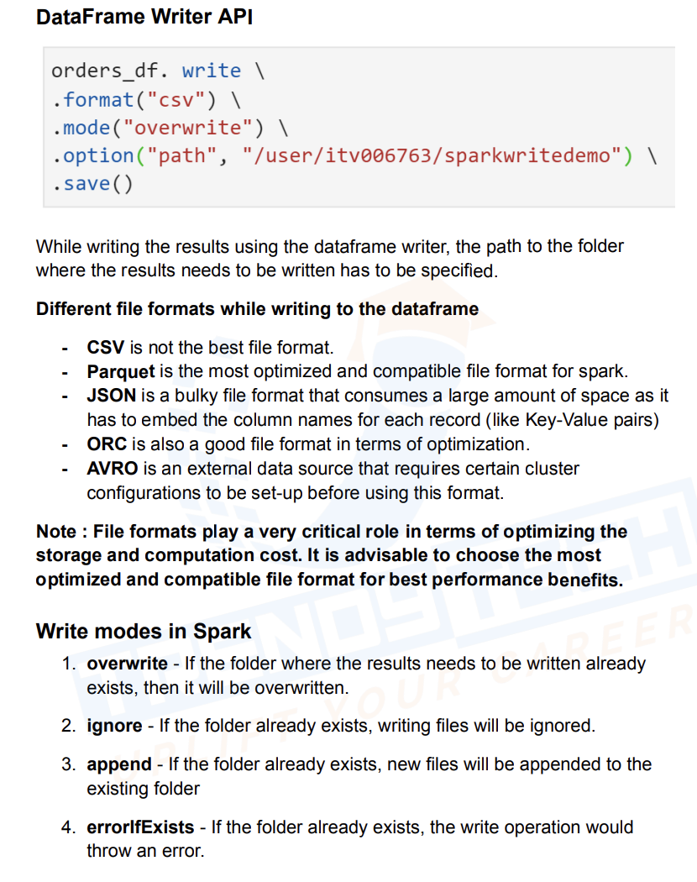

Partition By:

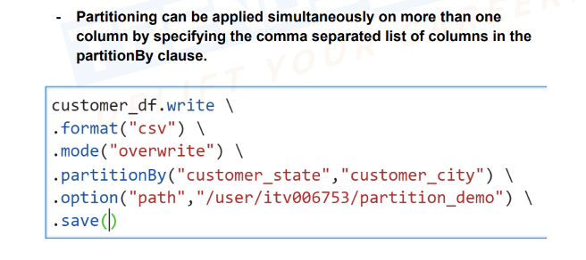

Without Partition With Partition

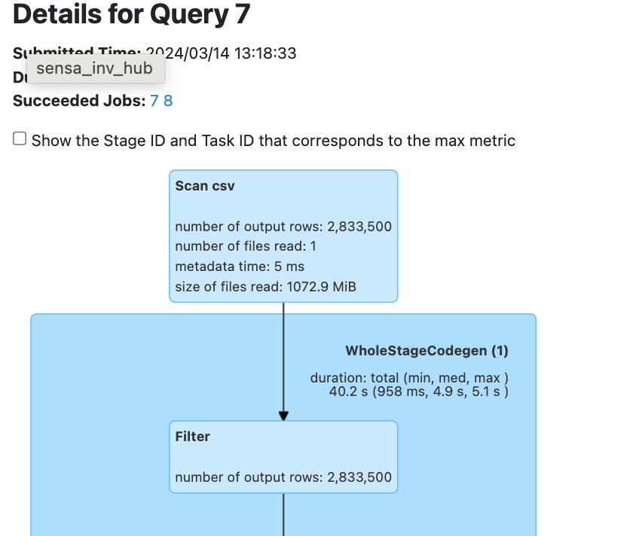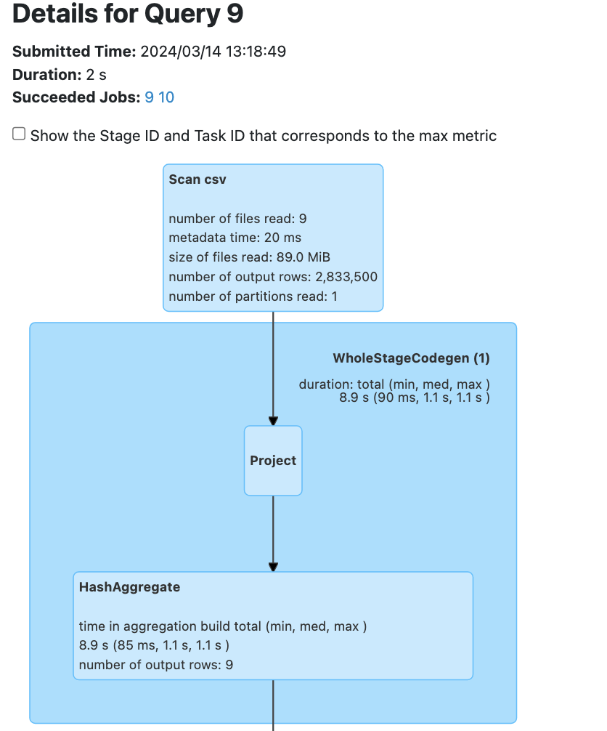

Bucketing:

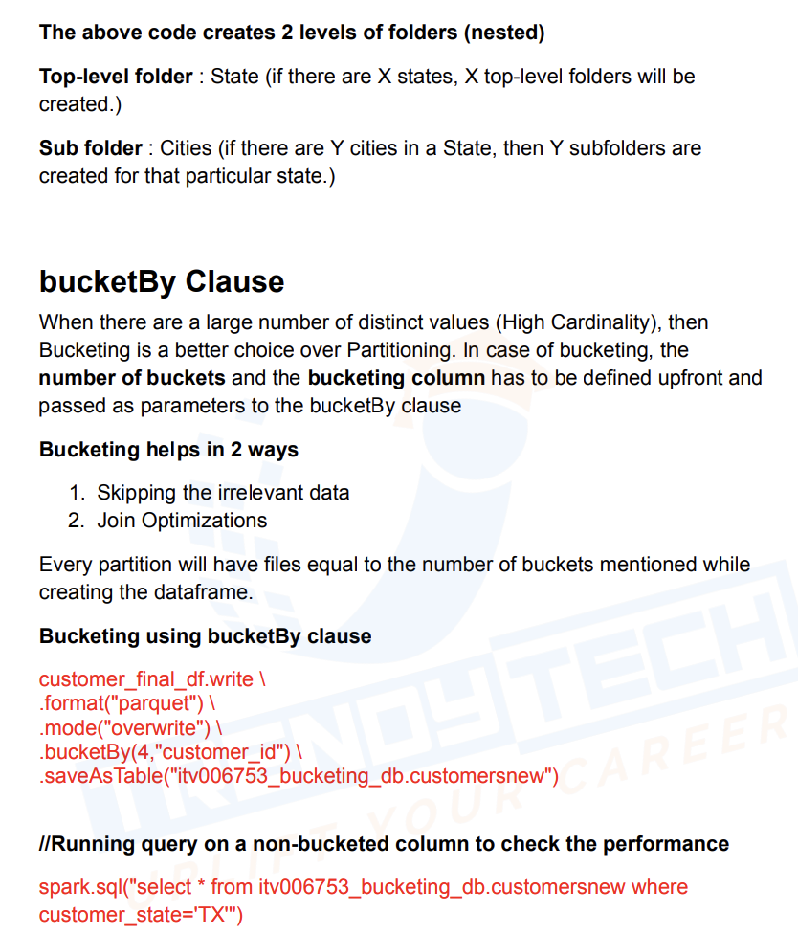

Scan Records with buckets - Scan records without buckets

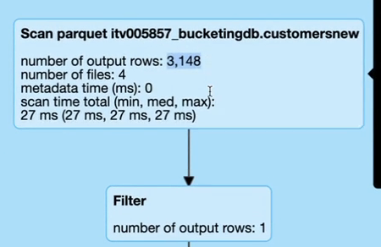 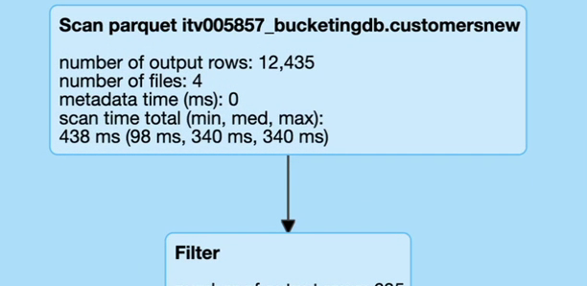

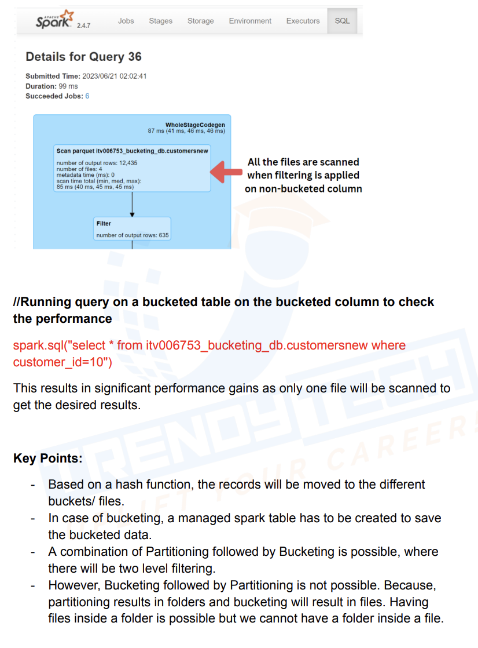

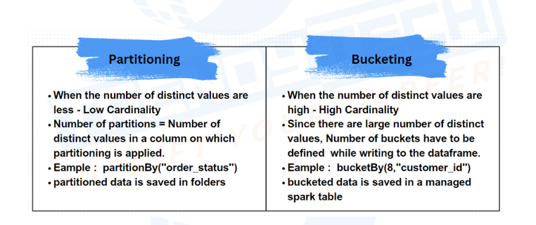

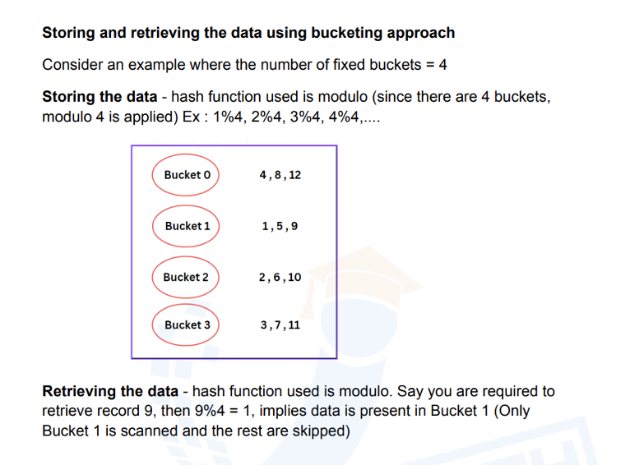

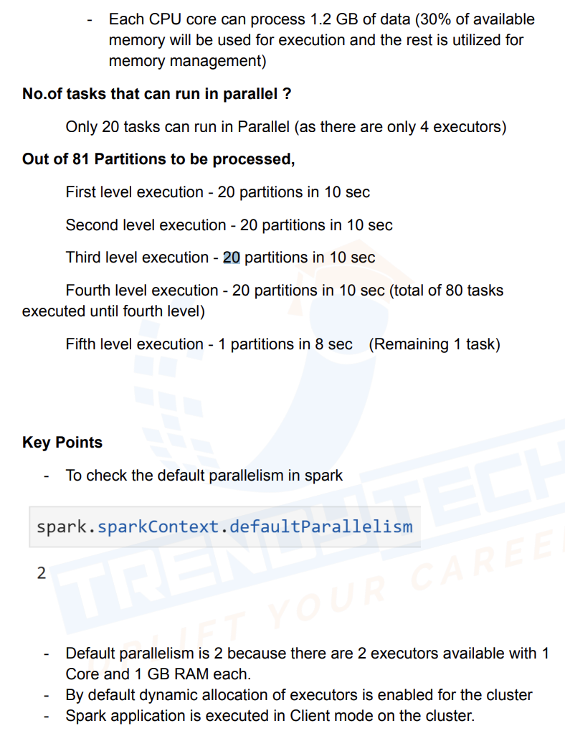

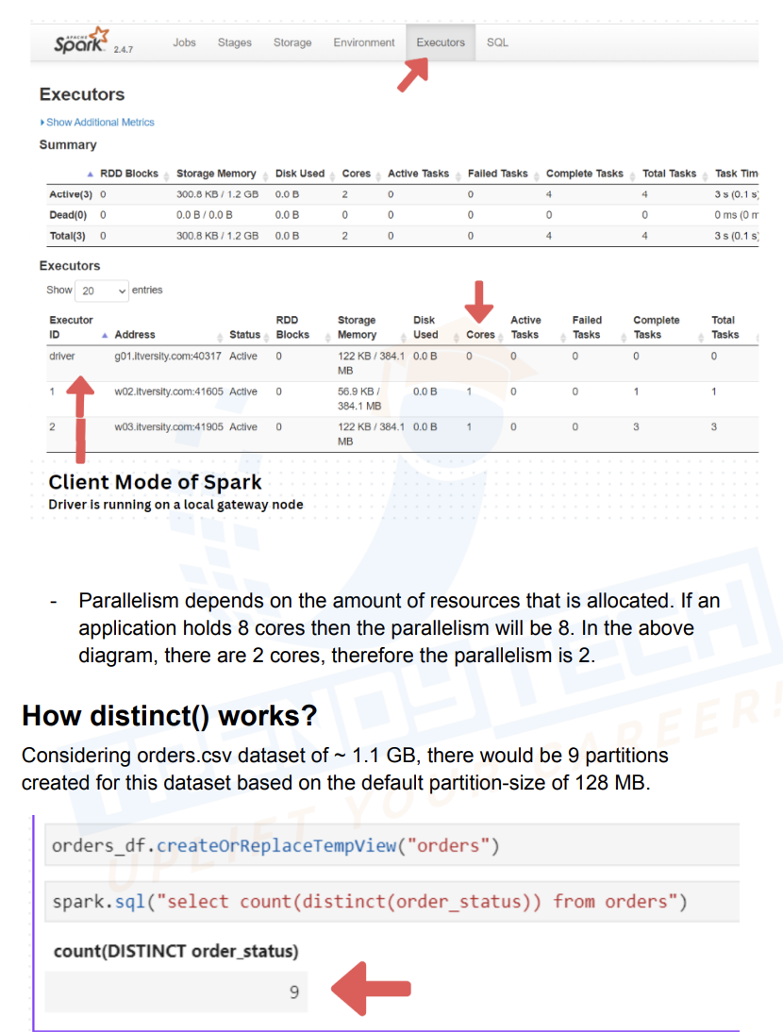

When we run above code first it creates 9 partitions and in each partition spark finds distinct of order_status, as distinct is wide transformation there will be a shuffling involved and there will be 200 partitions, suppose if there are only 10 unique values in order_status then only 10 executors will have data rest will be blank as seen below, now finally one more executor collects the data and return the results

**THIS IS WITH AQE DISABLED**

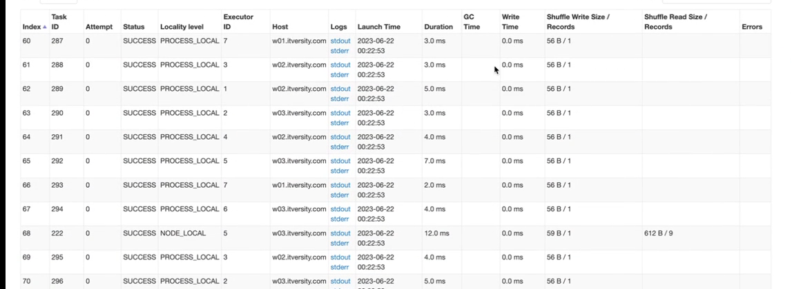

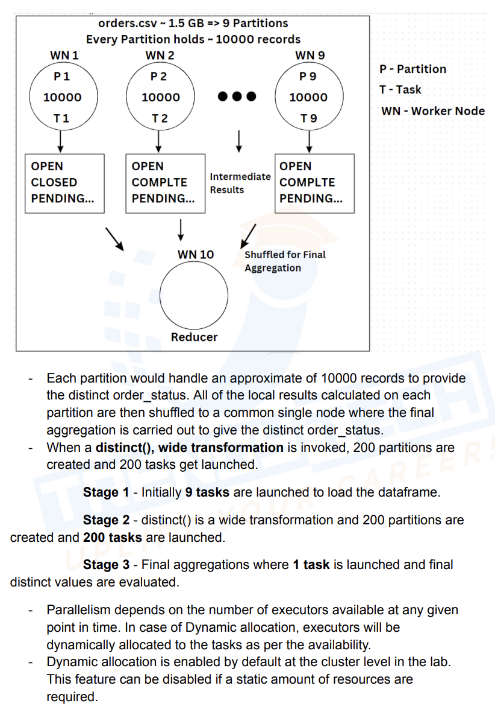

WITH AQE EANBLED WE GET LIKE BELOW, I HAVE SET DEFAULT BLOCK SIZE TO 50 MB

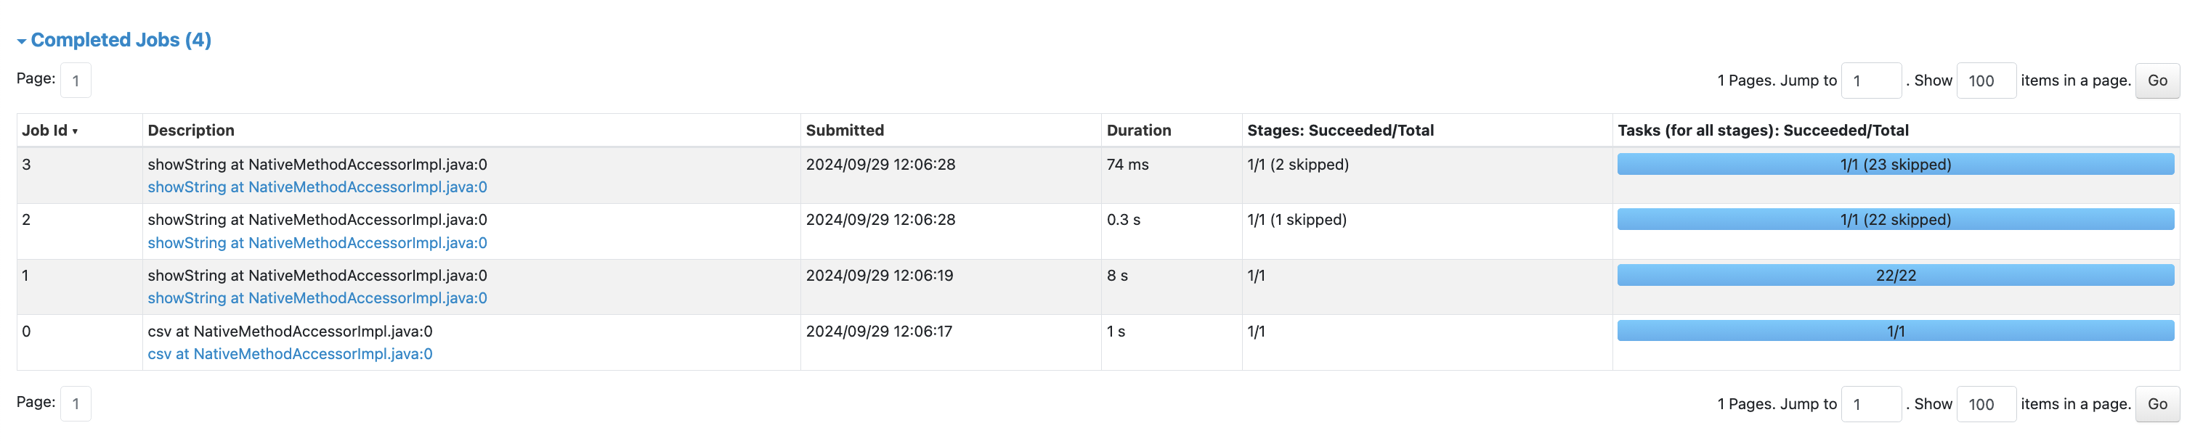

From initial partition itself it will try to find the distinct

Spark Submit:

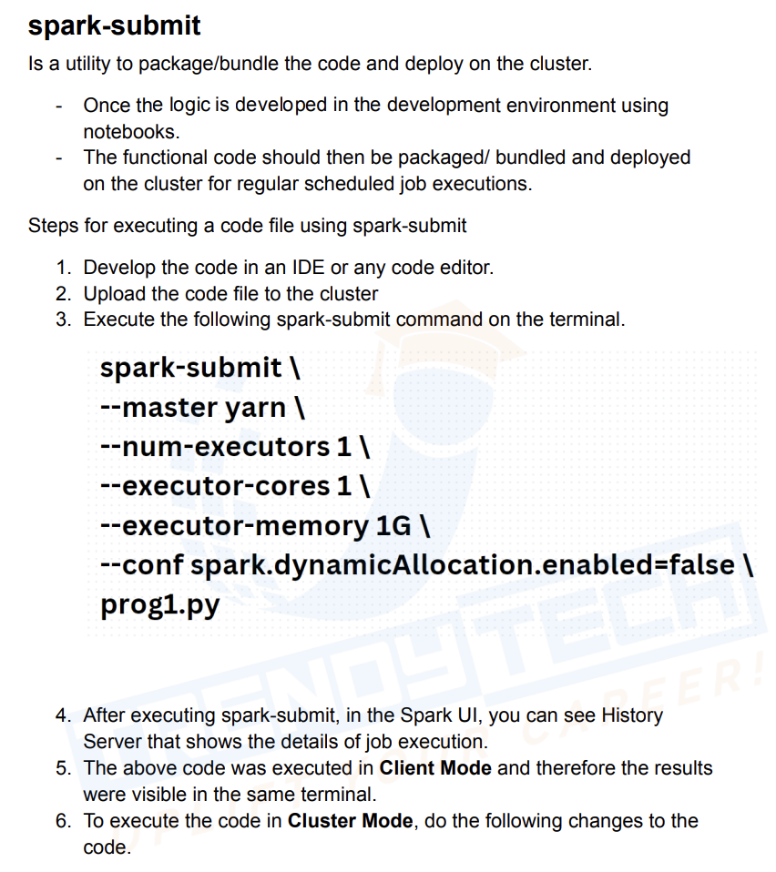

How Partitions is calculated during read

For a single file we first calculate total cores used for spark job, lets assume I use 4 cpu with 3 executors==12, then min(128MB, total_file_size (1.1GB)/12=91 MB)=91 MB, now 1.1GB/91 will give 12 partitions, similarly if I use 2 cpu and 3 executors it will be executors==6, then min(128MB, total_file_size (1.1GB)/6=183 MB)=128MB, now 1.1GB/128MB will give 9 partitions

If file size is less than 128MB, then no of partitions==no of parallelism

For Multiple Files

This formula works most of the cases

This is latest and it works

total_file_size=((over_head_size+each_file_size)*no_of_files)

total_file_size/min(default_block_size**,**(total_file_size/total_cpu_count))

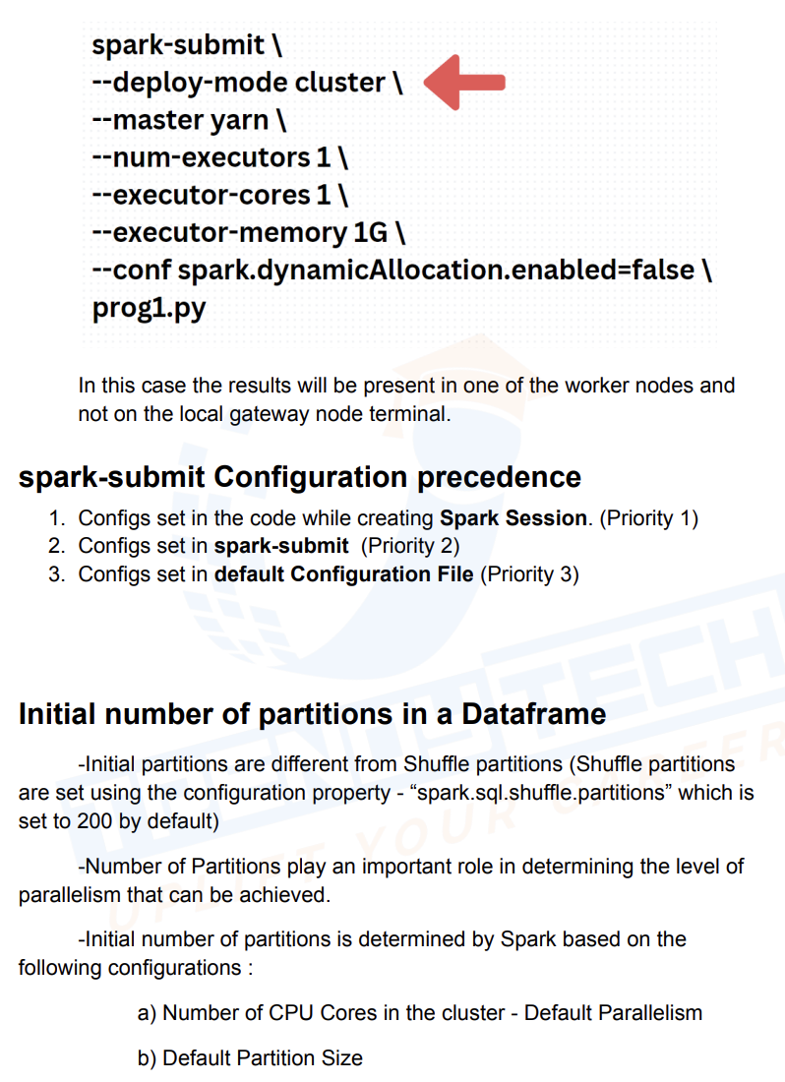

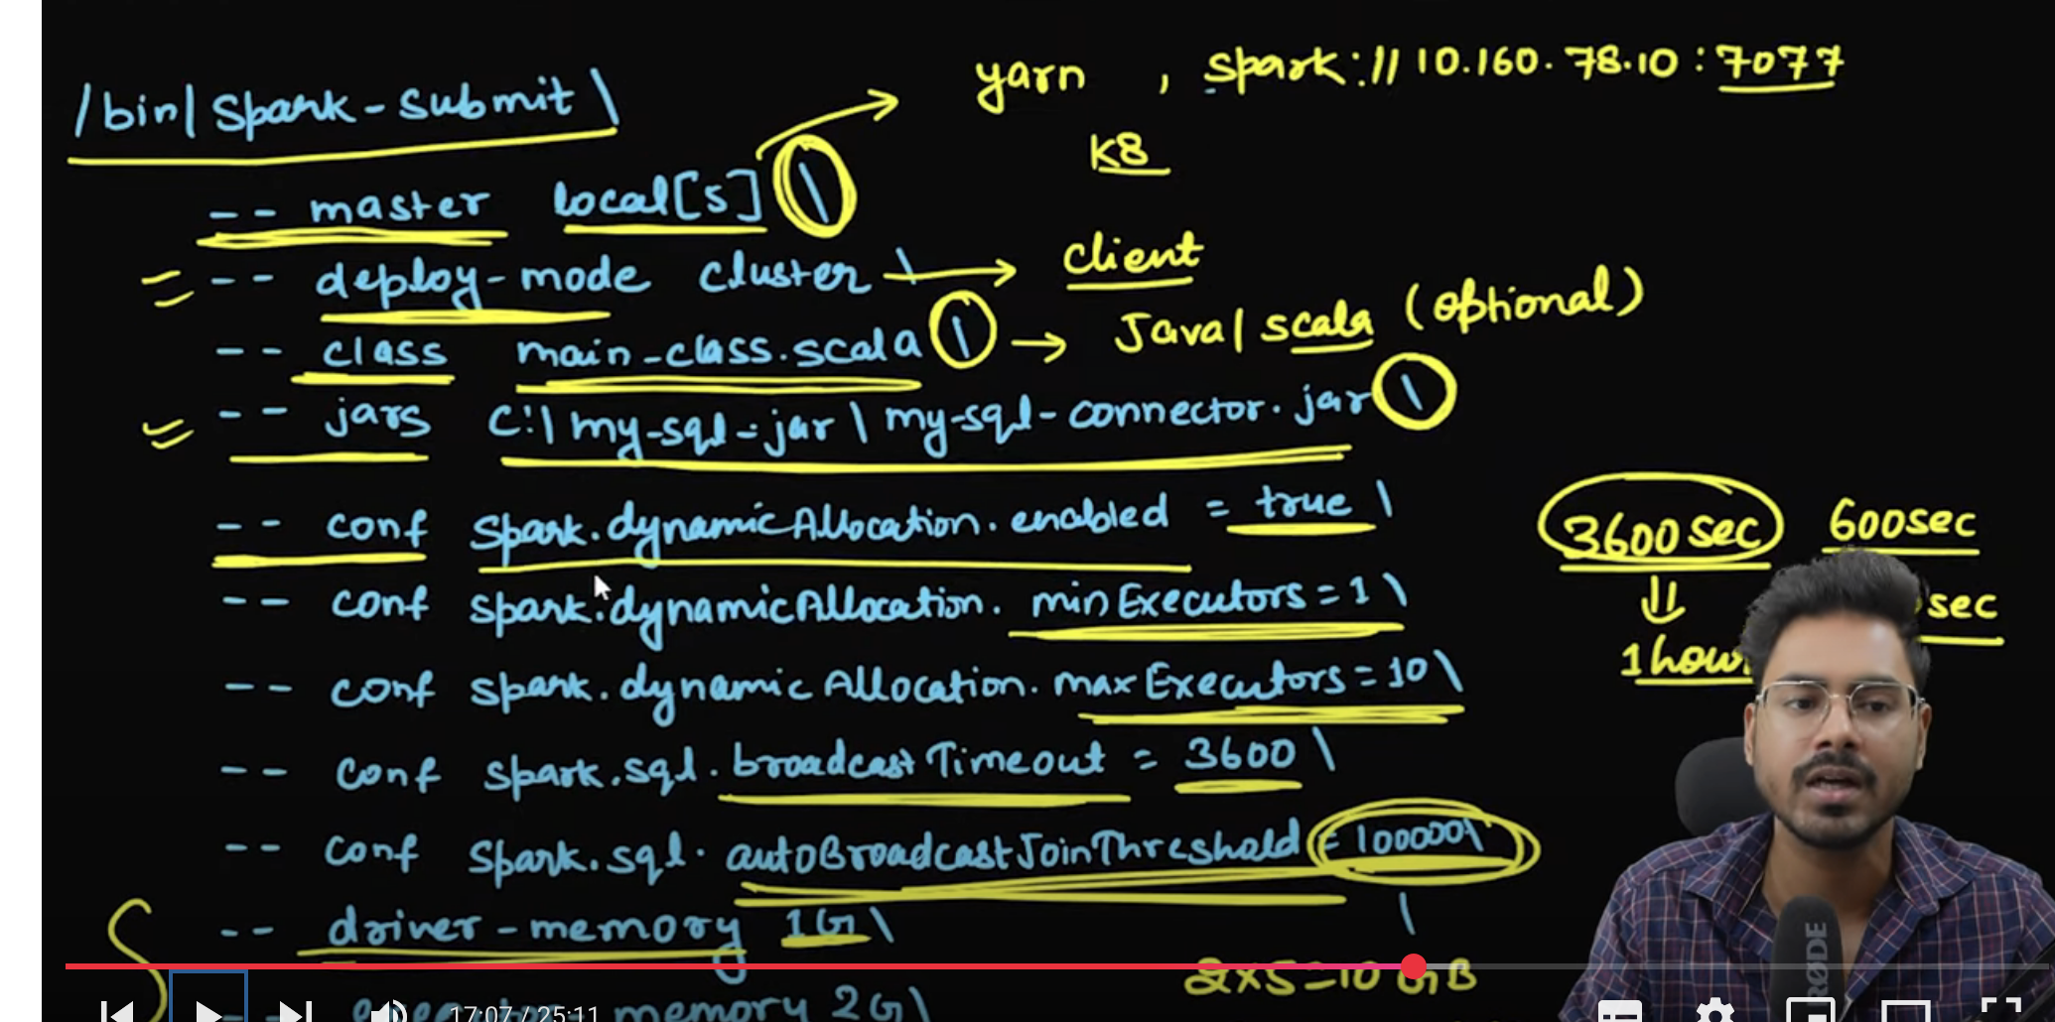

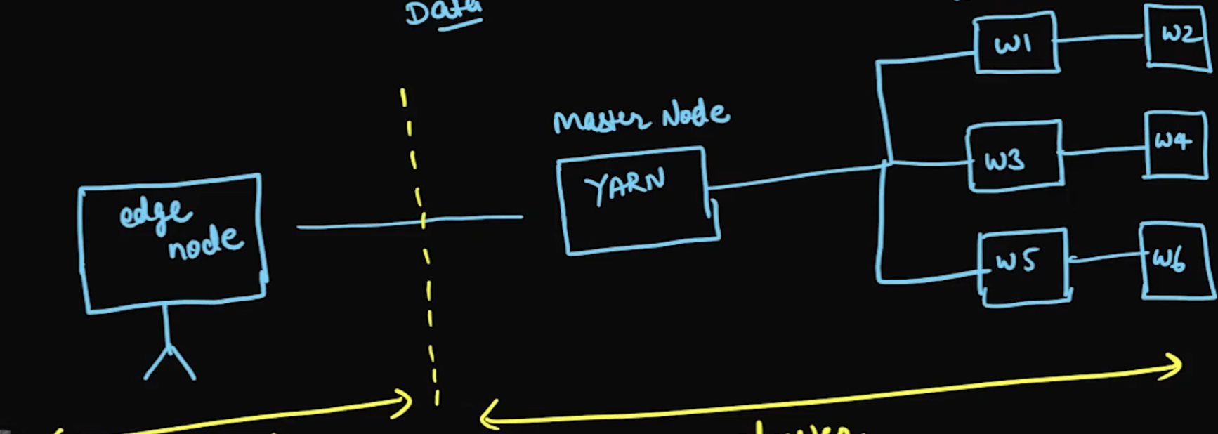

Spark Optimization:

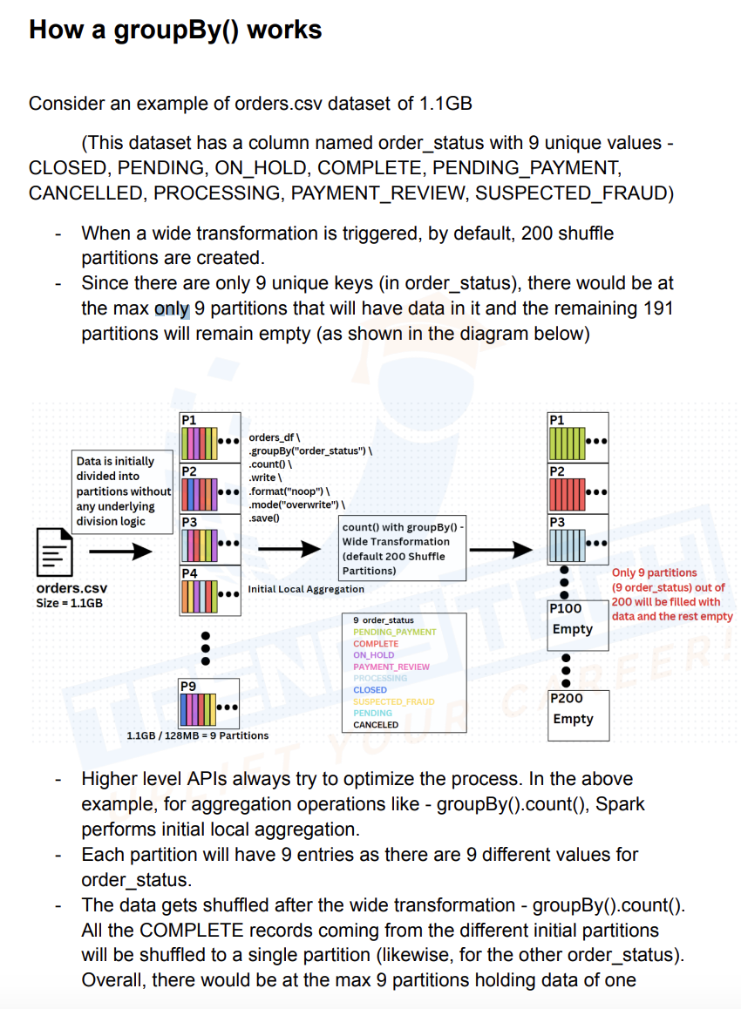

Joins:

Inner Join:

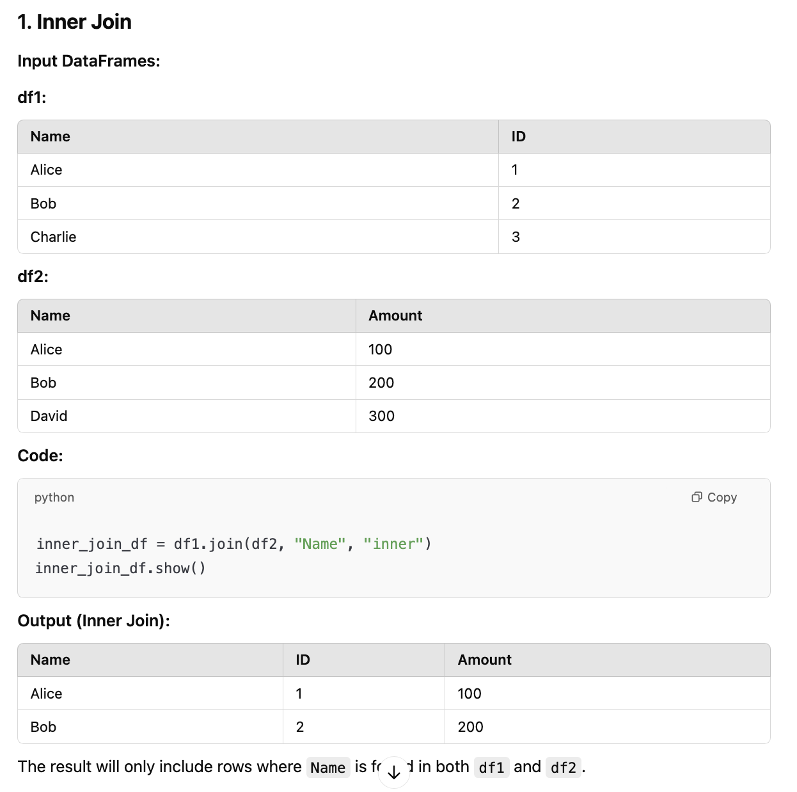

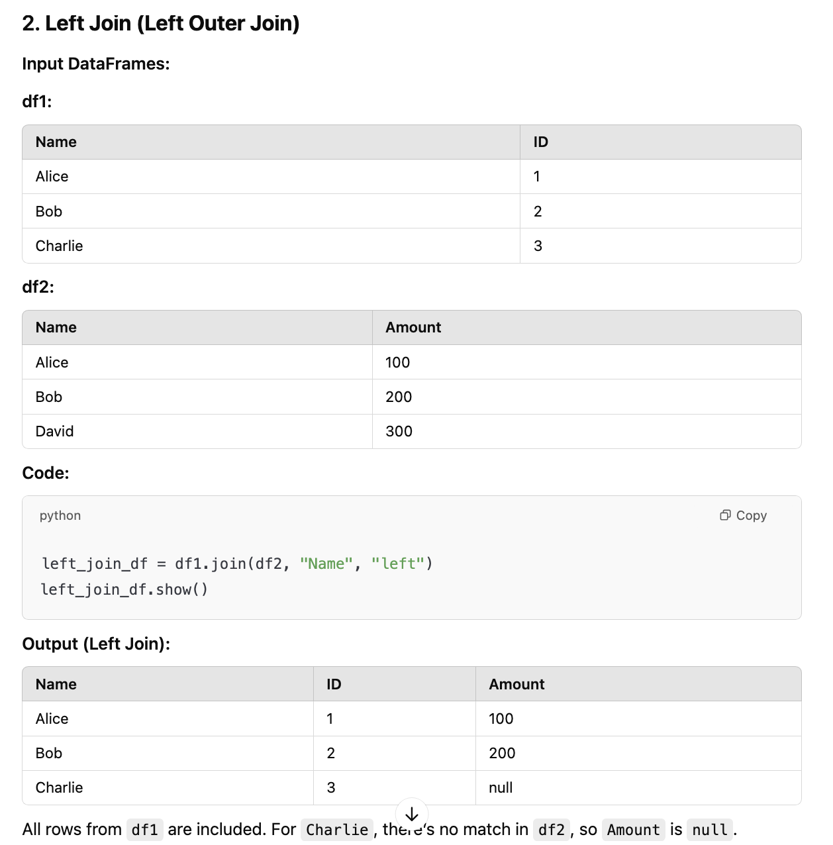

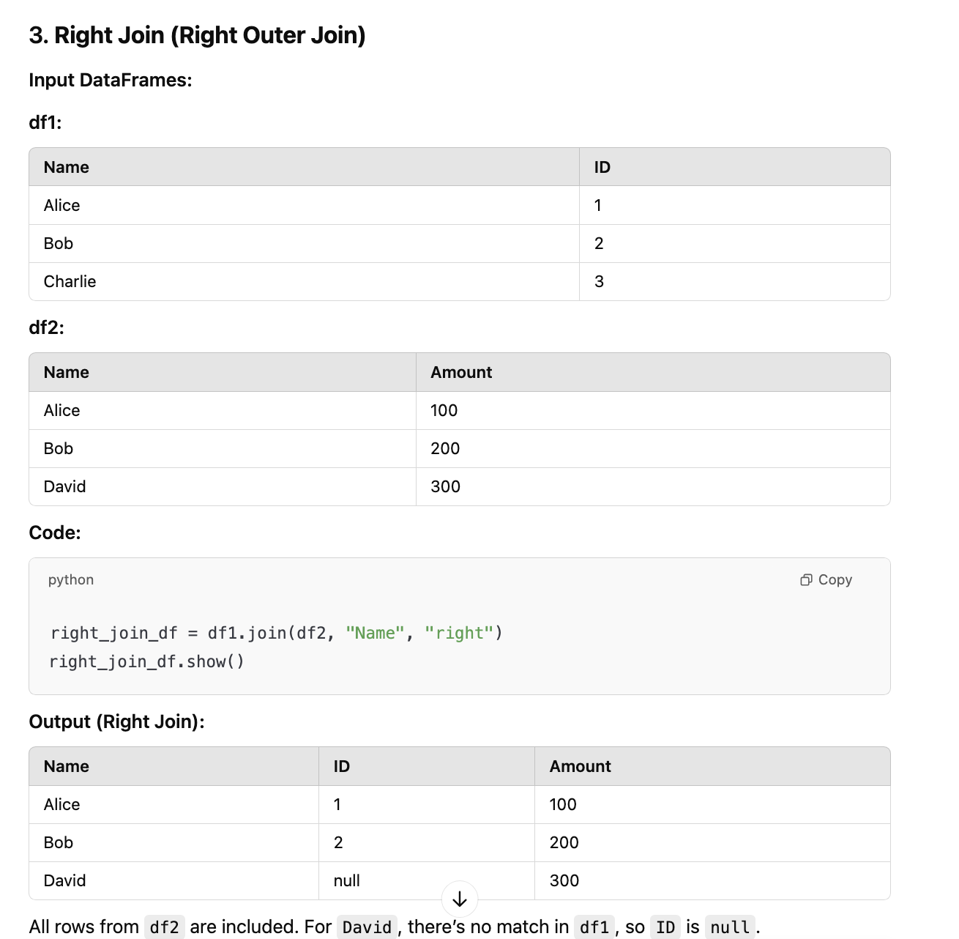

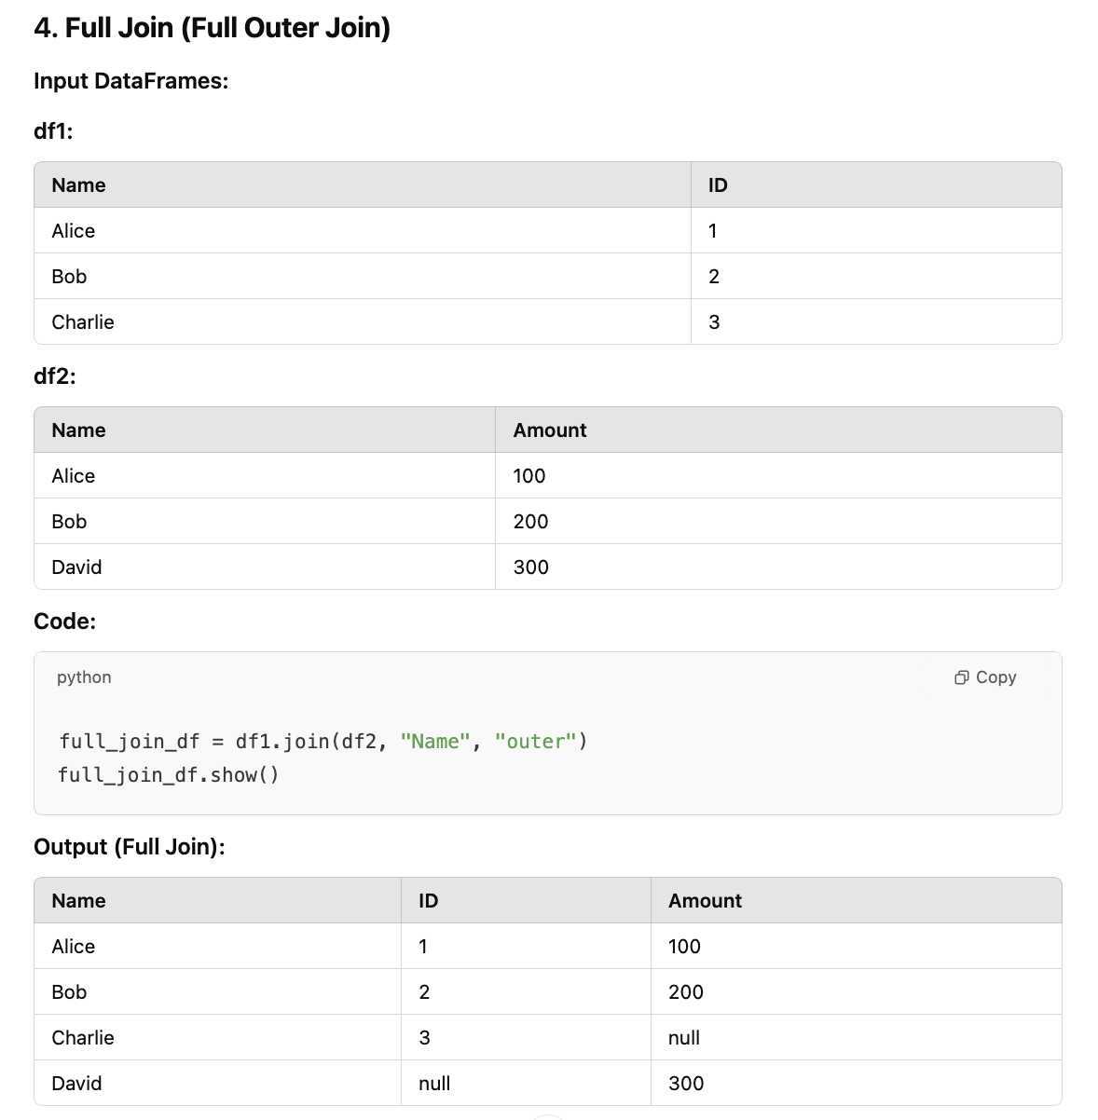

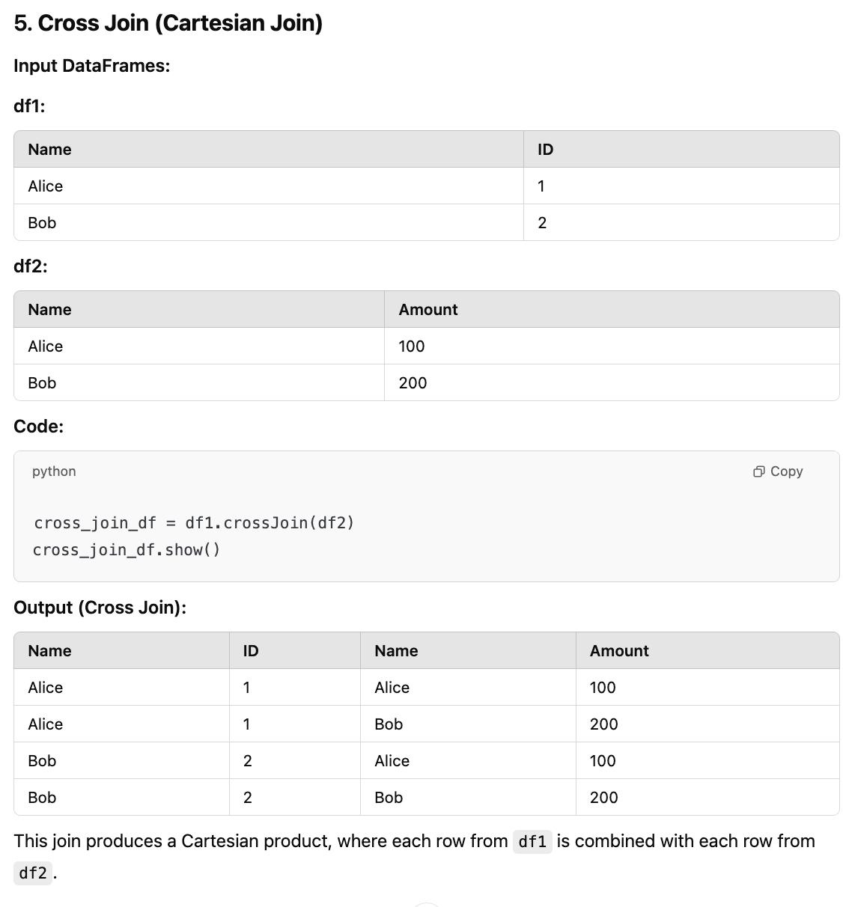

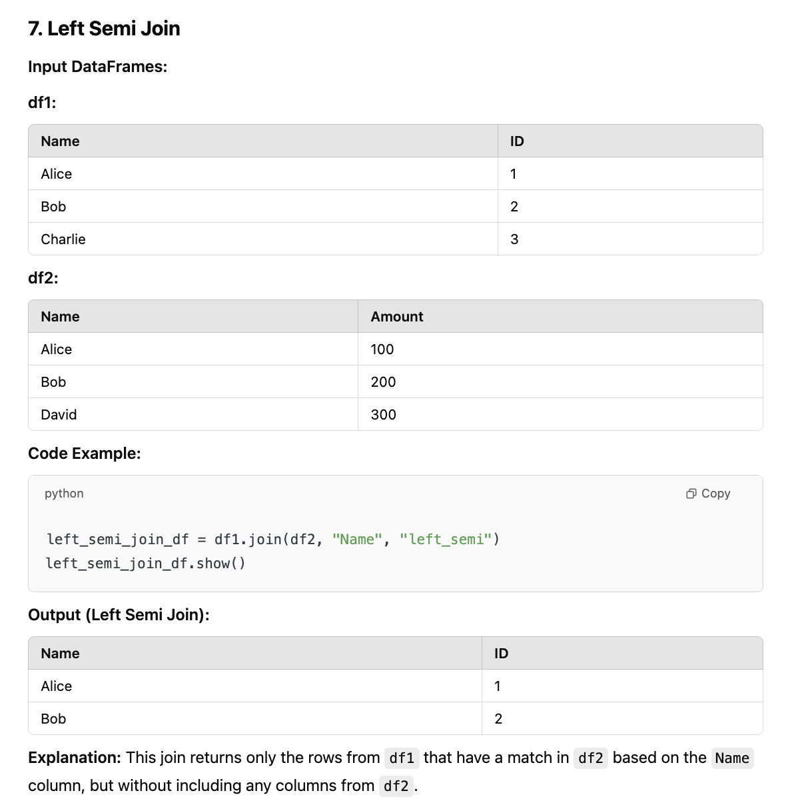

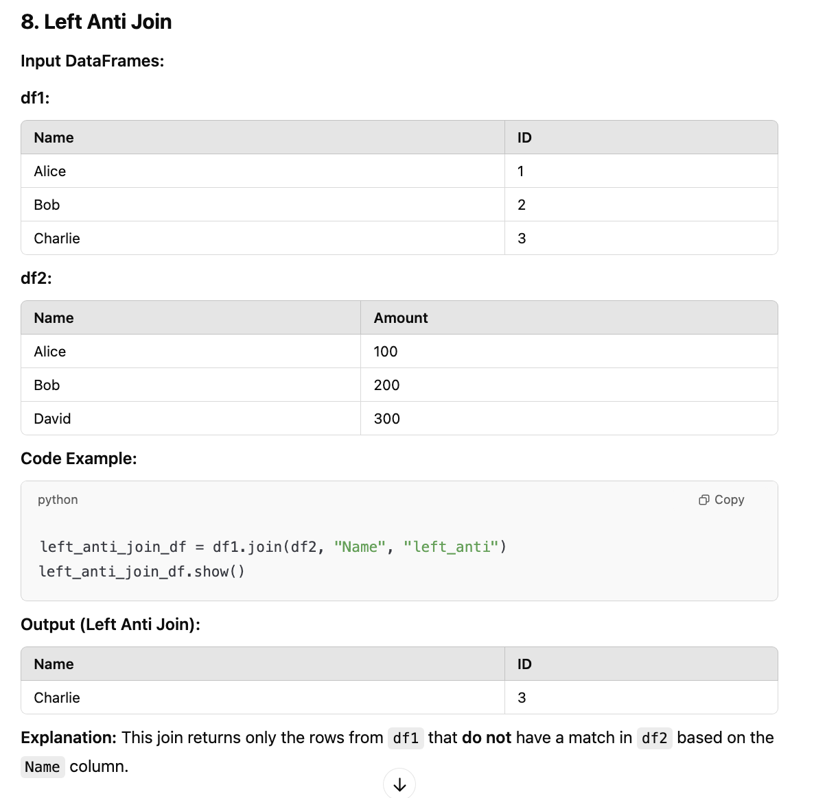

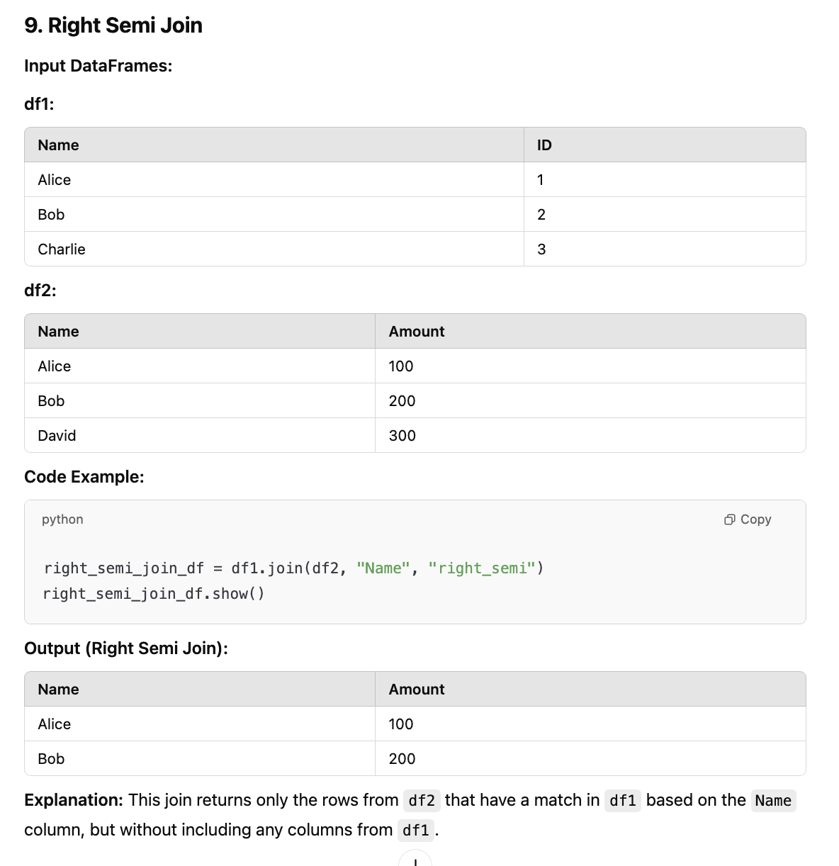

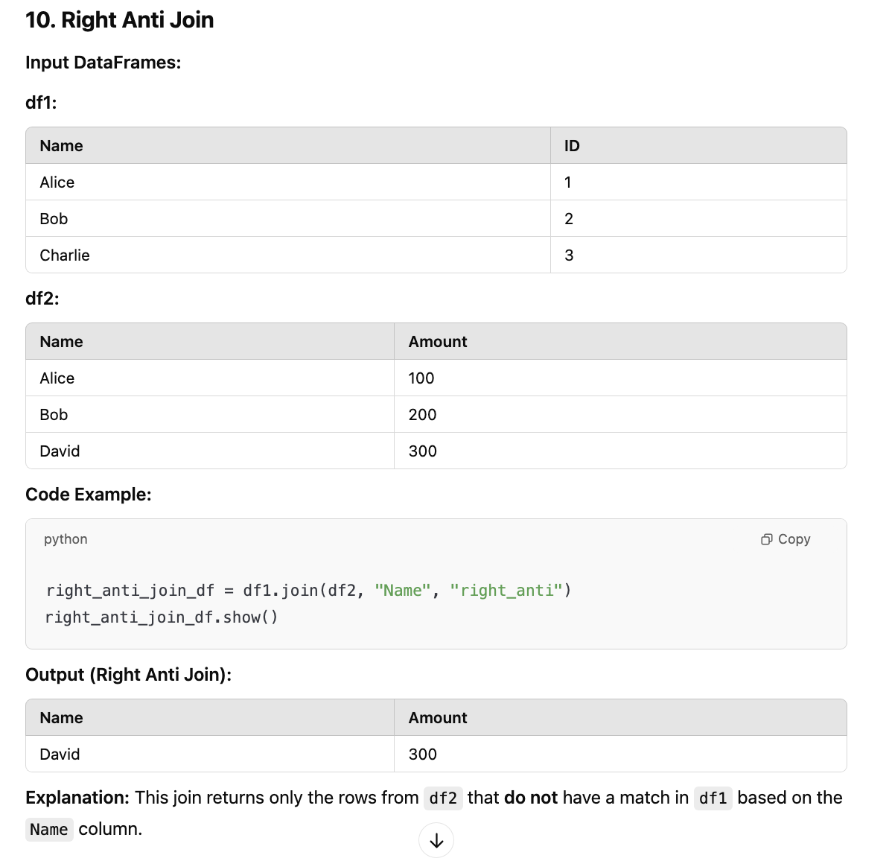

Different Join Strategies:

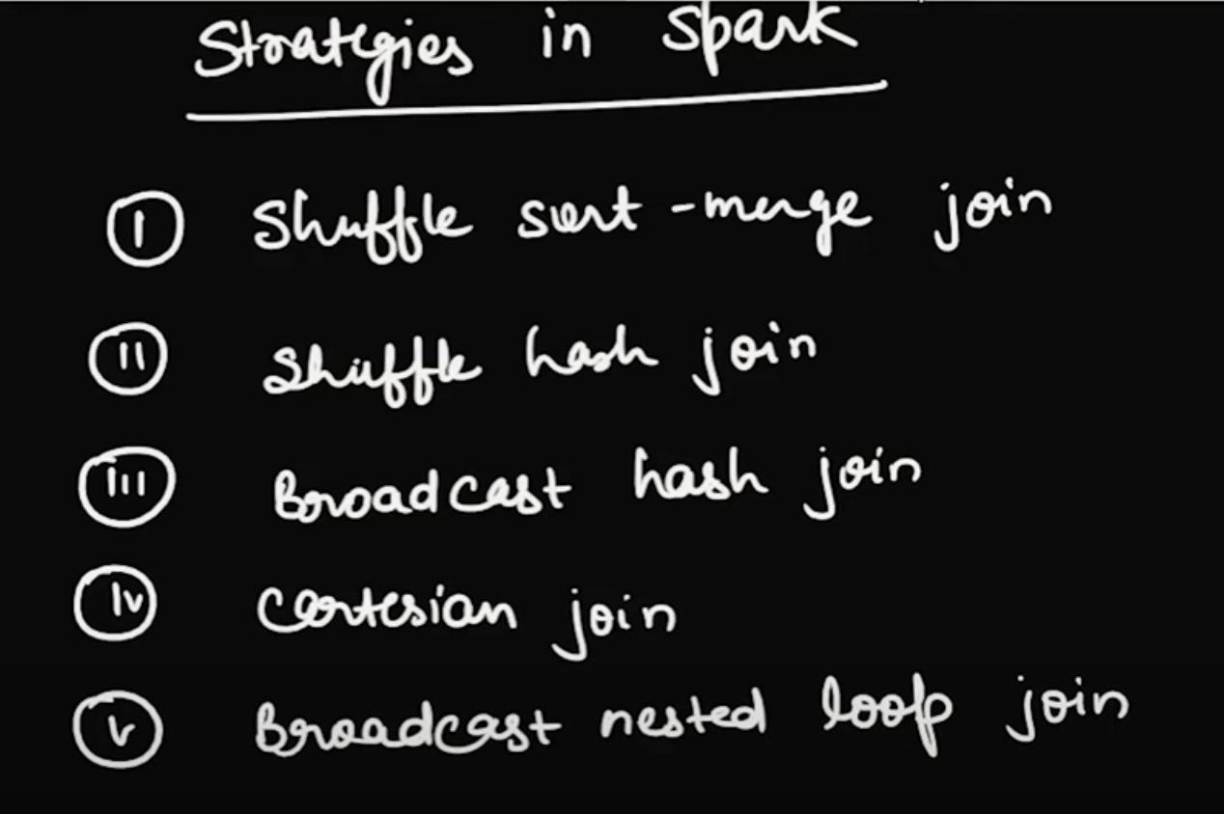

Broadcast Hash Join

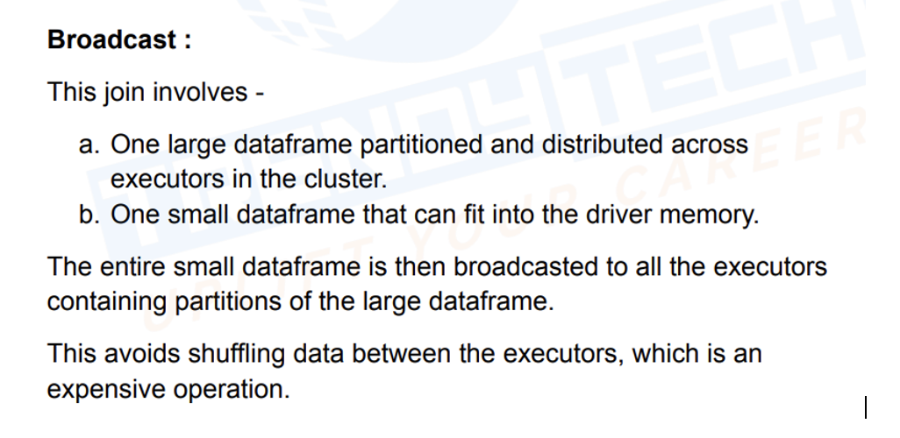

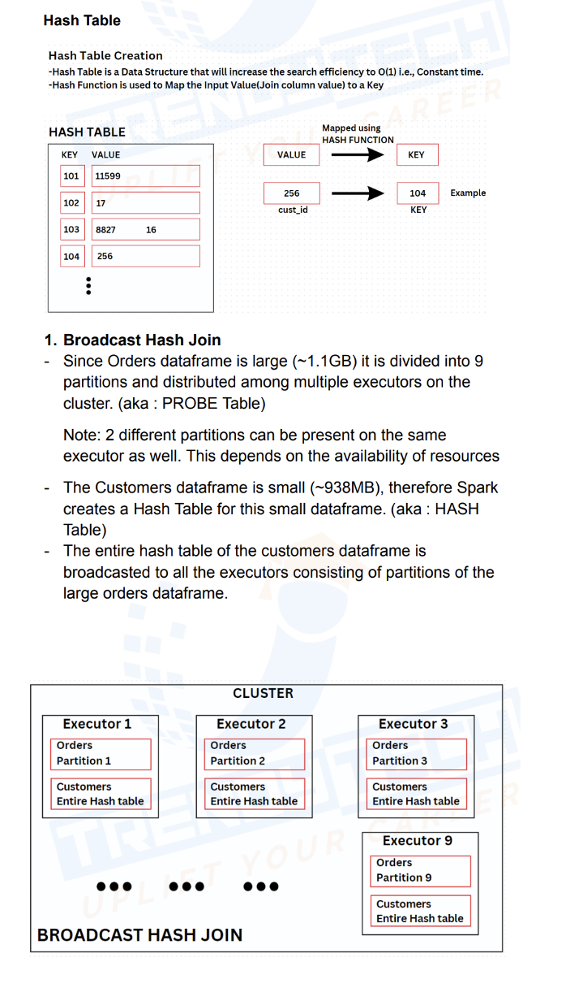

Shuffle Hash Join

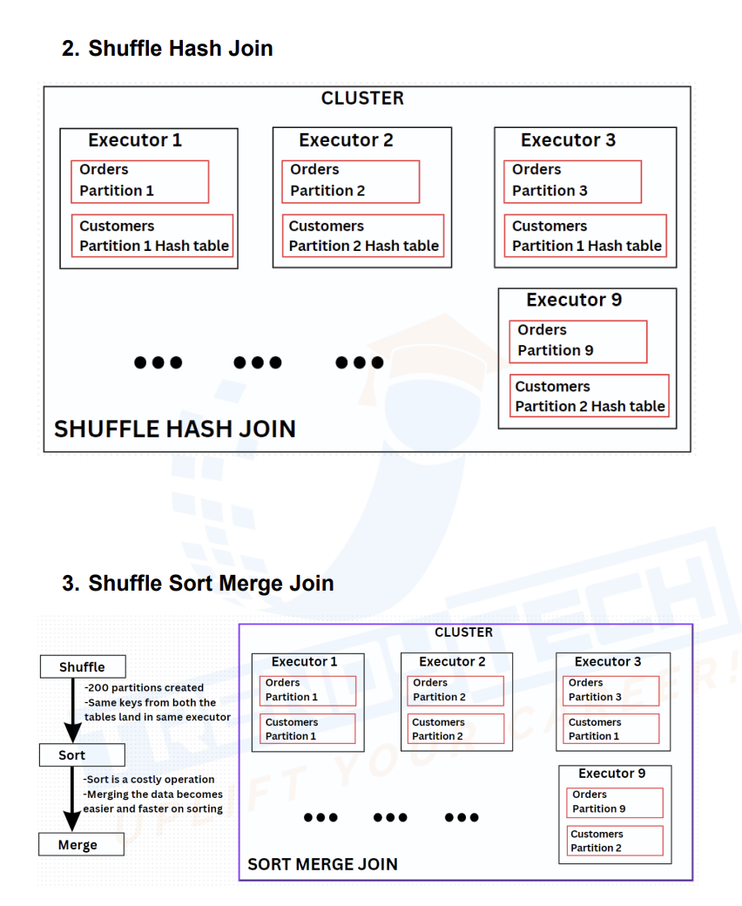

Shuffle hash join

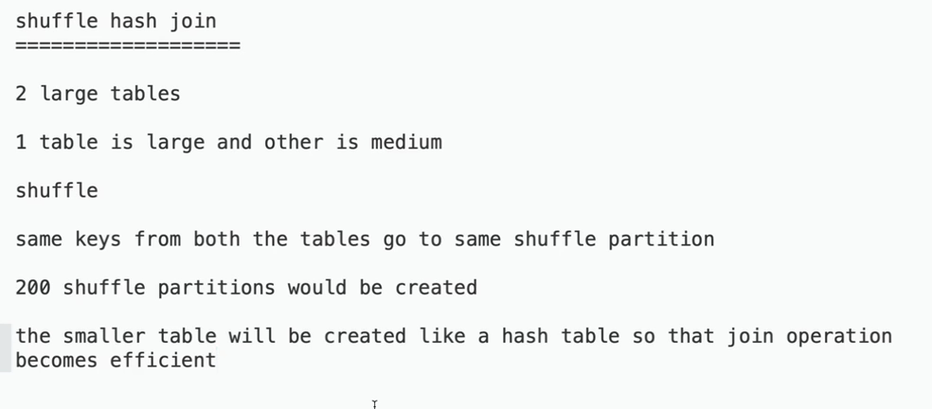

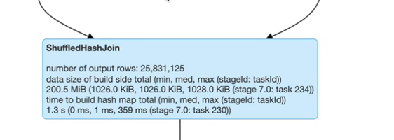

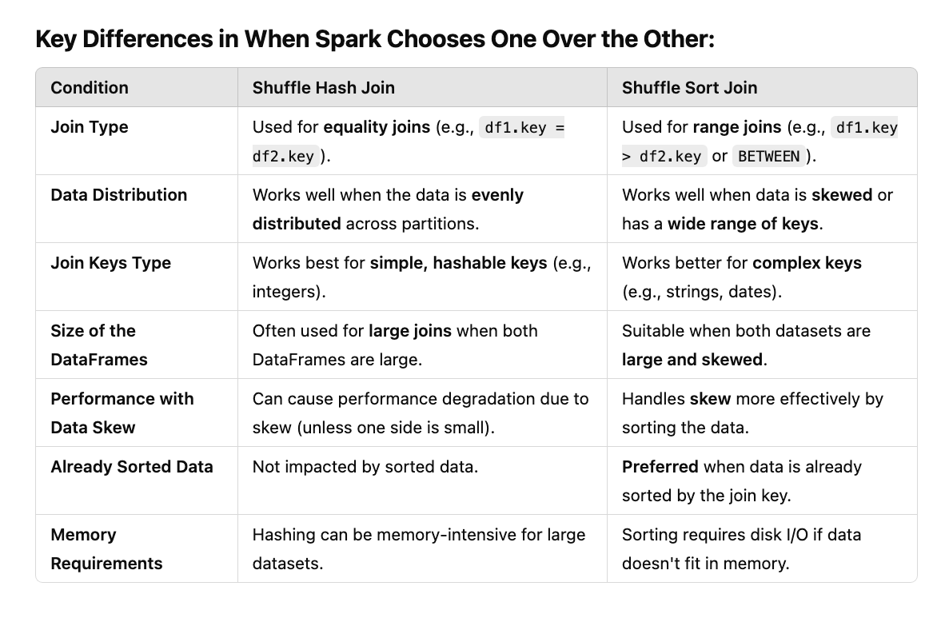

Join Stratagies:

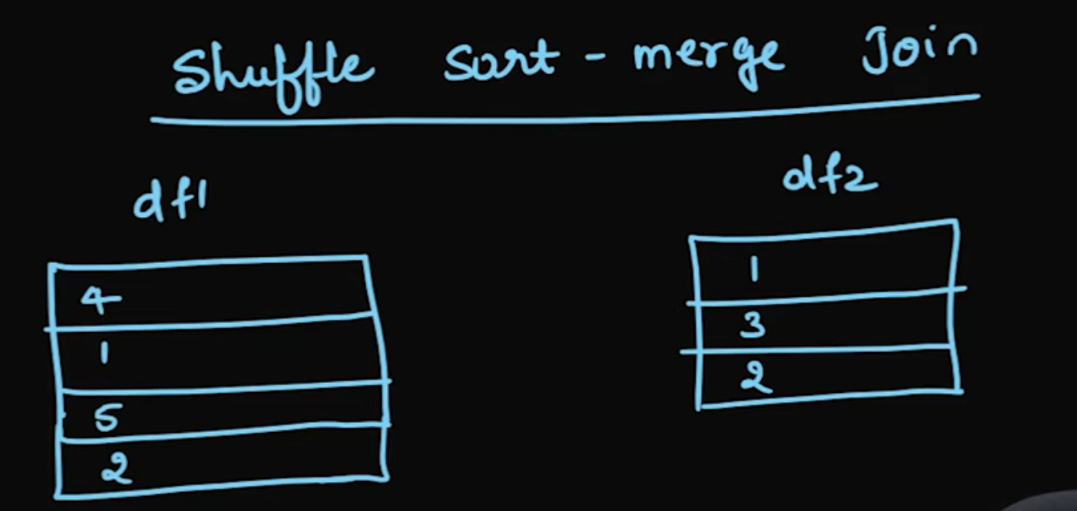



After Shuffle sort is done

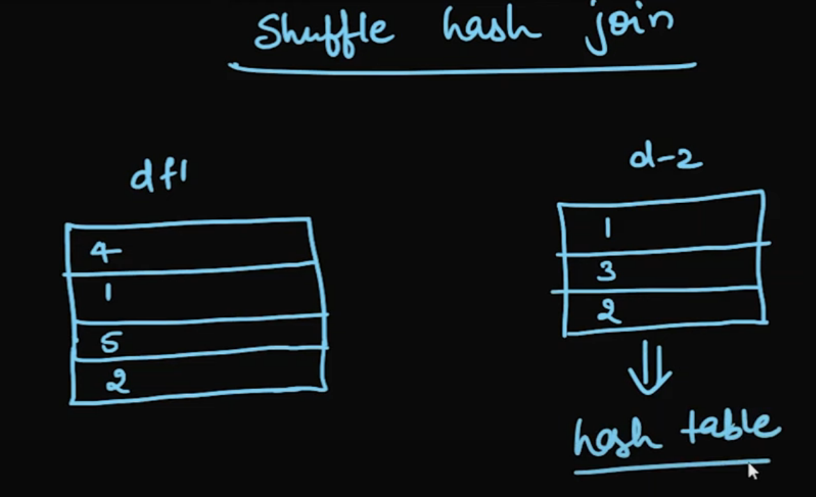

In shuffle hash once shuffling is done, it will consider smaller table and create hash table out of it and it happens in-memory and it will compare with hash table

Broadcast Hash Table

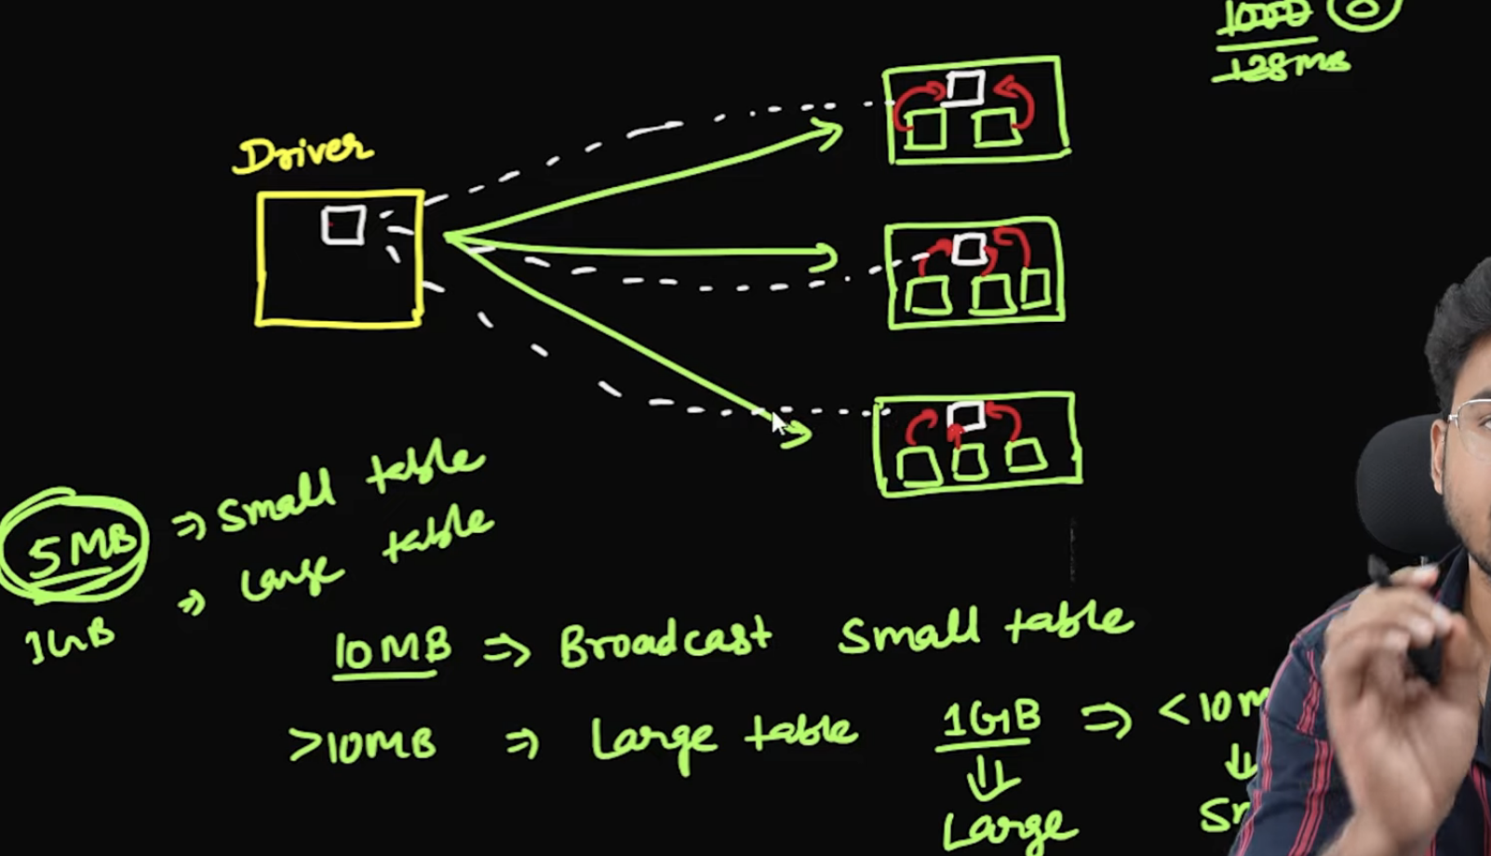

Driver will broadcast df into all executors

During join if join column has null first it will filter out

JOIN Of Two large Tables

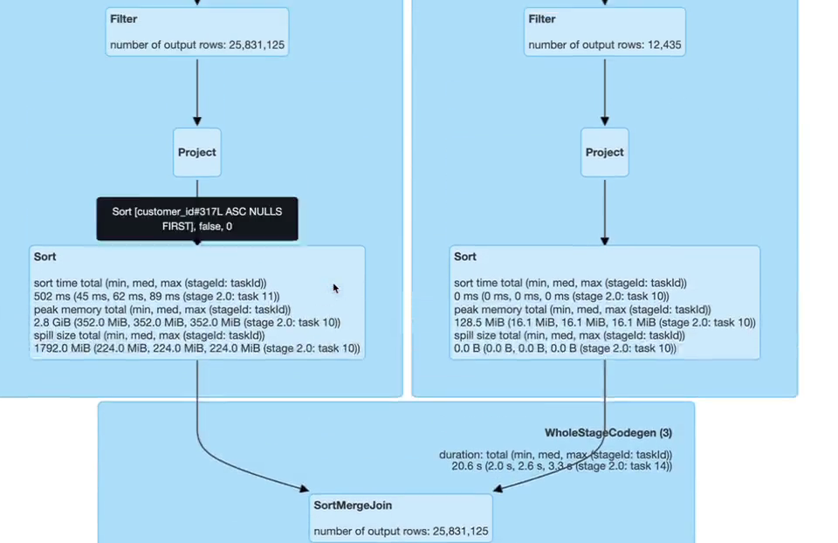

When we do bucketing of 8 files, it creates 8 files for each partition

When we do bucketing there will be no shuffling involved, As there are multiple files as part of each bucket, hence there will be some level of sorting involved

Sort Merge Bucket Join works when both the table are bucketed with same key and number of buckets are same across both the table

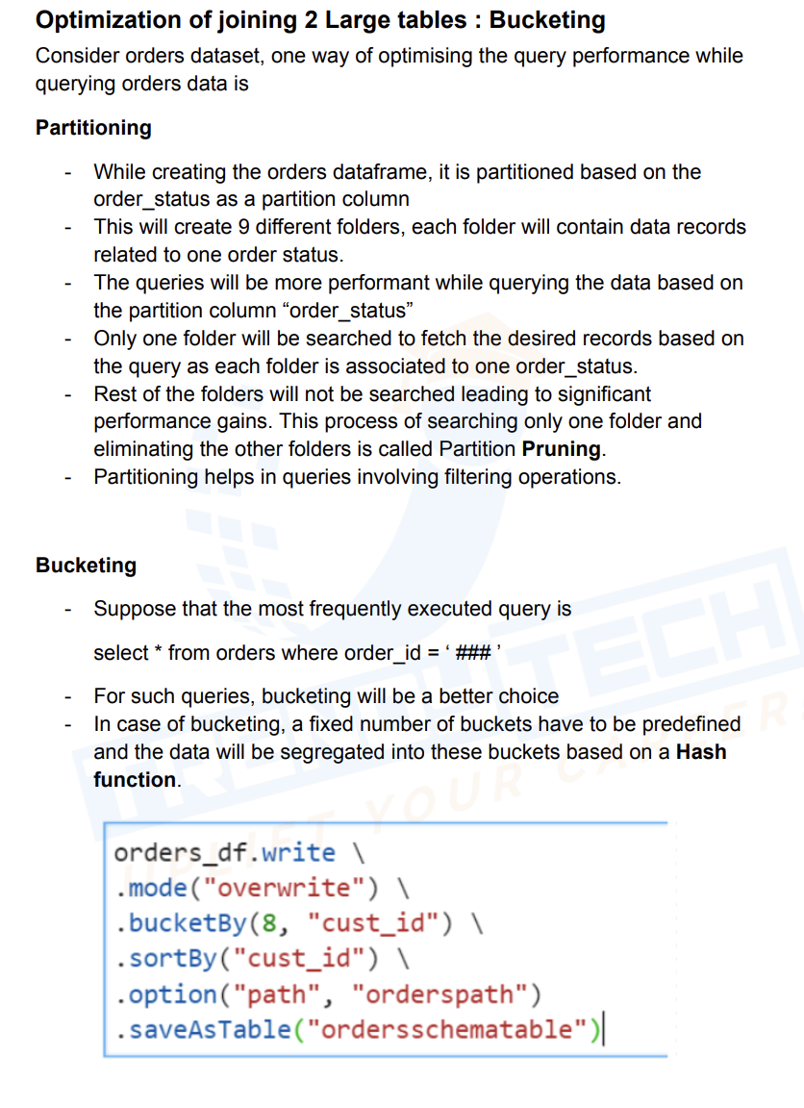

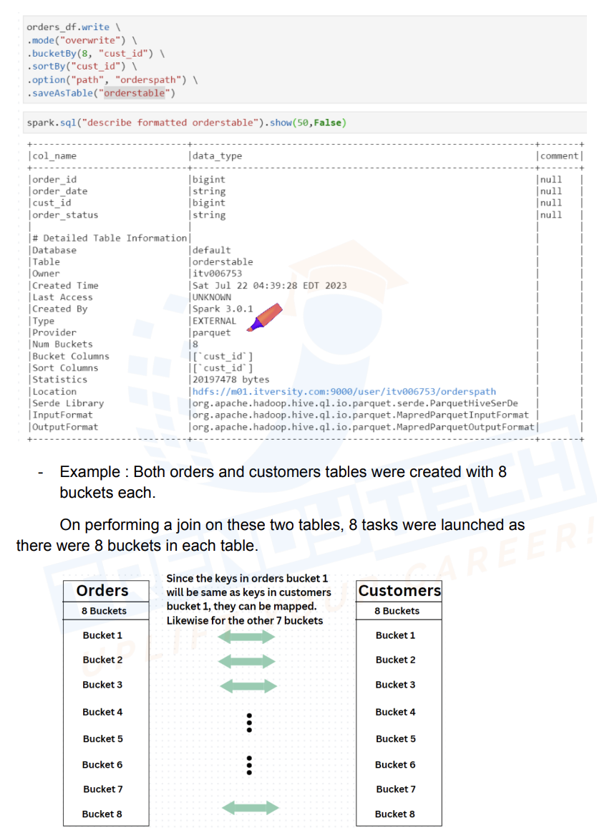

Spark Memory Management:

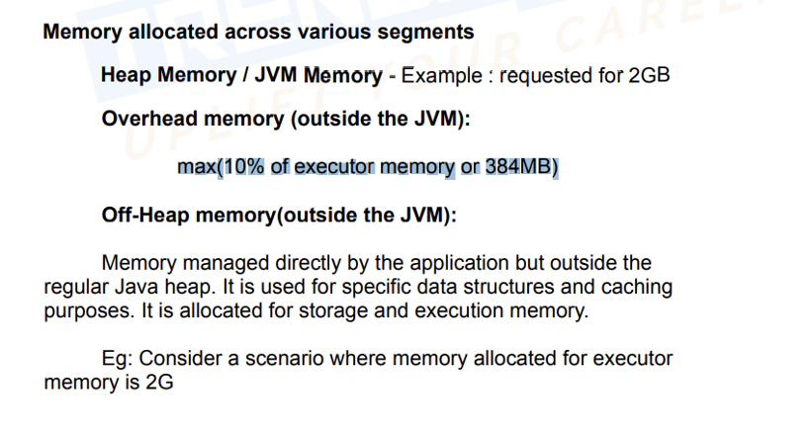

AQE:

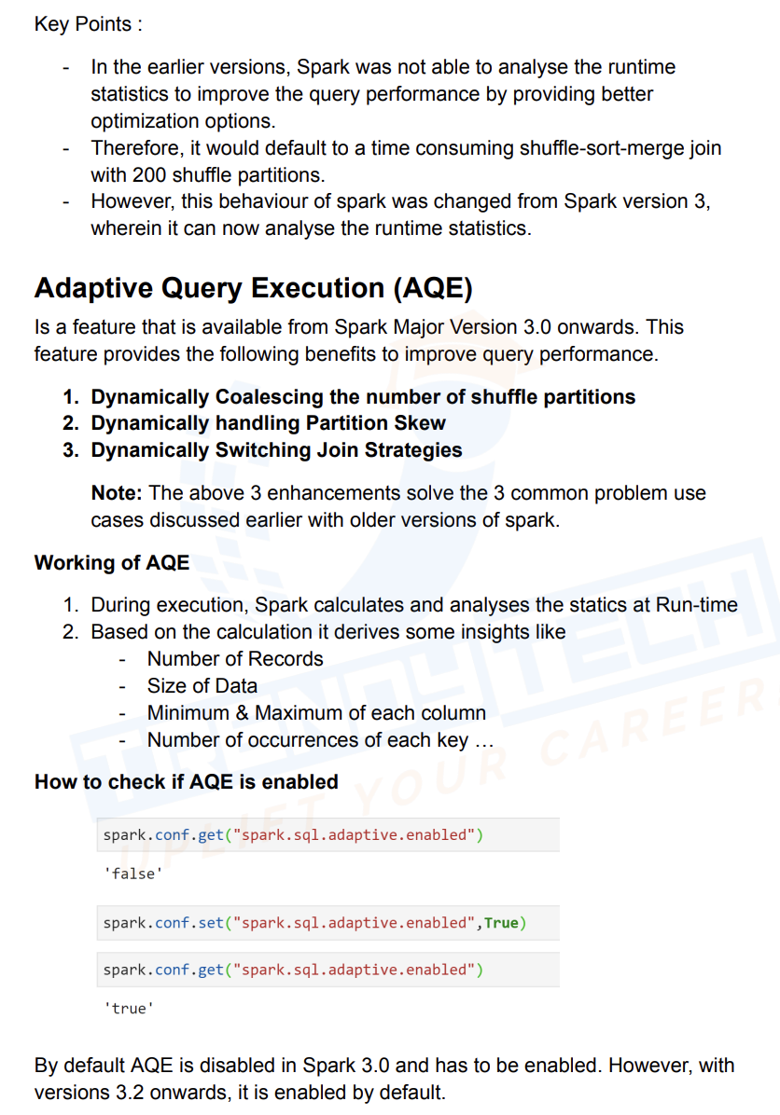

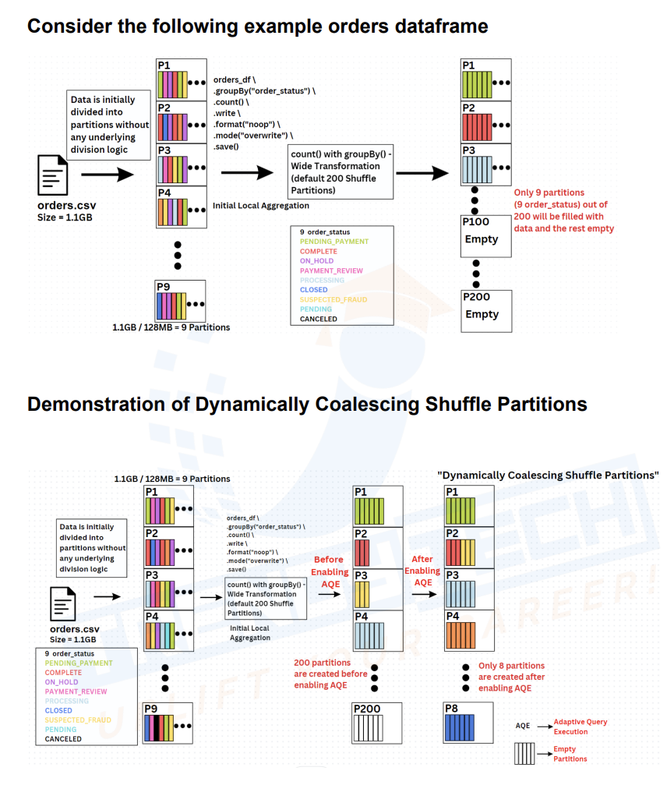

After dropping shuffle partition when partition size is less, it merge those two partitions

Suppose If one of the partition is too big then it will split the skew partition



Here it will split skew partitioned data into 2 and replicates customers data so that join can happen faster

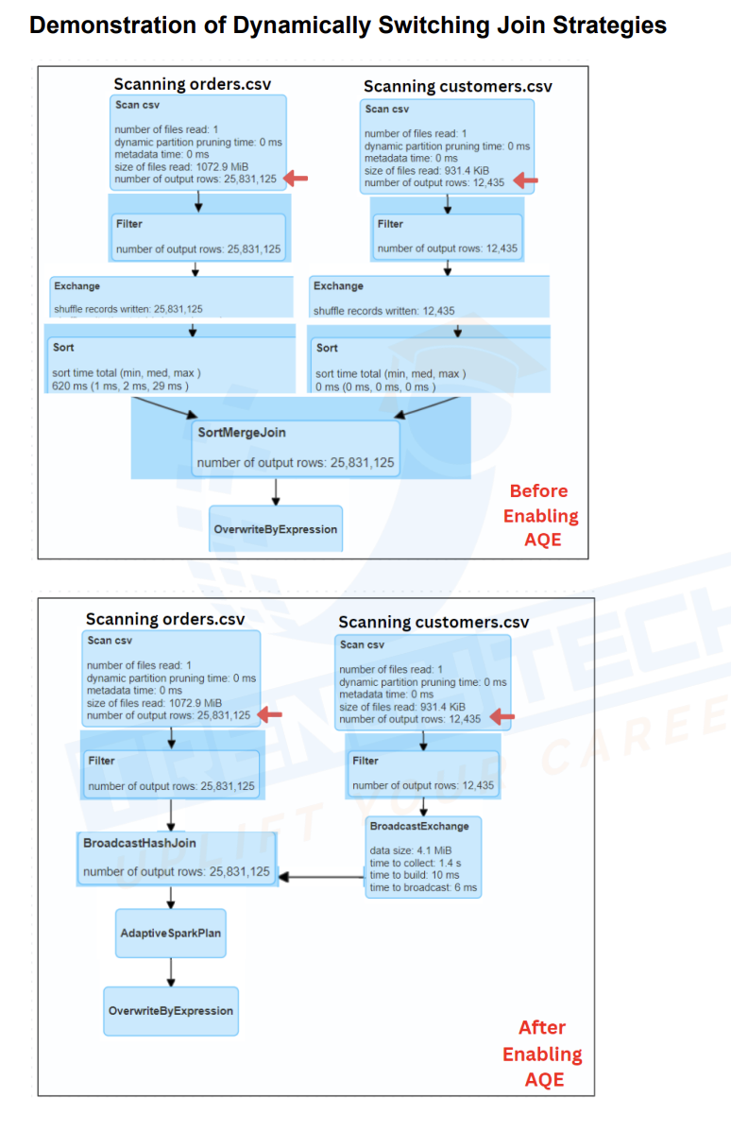

When we request a memory of 2GB spark adds additional max(384MB,10% of executor memory) as overhead. Overhead memory is a Non heap memory which is outside JVM.

Heap memory is controlled by JVM

Overhead Memory

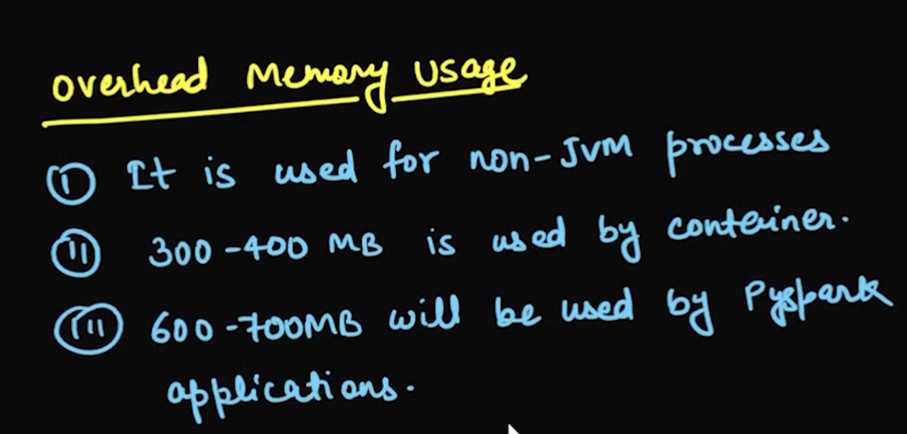

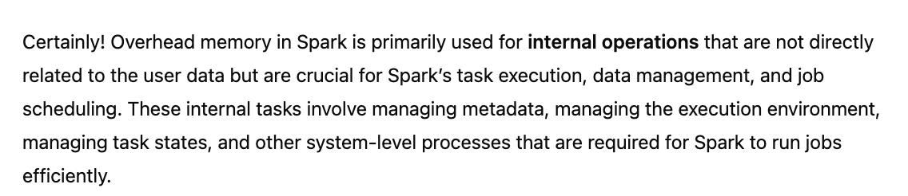

Reserve Memory:

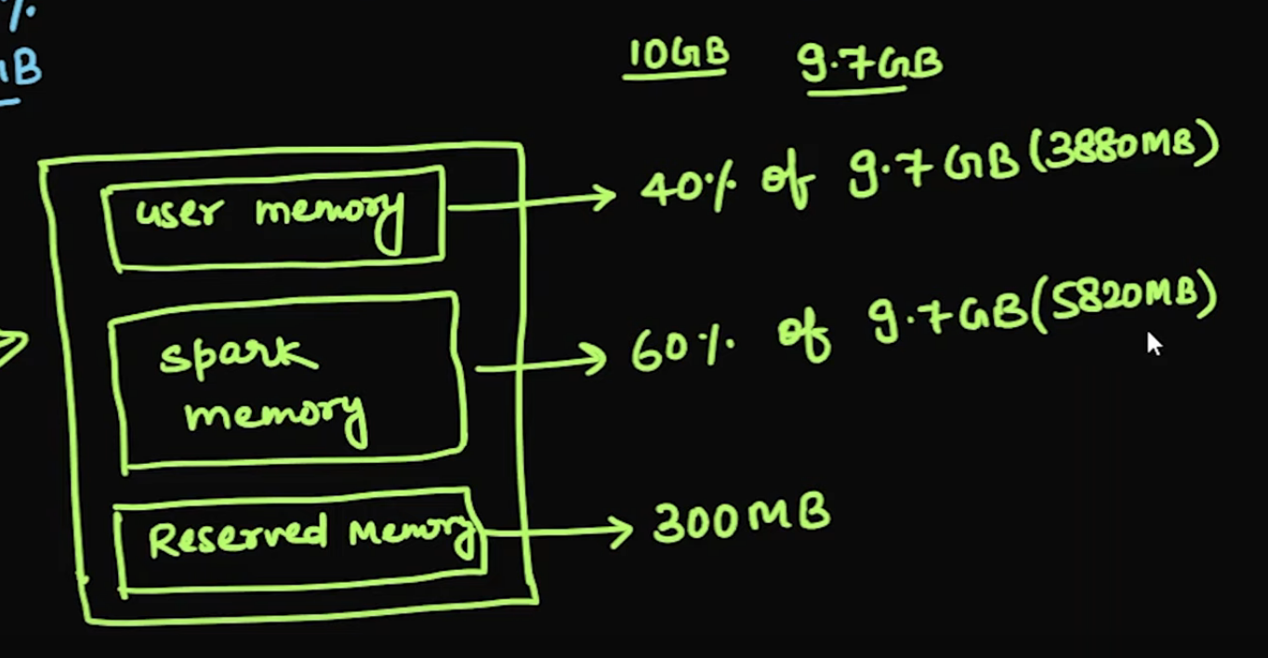

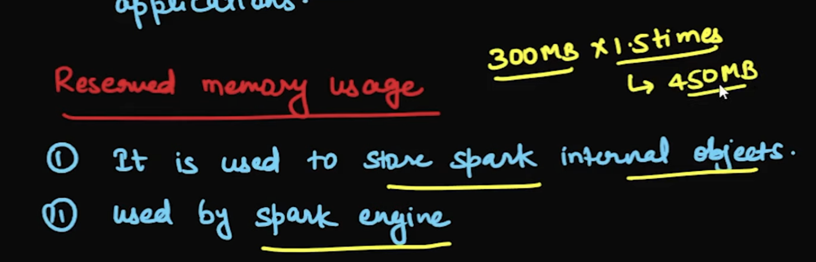

User memory is used for storing hashmap during broadcast join, Storage memory is used during cache or persist, execution memory is for join and other transformation, reserved memory is more for spark engine

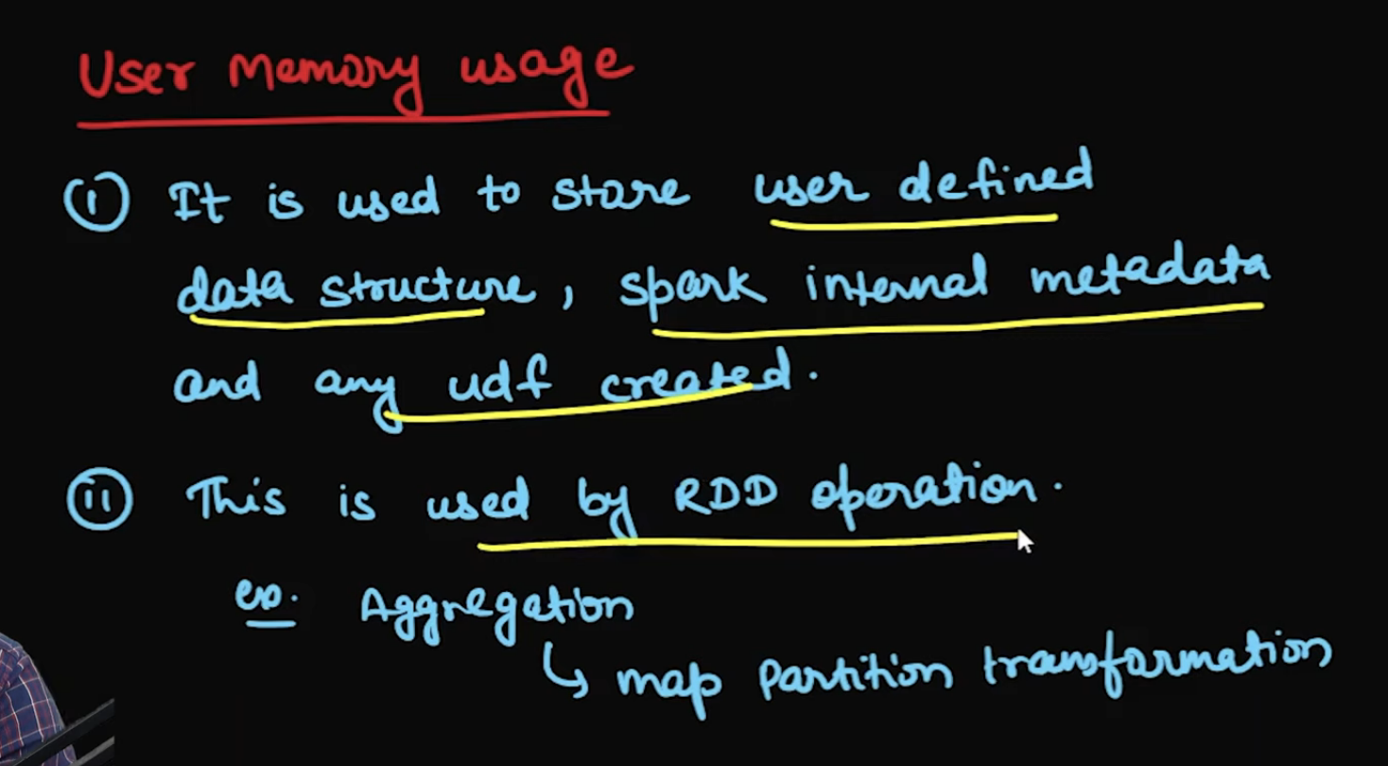

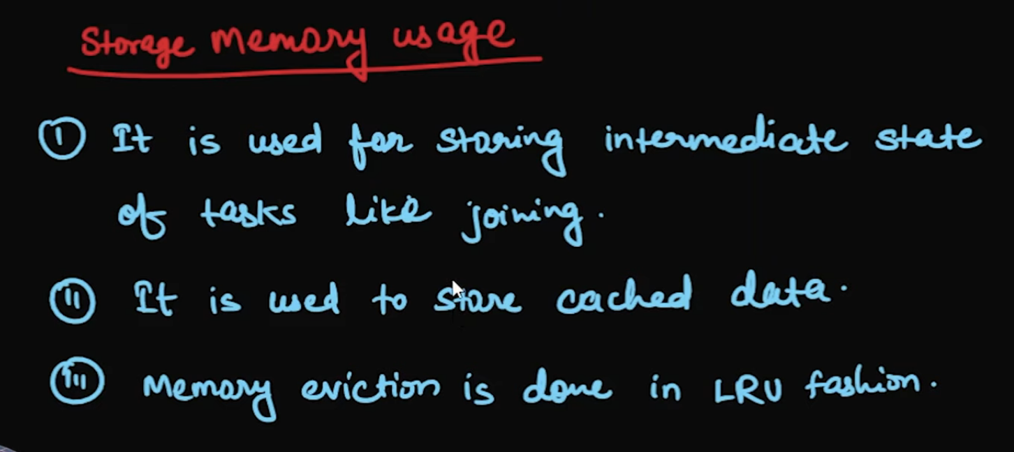



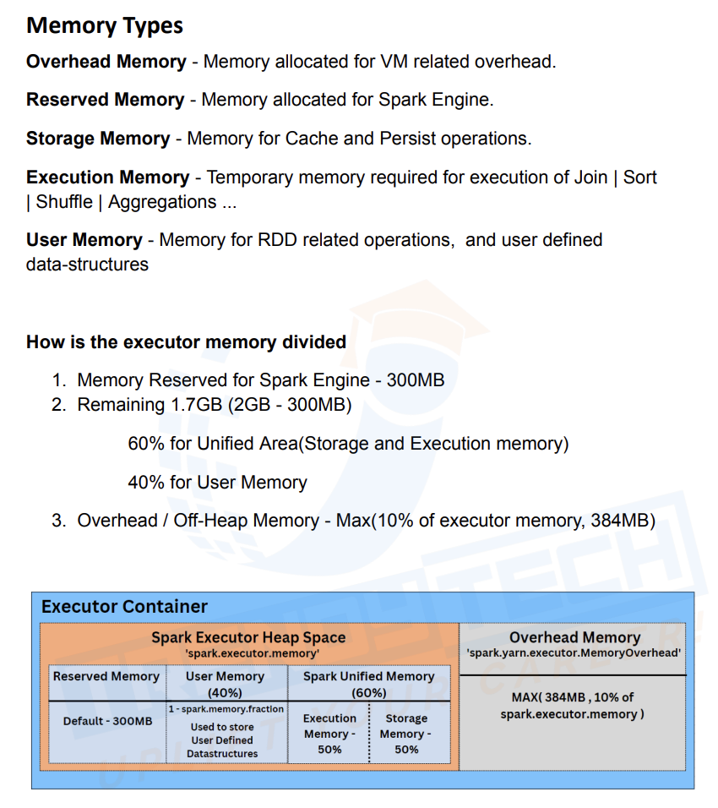

Suppose storage memory has used around 700MB, If execution memory requires 500MB then storage memory is evicted but viceversa can’t happen as execution memory can’t be evicted

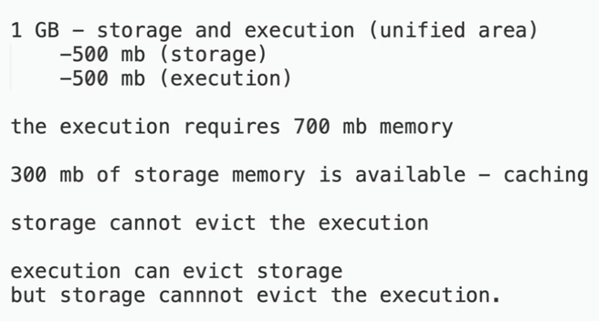

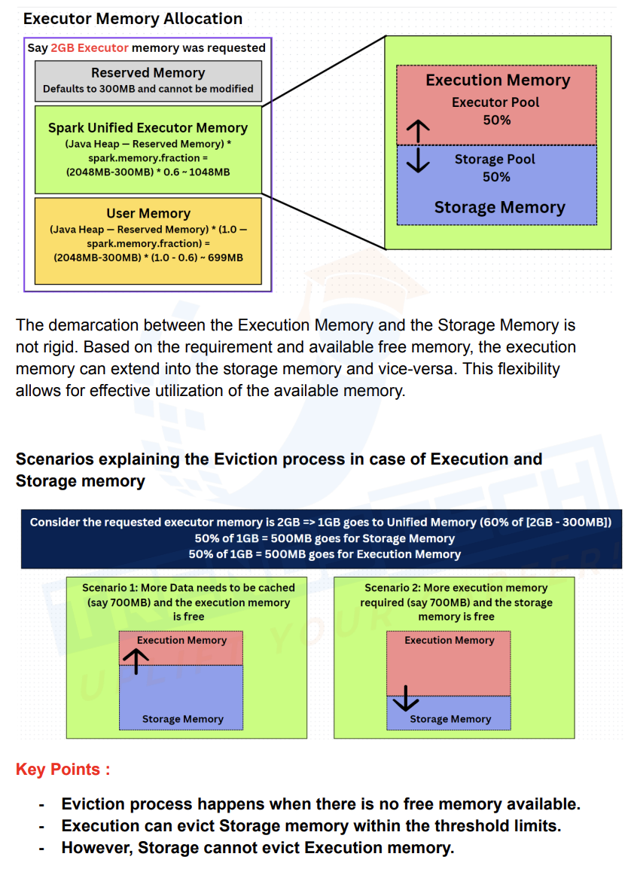

If we are adding some python related code then we would need to add some memory to it which is nothing but pyspark memory

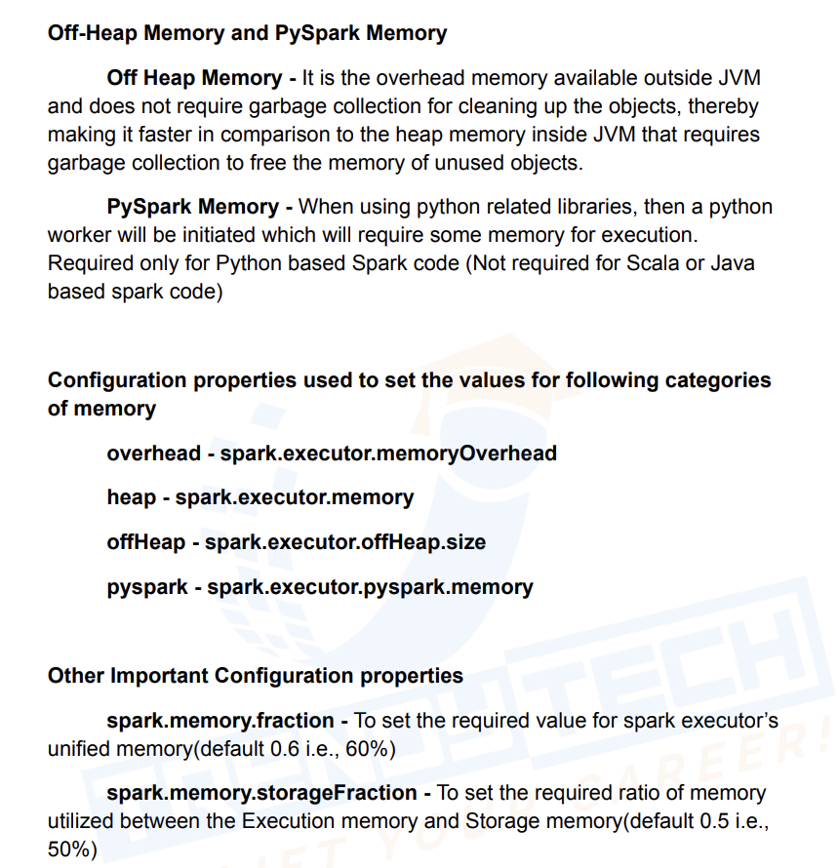

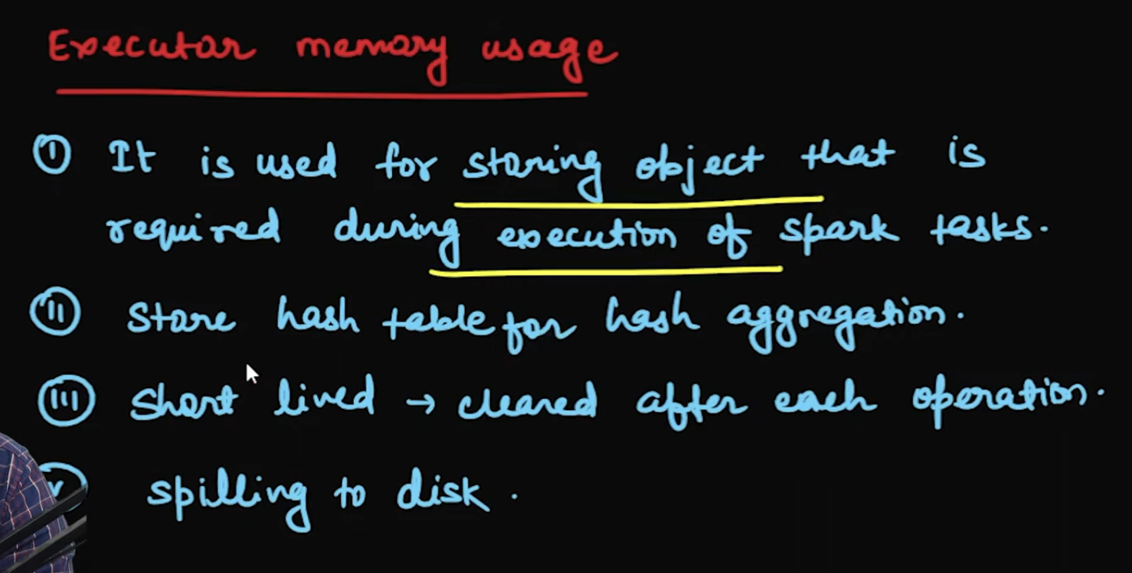

LRU -> Least Recently Used

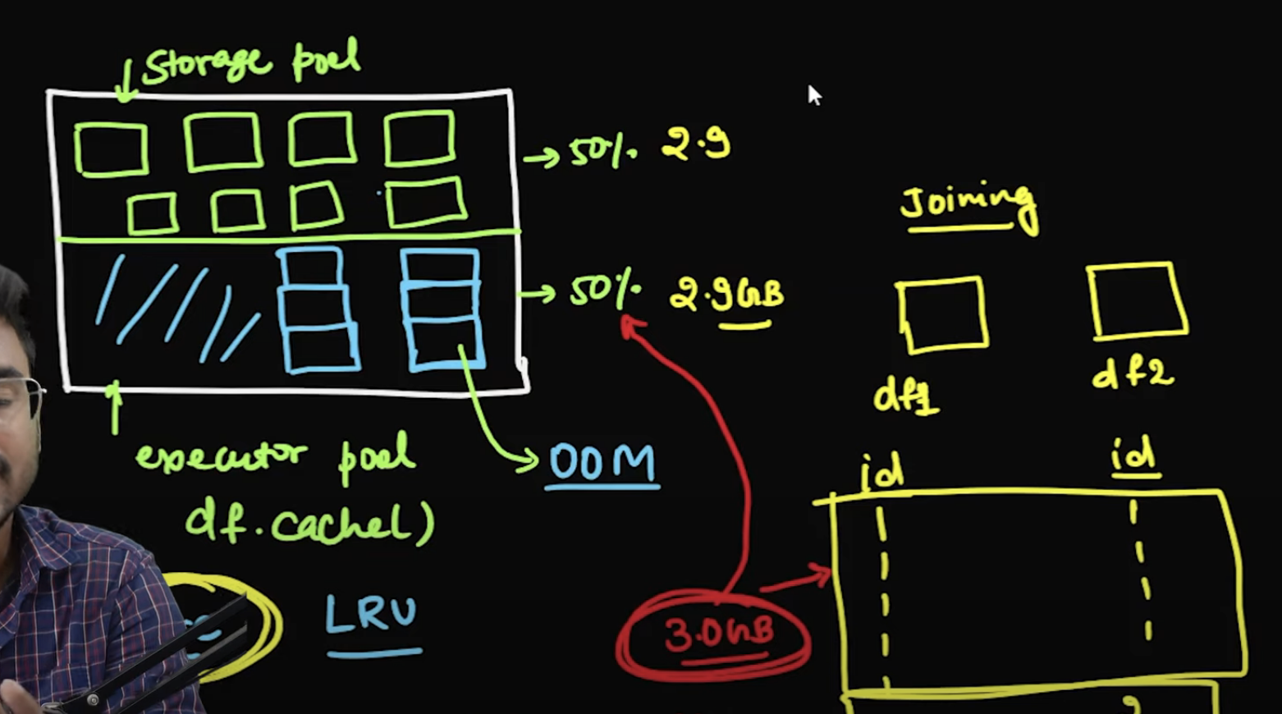

When storage memory is full and it tried to store new object then object will be removed based on least recently used (LRU)

OOM (out of Memory) in Driver:



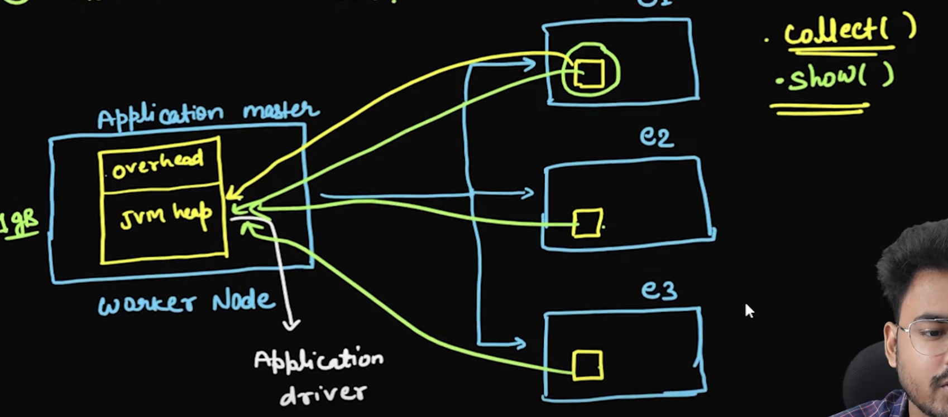

When we run collect it will take all partitions from executors and copies to driver which in some cases lead to OOM

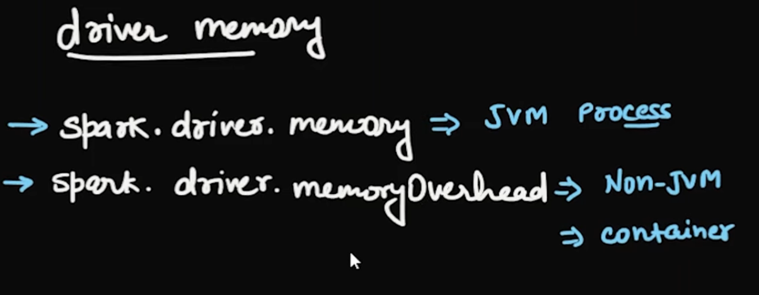

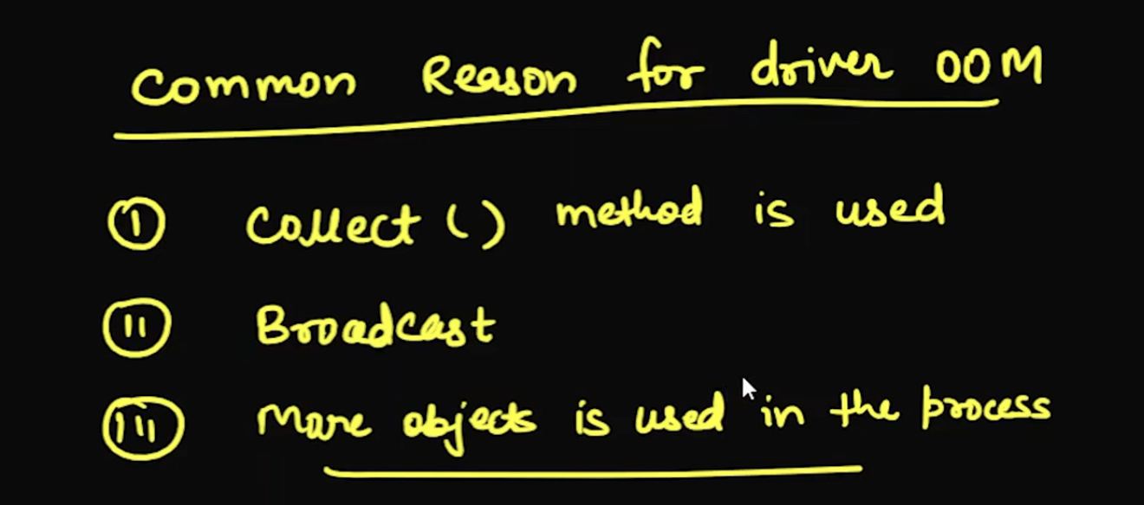

OOM in Executor

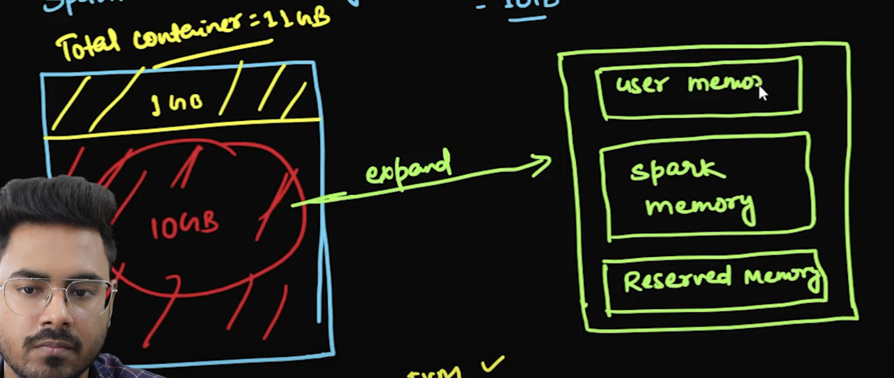

If I used RDD based operations that will go to user memory, but df related operations will not go to RDD

If there is **data skew**, one partition might end up with a disproportionate amount of data, while others are smaller. In such cases, Spark may be unable to spill data from the large partition to disk in a timely manner, resulting in an OOM error.

Even though Spark can spill data to disk, it still needs enough memory to hold the intermediate data before spilling to disk. If the memory is exhausted before Spark can spill, it can result in an **OOM error**.

Sort & Hash Aggregate

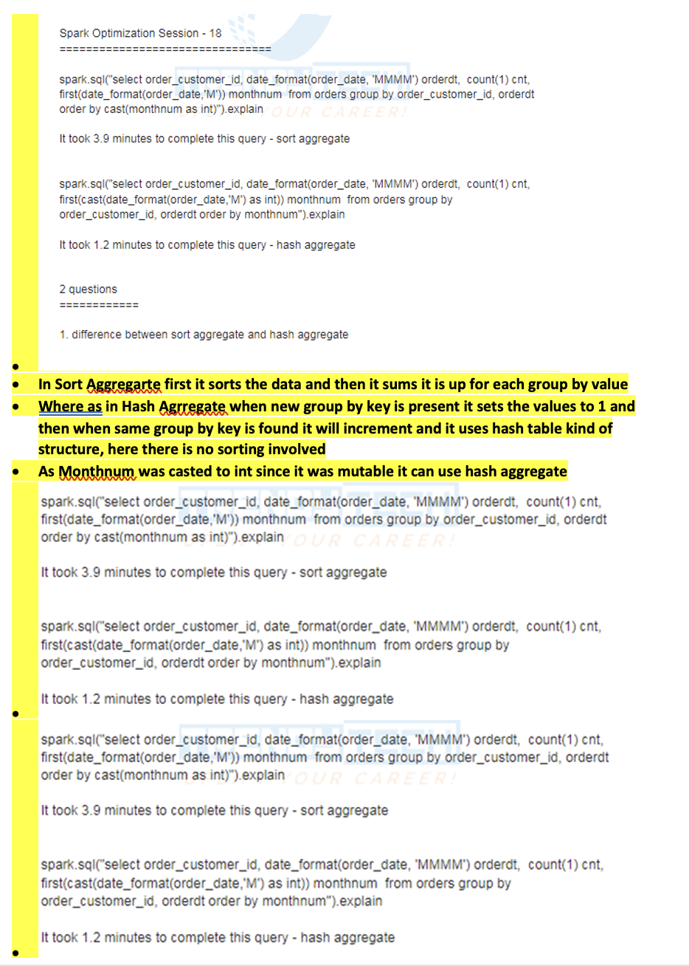

* If we see the query there are 4 columns in select query, customer_id,month, count(1) &month_num, , customer_id,month are part of group by they are keys and count(1) is aggregate function & month_num are part of values, as there is a string type in value it can’t do hash aggregate as string in immutable and can’t be updated at same place
* When month_num is string, it can’t update the existing value after group by as it is a string type and string is immutable, in the second case when month num was int type it can be updated during group by hence spark used hash aggregate instead of sort aggregate

Spark Plan:

* 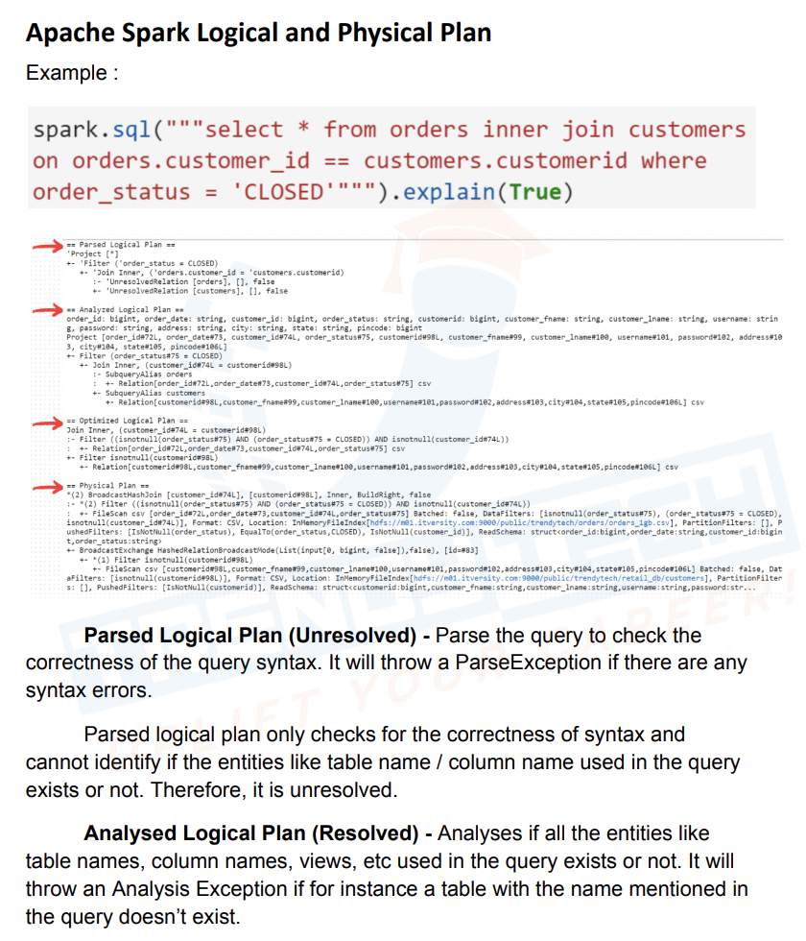
* 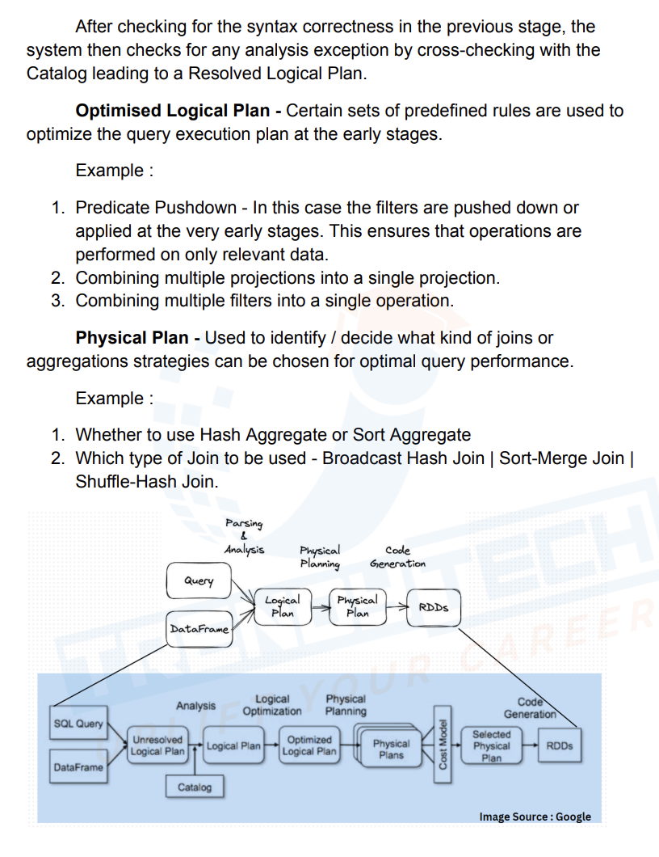
* 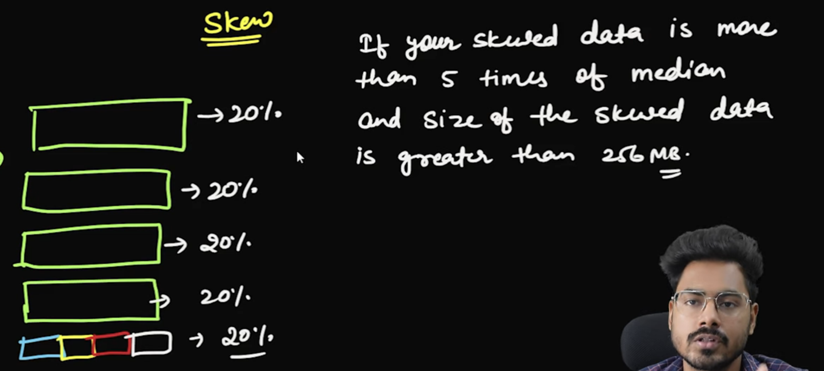

Spark Functions:

Add new column with Current time stamp

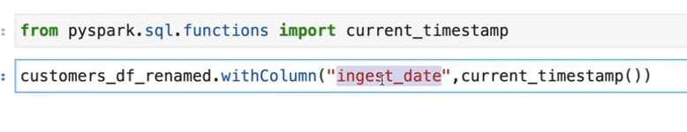

Drop Duplicates

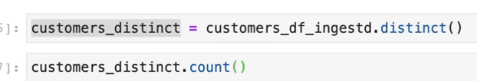

Replace 8 Years as just 8

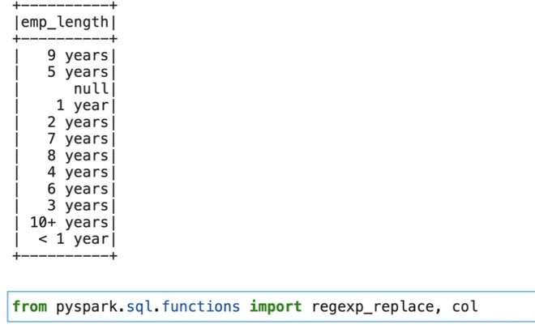



Fill NA

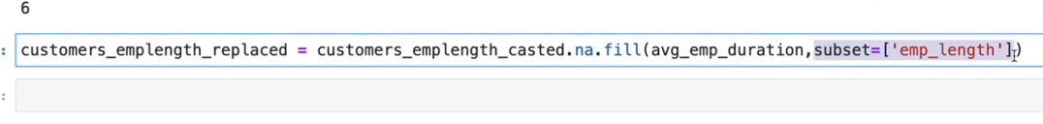

Replace 12 Months to 1 as value

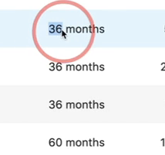

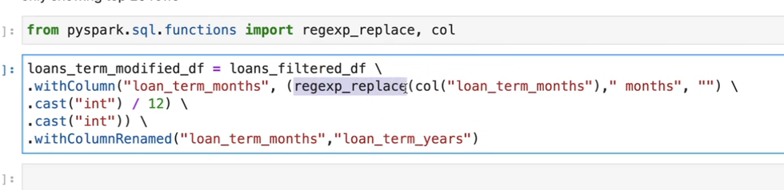

If column matches certail value in an array then consider that value else mark it as other

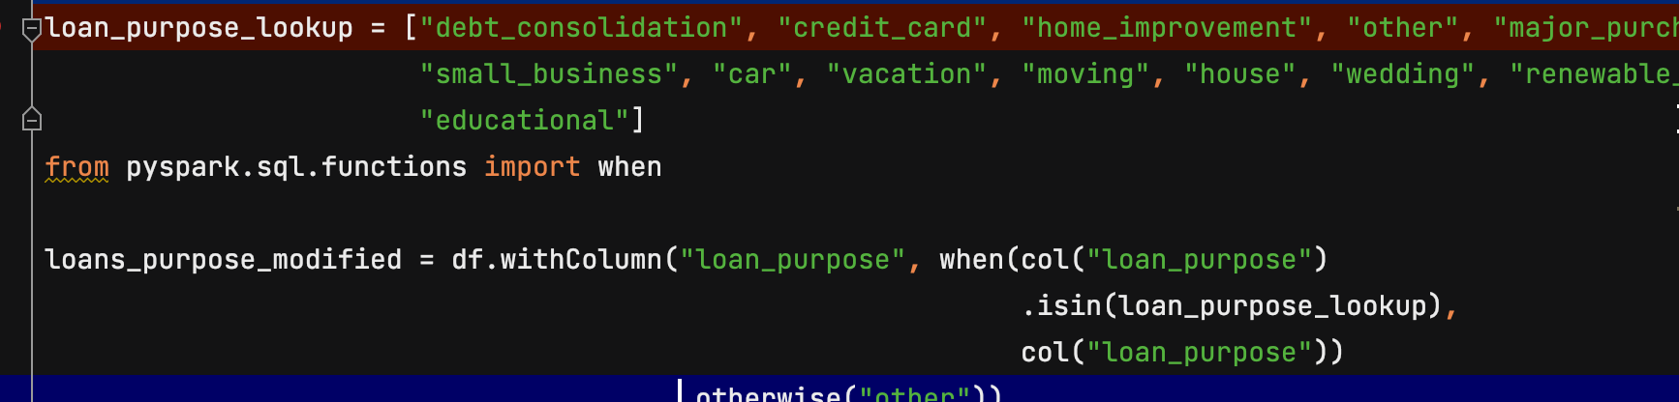

loans_payments_fixed_df = loans_repay_filtered_df.withColumn(

"total_payment_received",

when(

(col("total_principal_received") != 0.0) &

(col("total_payment_received") == 0.0),

col("total_principal_received") + col("total_interest_received") + col("total_late_fee_received")

).otherwise(col("total_payment_received"))

)

File Formats:

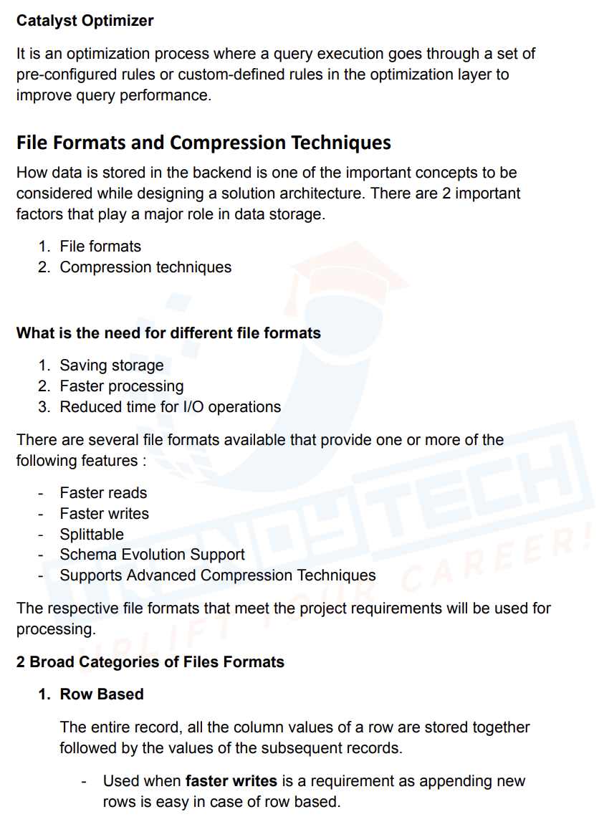

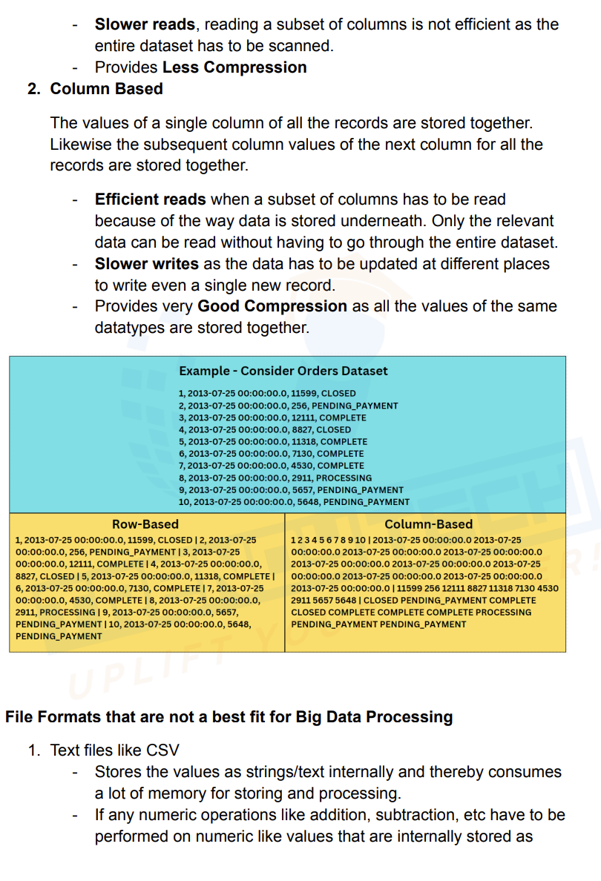

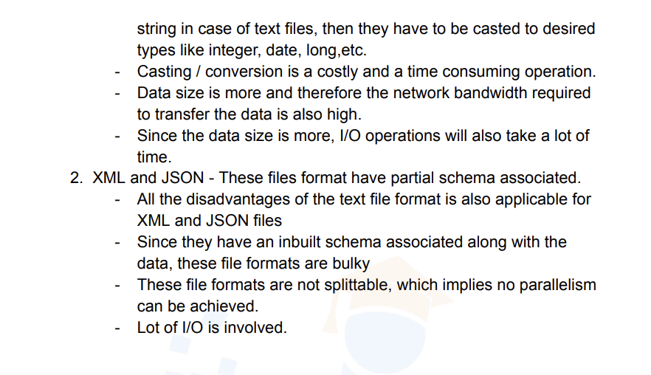

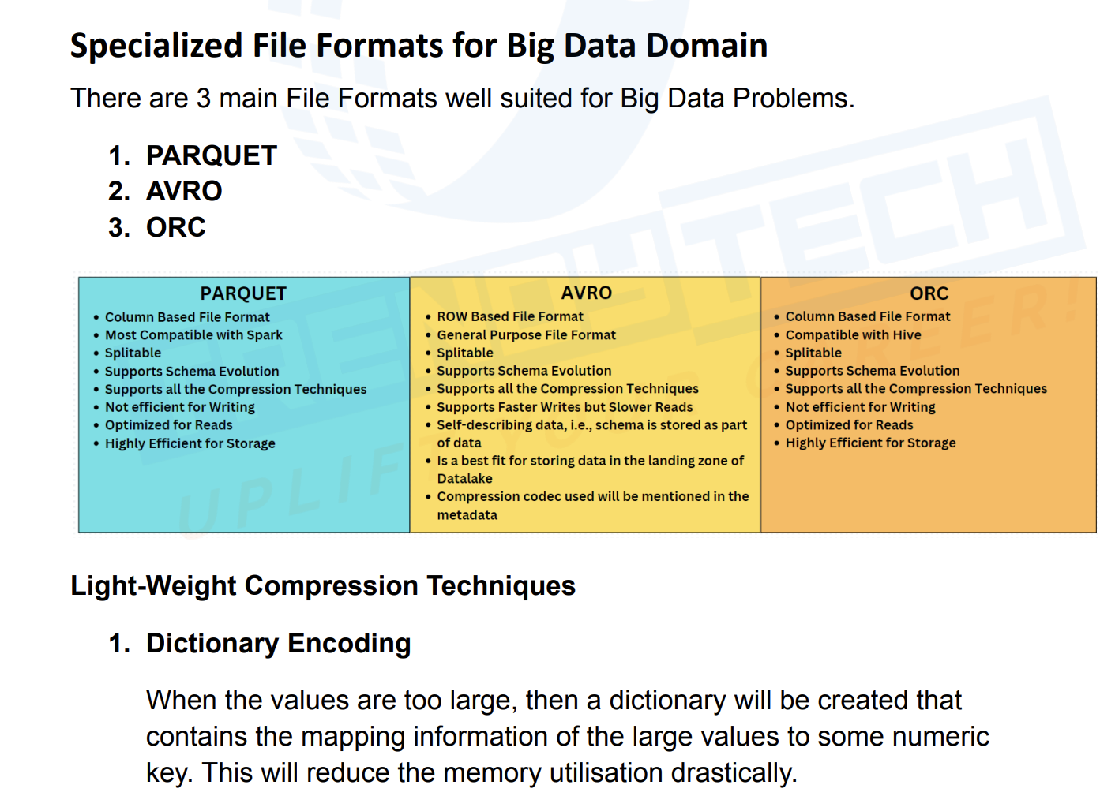

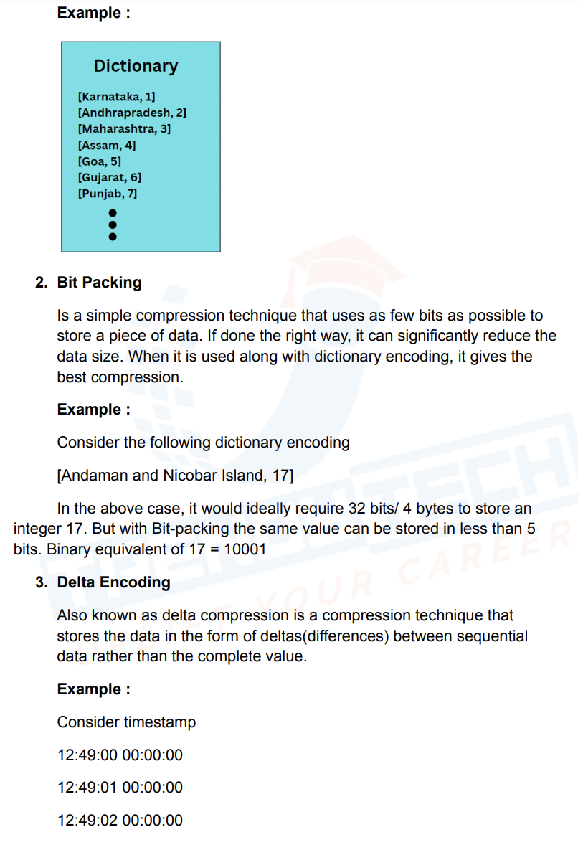

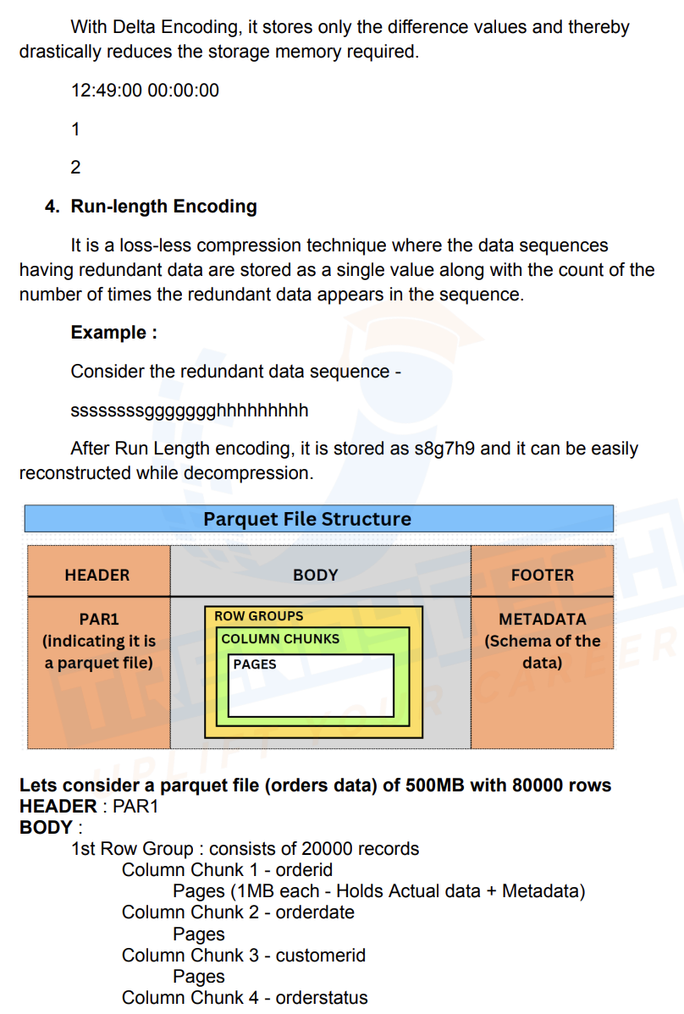

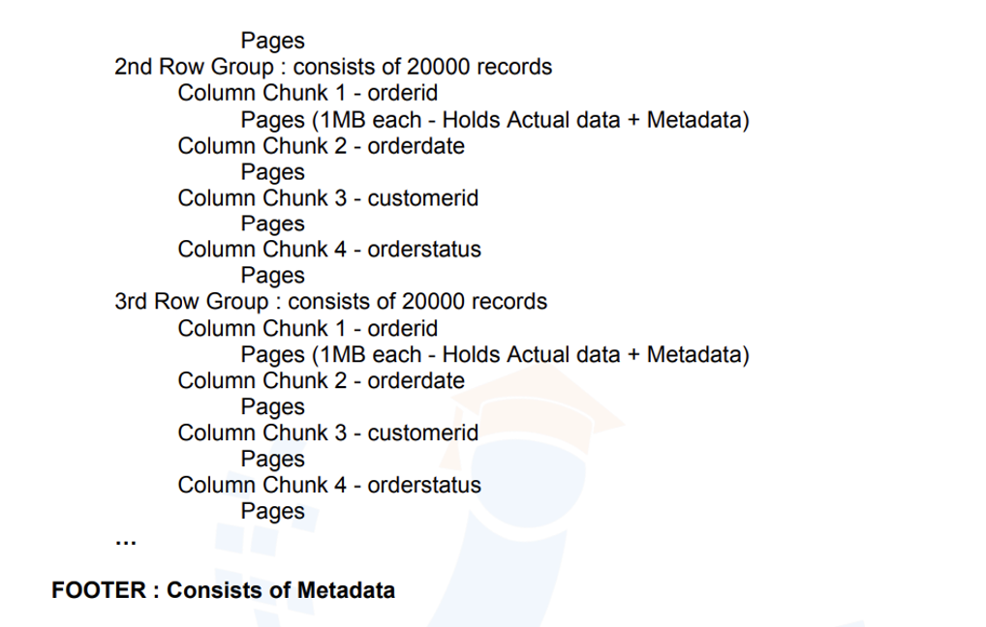

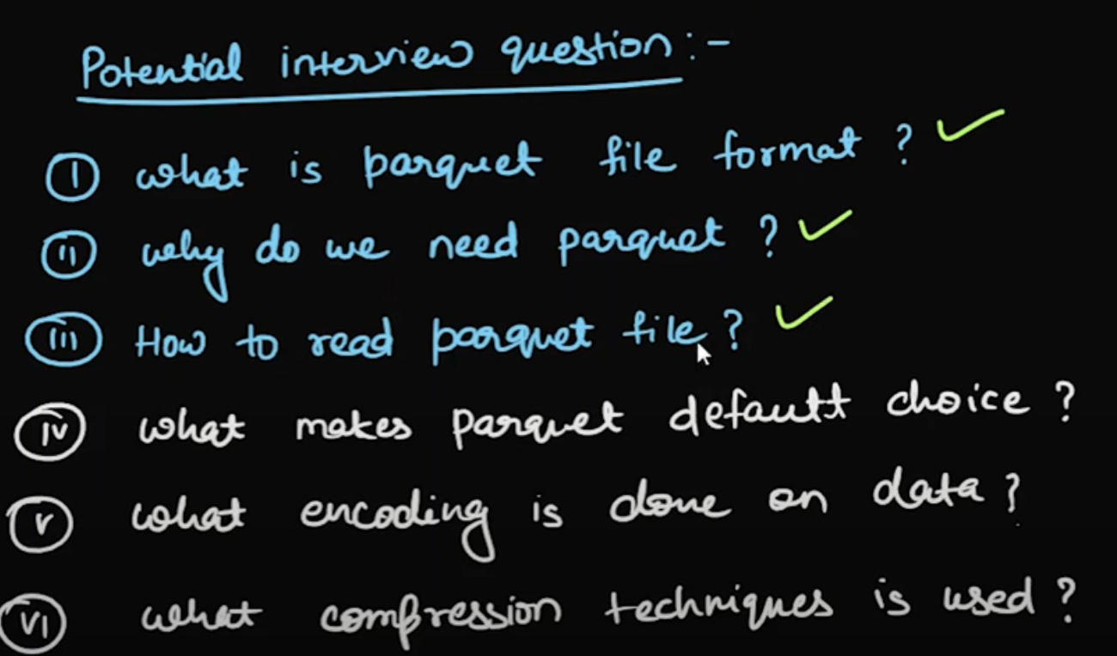



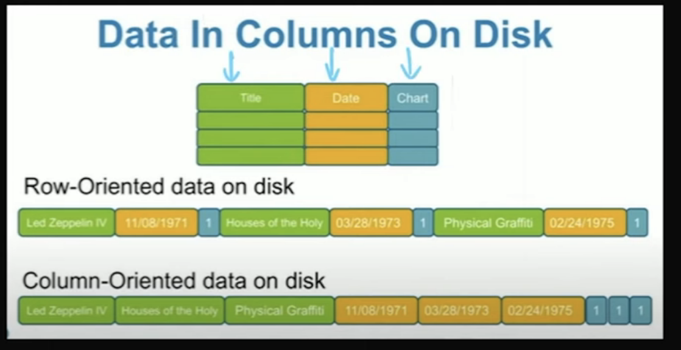

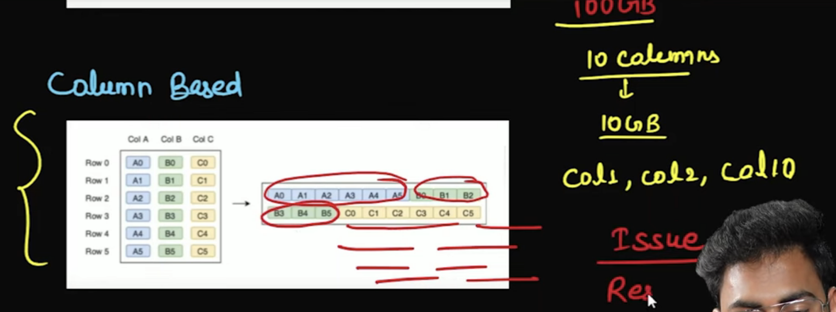

In column based storage and suppose if I have 10 columns c1 to c10 and I want to get c1,c2 and c10 columns then system has to read all 10 columns

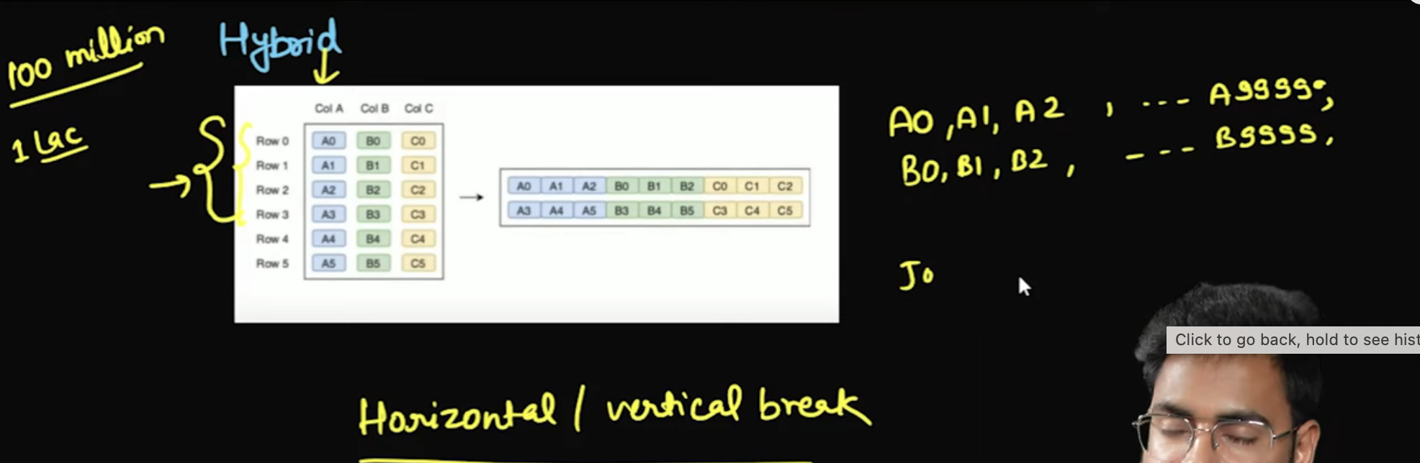

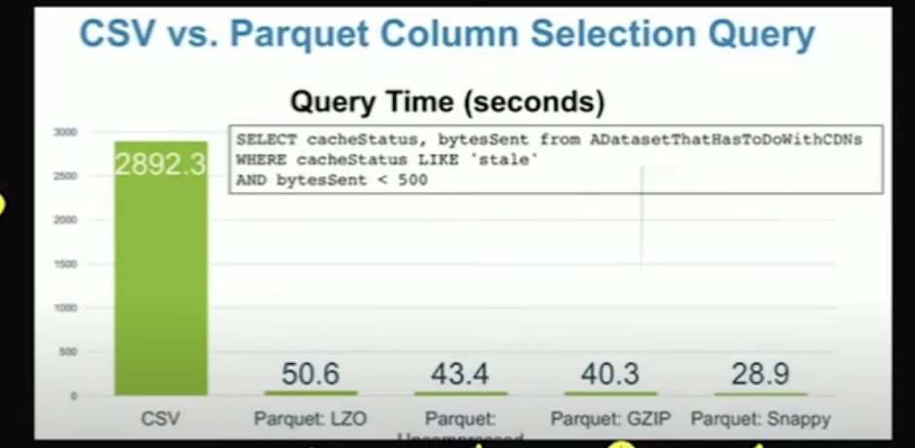

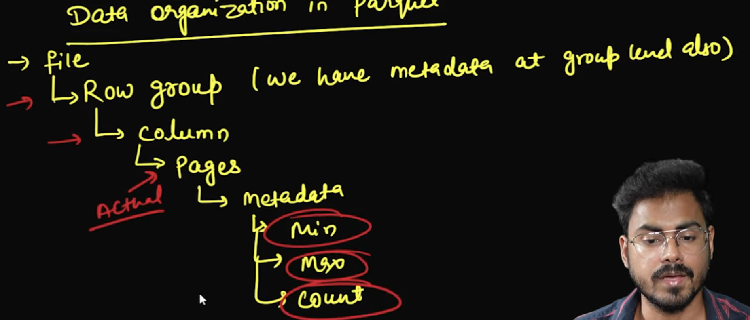



Predicate Push Down:

**Predicate Pushdown**:

* **Predicate pushdown** involves **pushing down** the **filtering** (where conditions or predicates) to the data source (e.g., a database, file system, or distributed storage). This means the filtering (e.g., WHERE conditions) is applied as early as possible, directly on the source data, rather than after the data is loaded into Spark.
* The goal is to **filter the data at the data source** itself, so that only the relevant rows are transferred to Spark.

**Projection Pushdown/Projection Pruning**:

* Pushes **column selection** (i.e., SELECT statement or select() operation) to the data source, which can reduce the number of columns being read.
* Example: df.select("column1", "column2") will push down the projection to only retrieve column1 and column2 from the source.

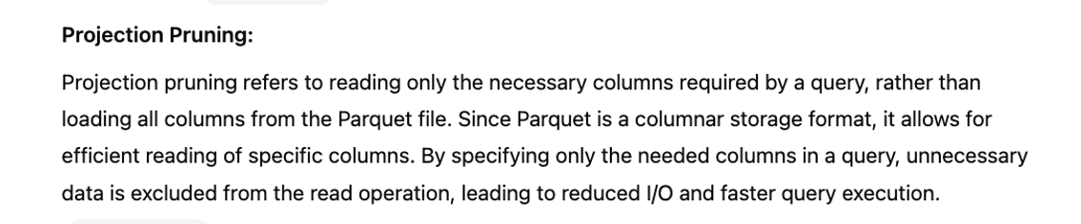

Salting:

Salting:

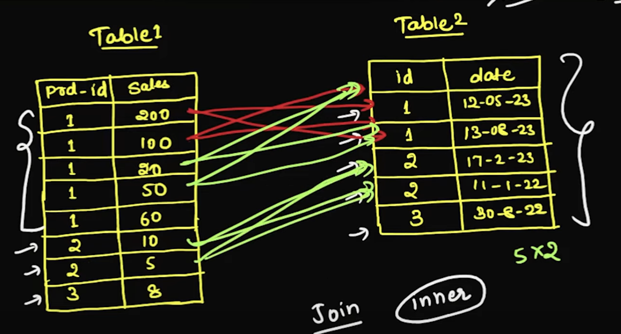

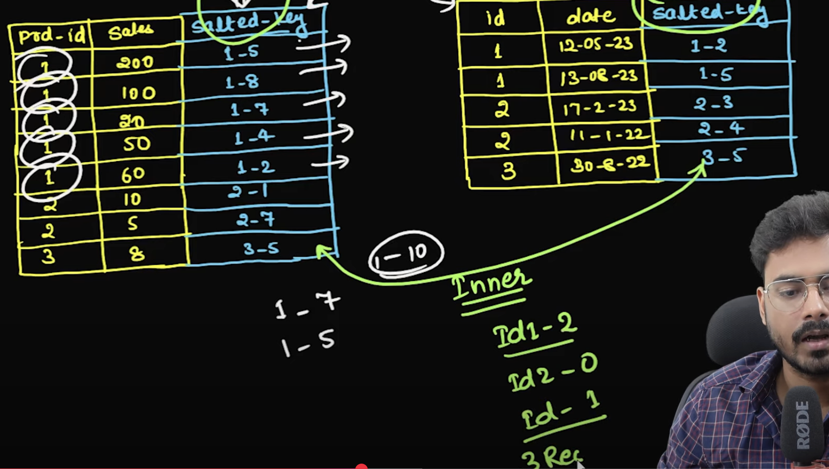

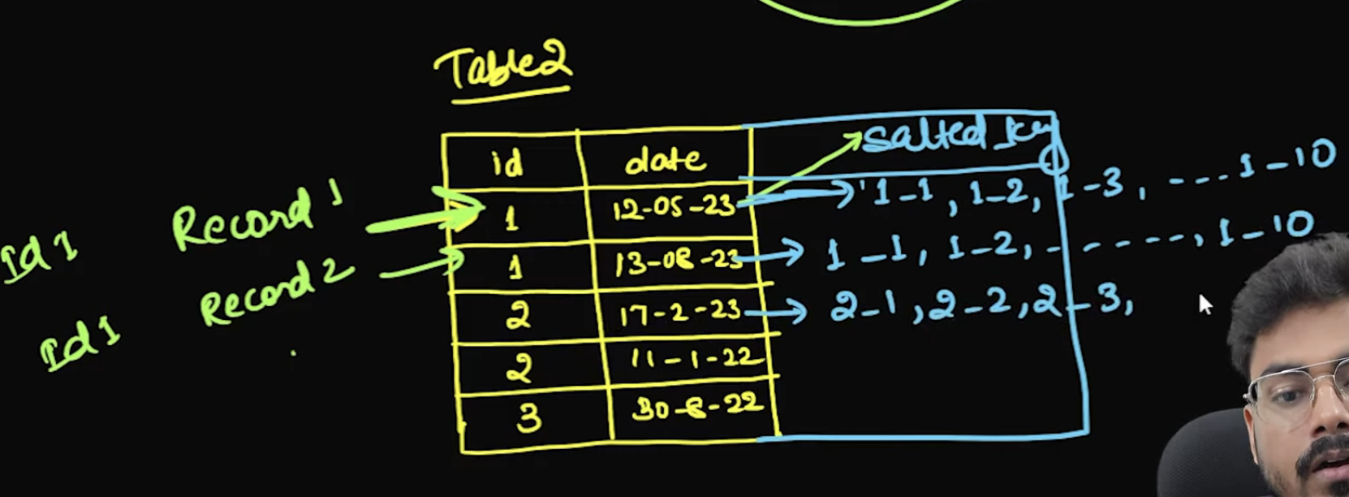

To handle all matching we do above step on table 2

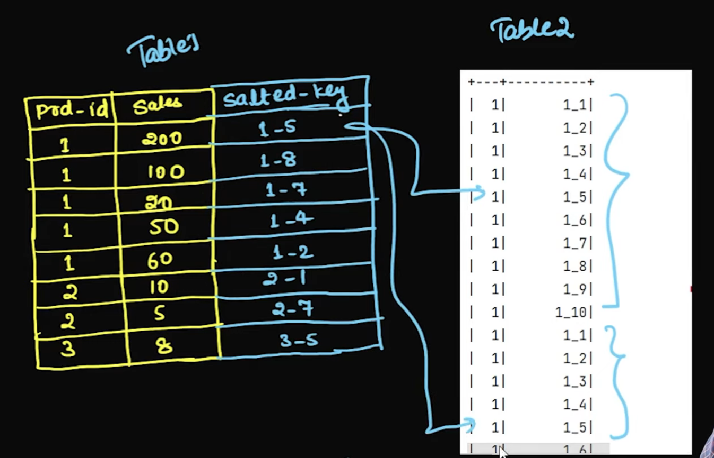

# Find Blank Lines in Text File  
import findspark  
  
findspark.init()  
from pyspark.sql import SparkSession  
from pyspark.sql.functions import *  
from pyspark.sql.window import Window  
spark = SparkSession.builder.config("spark.sql.adaptive.enabled"**,**False). \  
config("spark.sql.shuffle.partitions"**,3**). \  
appName("test").getOrCreate()  
  
id_values =[**1**]\***100000**+[**2**]\***5**+[**3**]\***5**table_1=spark.createDataFrame(id_values**,**'int').toDF('id')  
id_values =[**1**]\***100**+[**2**]\***5**+[**3**]\***2**table_2=spark.createDataFrame(id_values**,**'int').toDF('id')  
print(table_1.join(table_2**,**on=table_1.id==table_2.id**,**how='inner').count())  
  
  
table_1 = table_1.withColumn("random_num"**,**(rand()\***10**+**1**).cast("int"))  
table_1 = table_1.withColumn("salted_key"**,**concat(expr("id")**,**lit("_")**,**expr("random_num")))  
table_2=table_2.withColumn("explode_col"**,**explode(array([lit(i) for i in range(**1,11**)])))  
table_2 = table_2.withColumn("salted_key"**,**concat(col("id")**,**lit("_")**,**col("explode_col")))  
print(table_1.join(table_2**,**on=table_1.salted_key==table_2.salted_key**,**how='inner').count())  
print(**1**)

UDF:

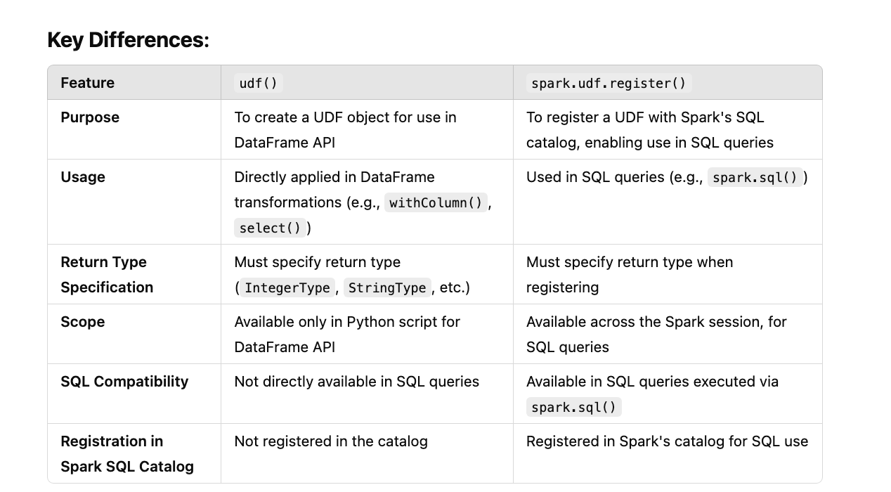

For Spark SQL based use spark.udf.register

# Find Blank Lines in Text File  
import findspark  
  
findspark.init()  
from pyspark.sql import SparkSession  
from pyspark.sql.functions import *  
from pyspark.sql.window import Window  
spark = SparkSession.builder.config("spark.sql.adaptive.enabled"**,**False). \  
config("spark.sql.shuffle.partitions"**,3**). \  
appName("test").getOrCreate()  
  
from pyspark.sql import SparkSession  
from pyspark.sql.functions import udf  
from pyspark.sql.types import IntegerType  
  
# Initialize a Spark session  
spark = SparkSession.builder.master("local").appName("UDF Outside SQL").getOrCreate()  
  
# Define a simple Python function  
from pyspark.sql import SparkSession  
from pyspark.sql.functions import udf  
from pyspark.sql.types import IntegerType  
  
# Initialize a Spark session  
spark = SparkSession.builder.master("local").appName("UDF Example").getOrCreate()  
  
# Define a Python function  
def add_ten(num):  
 return num + **10**# Register the Python function as a UDF  
spark.udf.register("add_ten_udf"**,** add_ten**,** IntegerType())  
  
# Create a DataFrame  
data = [(**1,**)**,** (**2,**)**,** (**3,**)]  
columns = ["number"]  
df = spark.createDataFrame(data**,** columns)  
  
# Use the UDF in a SQL query  
df.createOrReplaceTempView("numbers")  
result = spark.sql("SELECT number, add_ten_udf(number) AS new_number FROM numbers")  
  
result.show()

For DF operation Based use:

# Find Blank Lines in Text File  
import findspark  
  
findspark.init()  
from pyspark.sql import SparkSession  
from pyspark.sql.functions import *  
from pyspark.sql.window import Window  
spark = SparkSession.builder.config("spark.sql.adaptive.enabled"**,**False). \  
config("spark.sql.shuffle.partitions"**,3**). \  
appName("test").getOrCreate()  
  
from pyspark.sql import SparkSession  
from pyspark.sql.functions import udf  
from pyspark.sql.types import IntegerType  
  
# Initialize a Spark session  
spark = SparkSession.builder.master("local").appName("UDF Outside SQL").getOrCreate()  
  
# Define a simple Python function  
from pyspark.sql import SparkSession  
from pyspark.sql.functions import udf  
from pyspark.sql.types import IntegerType  
  
# Initialize a Spark session  
spark = SparkSession.builder.master("local").appName("UDF Example").getOrCreate()  
  
# Define a Python function  
def add_ten(num):  
 return num + **10**# Create a DataFrame  
data = [(**1,**)**,** (**2,**)**,** (**3,**)]  
columns = ["number"]  
df = spark.createDataFrame(data**,** columns)  
  
add_ten_func = udf(add_ten**,**IntegerType())  
  
df.withColumn("add_ten"**,**add_ten_func(col('number'))).show()